Garland’s Story
New Zealand Engineers Divisional Signal Company
Egypt and Dardanelles 1914-1915
World War 1
Killed in Action
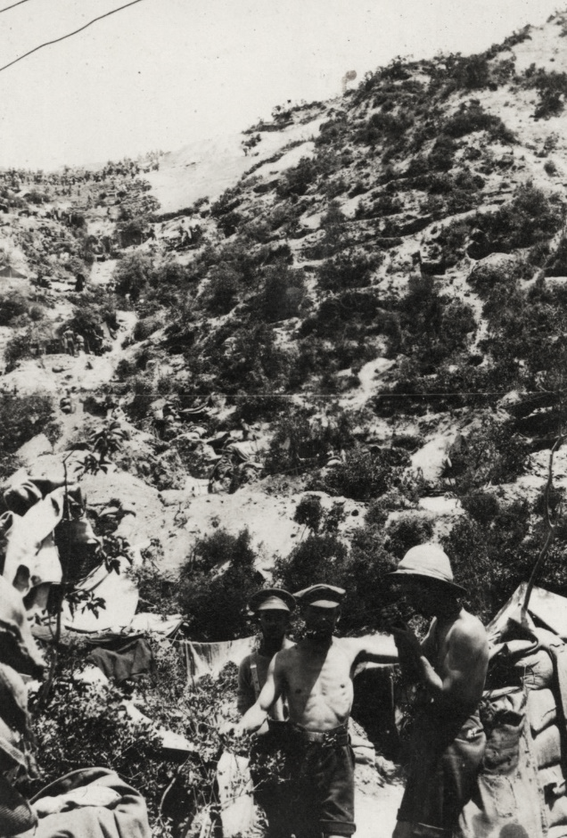
New Zealand soldiers in Monash Gully circa May-Aug 1915 including 4/560 Sapper George Vivian Moore and 4/481 Sapper Norman Roy Vause. Behind them one can see a track lined with dugouts going up to Quinn's Post and Pope's Hill, Gallipoli, 1915.

MORGAN, Garland Oswald
  - 4/558 Sapper G. O. Morgan, New Zealand Engineers Divisional Signal Company, was killed in action at the Dardanelles during the Gallipoli campaign in 1915.
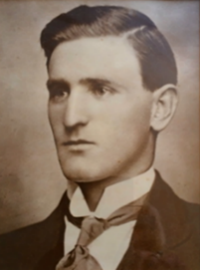
Garland Oswald MORGAN was born in Hawera, New Plymouth [Taranaki] on 14 December 1892. The only son of Thomas Henry MORGAN and Mary Amelia NUTTALL, Garland had four sisters [Catherine, Sarah, Bryl and Hilda] and the family lived at ‘Heatherlea House’ in Hawera.
  - His father, Thomas Henry MORGAN, was younger brother of my great-great grandfathers, John and William MORGAN – a fourth cousin to our generation [first cousin 3x removed].
Educated at Hawera District High School, Garland passed the Civil Service examination in 1908, and entered the local post office where he became one of the smartest operators. He was transferred to Wellington and acquitted himself well both in work and in sport - being an athlete of some ability, he represented Taranaki in hockey.
As a swimmer Garland was well known and took a keen interest in surf lifesaving. He was a prominent member of the Lyall Bay Surf Bathing Club and on one occasion was successful in saving life at injury to his own, for he was invalided for two months after the rescue.
Around 1913 he was transferred to Christchurch to work as Head Clerk at the Old Age Pension Department where he resided at Bealey Avenue, just a short walk to the city centre. On his Attestation Garland noted this as his address where he last resided.

Enlistment
  - At the outbreak of World War 1 Garland was among the first to enlist - enlisting on 14 August 1914 at Christchurch, aged 21 years.
Bearing in mind the nature of his civilian occupation with the Post Office, Garland was posted to the New Zealand Engineers - Divisional Signal Company, with the rank of Sapper [equivalent to Private or Trooper]. He was 5’8” tall (173cm), 148lbs (67kg) in weight with grey eyes and brown hair.
From mid-August 1914 the Divisional Signal Company trained for five weeks at Awapuni Racecourse in Palmerston North under Sergeant-Major Vickery. Being a ‘Specialist Unit’ of the Engineers, troops in the Divisional Signal Company were attached [loaned out] to various units of the NZEF. In Garland’s instance he was attached to the New Zealand Infantry Brigade – Auckland Infantry Battalion.
Garland and the Auckland Infantry Battalion sailed from Wellington with the main body of the NZEF on 16 October 1914 aboard the transport ship HMNZT 12 Waimana. One of ten transport ships that sailed that day, the convoy linked up with the Australian Imperial Force (AIF) in Australia, then set out across the Indian Ocean reaching Alexandria, Egypt on 3 December 1914.
He and another local lad [from Hawera], Reydon BATES, were engaged as signallers on the troopship going to Egypt [HMNZT 12 Waimana]. On arrival there these two schoolmates stood their training well, but just before leaving for the Dardanelles Signaller [Sapper] BATES was sent to the hospital, invalided with pneumonia.
On arrival at Egypt, Garland traveled to Cairo by train, then marched to the newly established Zeitoun Camp. ‘Zeitoun’ was to be their training camp for the next few months. Cold nights and hot days in the desert, he describes it as “most god forsaken place I have ever seen”. The time spent ‘training’ here was hard. Signals training with the New Zealand and Australian Division emphasised the use of heliographs, which sent messages in Morse code by using a mirror to reflect sunlight19F.
In April 1915, the Australian and New Zealand Infantry Division received orders to prepare for the invasion of Gallipoli.

Signallers
  - Signallers served with the New Zealand and Australian Division at Gallipoli in 1915 and served on the Western Front with the New Zealand Division from 1916 to 1918.
Communications were crucial during the First World War and signallers enabled military units to communicate by using flags (semaphores), operating signalling lamps, laying telephone lines and using wireless radios. Sections of the New Zealand Divisional Signal Company [New Zealand Engineers] were attached to the New Zealand infantry throughout the war.
The Divisional Signal Company were drawn from detachments provided by the four military districts and was part of the Main Body of the New Zealand Expeditionary Force that left New Zealand in October 1914. Its four officers and 109 NCOs and men were divided into three sections, some served in the front line from the day of the initial landing at Gallipoli.20F
Men from the Post and Telegraph Department were prominent in the initial formation of the Divisional Signal Company. Garland’s civilian background with the post office made him an obvious choice for a role here.

Gallipoli
  - The eight-month campaign in Gallipoli was fought by Commonwealth and French forces to force Turkey out of the war, to relieve the deadlock of the Western Front and to open a supply route to Russia through the Dardanelles and the Black Sea.
The plan was to capture the narrow Dardanelles strait, which would mean naval forces could enter the Sea of Marmara and directly attack Constantinople, the capital of Turkey and the Ottoman Empire. However, over-confidence, poor planning and lack of resources dogged the Allied effort. Following the failure of a naval attack on the Dardanelles, the Allies landed on the Gallipoli Peninsula on 25 April 1915.
While British [and later French] forces made the main landing at Cape Helles on the tip of the peninsula, General William Birdwood’s troops, the Australian and New Zealand Army Corps [ANZACs] landed 20 kilometres north. The New Zealand troops followed the Australians ashore on the first morning of the assault and the division took responsibility for the northern sector of the battlefield.
In the face of a vigorous Turkish response, no significant Allied advance proved possible. The fighting quickly degenerated into trench warfare, with the ANZACS holding a tenuous perimeter. The troops endured heat, flies, the stench of rotting corpses, lack of water, dysentery, and other illnesses - and above all a sense of hopelessness.
Ultimately, the Allies were to cut their losses. By early January 1916 all troops had been evacuated from Gallipoli. In all, 2,779 New Zealanders died during this campaign.

Baptism of Fire
  - On 9 April 1915, the Aucklanders’ received their orders to depart for the Dardenelles.
Excitement all round at this news, they marched out of Zeitoun Camp, making their way to Alexandria where they boarded transports headed for the Port of Mudros, Lemnos.
The Greek island of Lemnos was the staging point for the Allied Forces [MEF - Mediterranean Expeditionary Force] where they prepared for the invasion of Gallipoli. Garland’s time here was taken up with boat drill, incessant practice at climbing up and down the ship's side on rope ladders, and frequent marches ashore – with full equipment, rifle, and packs. There was great activity here; “Seaplanes, Submarines, Battleships, Dreadnaughts, Predreadnaughts, Cruisers, and Torpedo Boats buzzing around everywhere.”
On 23 April 1915, they weighed anchor at 4.30 PM and calmly turning around, steamed quietly past numerous troop transports and ‘Ships of War’. Out on the open sea now they anchored and waited. Warships are slipping out by the dozen. On the eve of battle Garland comments “All are as excited and as happy as can be. I wonder what the morrow will bring forth”.
The MEF launched its invasion of the Dardanelles on 25 April 1915 with New Zealanders and Australians making up nearly half of the MEFs 75,000 initial landing force. The ANZACs made a diversionary attack 20 km to the north at Gaba Tepe, and the first Australian troops ashore landed at 4.30am. Elements of the New Zealand Infantry Brigade [Auckland Battalion and half of the Canterbury Battalion] start landing later in the morning.
Setting sail at 1.30 AM he was awakened at 4.30 AM by strong gun fire. Leaving his ship at 9.30 AM he was landed by 10 AM under heavy shell fire. Twenty-five Signallers were amongst the first New Zealander’s who landed that day and Garland was one of them.

Killed in Action
  - Garland was killed in action at Monash Gully by a sniper on 11 May 1915. Originally buried in Monash Gully he was later reinterred at Quinn’s Post Cemetery, Anzac.
Fourteen Signallers were killed in action while serving here – Garland being the second. Like other units of the division, the Signal Company prepared to fight in the Dardanelles with limited understanding of the conditions they would face there.
Their work was both important and dangerous. Garland went ‘over the wire’ several times to examine and patrol the wires. On 30 April 1915 he comments “4 AM had to patrol wires again. Day very quiet here, no shells landing at all. Over wire again at 6.15 PM. Fired on by snipers while out and narrowly escaped but could not locate him to return his fire.”
Much of the Signal Company’s equipment was lost during their landing; use of semaphore flags was largely impracticable as most parts of the beachhead were exposed to Turkish fire. Linesmen risked their lives rolling out and repairing lines, and men carrying messages to and from the front line were in even greater danger.
  - Garland was killed in the early hours of the morning of 11 May 1915:
‘At about 4 a.m., a squad including Sapper Morgan was sent out to lay a loop on the line. Sapper Morgan had been on duty all night, and was really entitled to a rest, but he practically begged to be allowed to carry out this dangerous mission. He had only been away about 20 minutes when a member of the squad tapped the wire with his portable telephone and intimated that Morgan had been shot through the heart by sniper.’
An officer wrote "Sapper Morgan was always ready to tackle any work at any time. He was equally good as a Sapper or Driver and was very highly thought of by the officers commanding the company."
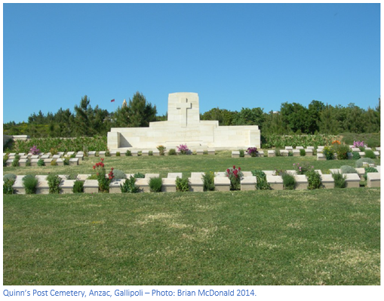
When Garland was killed, he was only aged 22 years and had only been on Gallipoli 17 days. He is buried at Quinn’s Post Cemetery, grave A.27 – one of the lucky few with a known marked grave.
He was remembered as a young man of sterling character and a most loyal and dutiful son— a soldier richly entitled to the garland of honour.
The Queen Elizabeth II Army Memorial Museum, Waiouru (National Army Museum of New Zealand) holds the 1915 Diary of Garland Morgan (RV3281), as well as his original service medals and memorial plaque.

References
Auckland War Memorial Museum – Online Cenotaph
https://www.aucklandmuseum.com/war-memorial/online-cenotaph/record/C10993
Military Records – NZ Archives
https://ndhadeliver.natlib.govt.nz/delivery/DeliveryManagerServlet?dps_pid=IE11473336
WW1 Lives
https://ww1lives.com/sapper-4-558-garland-oswald-morgan-22-killed-in-action/

The National Army Museum of New Zealand has a magnificent collection of photos from various theatres of campaign during the World War 1 era. Many of these can be viewed online. In my research I stumbled across a 100+ photographs (album) belonging to 4/560 Sergeant George Vivian Thomas MOORE, MM, of the Divisional Signals Company, New Zealand Engineers.
The album covers training in New Zealand, troopship journey aboard the HMNZT Waimana, training at Zeitoun Camp, Egypt, and action at Gallipoli including Anzac Cove, No. 3 Post, Walker's Ridge, and Monash Gully. The significance of this is that George and Garland belonged to the same regiment, travelled to Egypt and served at Gallipoli at the same time.
It is possible that Garland may be in some of these photos. He would have been acquainted with some of the people in them and would have seen or visited the sites depicted in the images. Of most interest are the photos around the time of the Gallipoli landings and Monash Gulley. Most soldiers in the images are from Garland’s Divisional Signals Company.
https://nam.recollect.co.nz/nodes/view/8989#idx14015

Thomas died accidentally in 1918 aged 73 years – it is believed he drowned.
This system had worked well during the South African War but was much less suited to cloudier climates. The need for each signal office to have a runner standing by to hand-deliver messages was underlined during the New Zealanders’ first fighting, against an Ottoman Turkish attack on the Suez Canal in February 1915.
The Canterbury Battalion was relieved from the front line on 6 June, the Aucklanders who replaced them had no fit signallers left and the Canterbury signallers had to stay on at Quinn’s Post, the most dangerous position at Anzac.
The Auckland Battalion embarked on the Lutzow, a captured German liner. The Lutzow was to be their home from 15 April to 24 April 1915.
Also known as Limnos.

