MALAYA 1960 – a SOLDIER’S JOURNAL

Ian Gunn
Captain, Royal New Zealand Engineers [RNZE]

Tour of Duty with All Arms Attachment of NZ Territorial Force Officers and Non-Commissioned Officers based with 2 NZ Regiment, Sabroan Camp, Taiping, Malaya

September to November 1960

PREFACE

When CMT (Compulsory Military Training) ceased in 1959 the government of the day decided to encourage those soldiers completing their 3 years Territorial Army service to stay on as Territorials by offering a carrot in the form of opportunity to undertake overseas service with the NZ Regular Army. The first contingent to undertake an overseas posting comprised an infantry group of around 40 personnel from various territorial infantry units throughout NZ. They were posted to Malaya during 1959 for three months attachment with the NZ Regiment, Far East Land Force (FARELF), which was stationed in Taiping as part of the NZ contribution to British Forces supporting Malaya at the time of the Malayan Emergency.

For 1960 it was decided to send an All Arms Attachment with one Officer and one Non-Commissioned Officer from each of the non-infantry territorial units throughout New Zealand. At the time I was serving with the Royal New Zealand Engineers (RNZE) at the Engineer HQ Unit in Wellington, and was selected to represent RNZE along with WOII Ken Oakenfull of 3 Squadron RNZE, Dunedin. The intention of the overseas assignments incorporating personnel across all Corps of the Territorials was to provide units with an Officer and NCO able to undertake jungle/bush training activities in NZ during weekend and/or Annual Camps.

The fifteen strong Attachment Unit assembled in Papakura Military Camp late August 1960 for two weeks intensive training prior to a three months attachment to Malaya as Regular Army soldiers. The training period involved extensive physical fitness activities, weapons training and background lectures on the Malayan Emergency and on jungle warfare. During the two weeks I read Bernard Fergusson’s book “The Wild Green Earth” about Brigadier Ord Wingate’s Chindits and the Chindits expedition into Burma in 1944 behind the Japanese lines. It was recommended to us as a good introduction to the jungle, and proved a fascinating and informative read.

This Journal is based on my daily log entries covering 85 days 7 September to 30 November 1960. The 25 day jungle patrol experience (13 October to 5 November) has been supplemented by material from the daily log for that period of Captain Brian Martin, RNZAC, leader of the All Arms Attachment Unit. Accompanying illustrations are produced from scans of slides taken during the attachment. Many of the 55 year old slides have faded significantly, hence photo production quality varies.

The group photo opposite was taken at 2 NZ Regt HQ at Sabroan Camp, Taiping This shows the fifteen members of the attachment along with WOII Rosie, 2 NZ Regiment, who was head of the camp Training School.

Ian Gunn, December 2015

FIRST TF ALL ARMS ATTACHMENT 2 NZ REGT MALAYA 1960

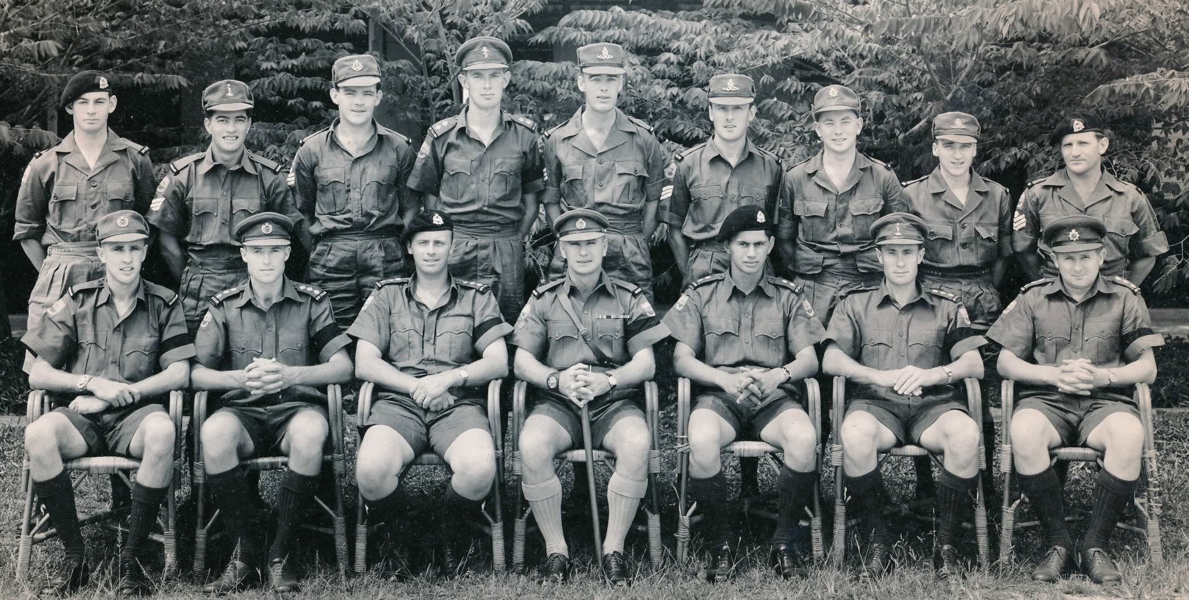

Sitting: WOII K.W. Oakenfull, RNZE; Capt I.W. Gunn, RNZE; Capt B. H. Martin, RNZAC; WOI I.E.D Rosie, 2 NZ Regt;
Lt E.T. Temoananui, RNZAC; Capt G.S Finlayson, RNZ SIGS; Capt M. Kenny, RNZASC
Standing: SGT M.J. Pearson, RNZAC; SGT D. E. Tuahine RNZ SIGS; S/SGT T.J. Williams, RNZMC; LT A.D. McDonald, RNZEME;
SGT P.J. REID, RNZA; SGT J.F. Ovens, RNZA; CPL M.A. Jack, RNZASC; BDR R.W. Gilchrist, RNZA; S/SGT J.G. Hay, RNZAC

CONTENTS

Page

PART 1: The Trip Over 5
[Days 1 to 5]

PART 2: Jungle Training at Sabroan Camp, Taiping 12
[Days 6 to 36]

PART 3: Jungle Patrol, Perak 29
[Days 37 to 61]

PART 4: Corps Experience with Royal Engineer Squadron, 47
Butterworth [Days 62 to 81]

PART 5: Homeward Bound via Singapore 67
[Days 82 to 85]

MAPS: (a) Extract from 1958 Shell map of Malaya showing 11
Ipoh, Taiping, Grik, Butterworth and Penang
(b) Extract from 1958 Shell map of Malaya showing 30
Sungai Ringat Jungle Patrol area

POSTSCRIPTS: 69
- Travel Home
- Chin Peng – the last CT Leader
- The Sungai Ringat Jungle Patrol Area, 2015

PART 1: THE TRIP OVER
[DAYS 1 to 5]

DAY 1: Wednesday, 7 September
Now the humdrum, the unexpected and the hustle and apparent disinterestedness that surrounded us during the last two weeks are over, climaxed by the panic stations organisation yesterday after our episode in the bush on Monday night, and we are on our way from Papakura camp to Malaya.

Whenuapai, money changing, officers, cadets, sergeants and children, we were all numbered onto the squat, solid yet dignified Hastings, and after the usual warming up and farewells, climbed through the clouds to a brilliant day over Auckland. Fairy-down below us and blue above; no sensation of moving, just the racket of four never tiring engines. We began to look for our halos – 8,500 feet and the sea glistening through the clouds.

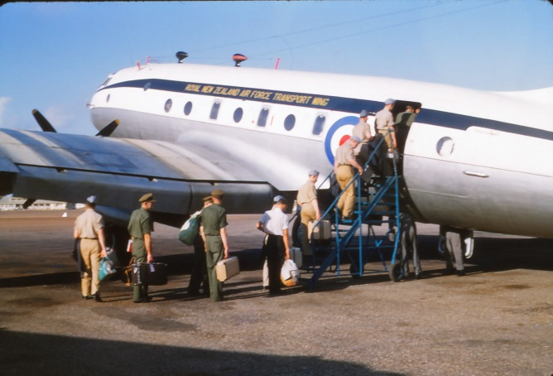  Boarding the Hastings | Time flew, writing letters, reading, dozing, lunch, and then putting watches back two hours. Then Sydney arising from the haze, the Bridge astride the harbour entrance, the dry ground beyond studded with gum trees. Landed at Richmond RAAF Station and as soon as quartered hitchhiked to Sydney, Martin Place and the War Memorial. George Finlayson and I got a ride with a friendly chap and caught a train to Sydenham and then to St James. The number of second-hand car sales yards on the way into Sydney was remarkable – sometimes whole blocks either side of the road.

Met several others of our group and posted two letters home, one to Isobel and one to Aunty Lila. Eddie Te Moananui and I then explored town and met Bruce Jenkins from SME who is doing a course over here on George Street. To a movie called “Lost World” by Arthur Conan Doyle which was very well filmed indeed, and then the adventure home by train. Phew, what a rocking trip.  DAY 2: Thursday 8 September  Today the aircraft climbed to 8,500ft and at 230mph we cruised for 8½ hour approx. above a murky or rather dusty haze. The ground was | 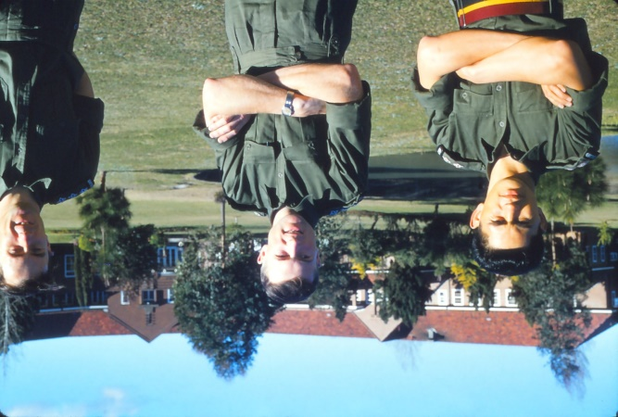  Eddie Te Moananui, self and George Finlayson at RAAF Officers Mess grounds
predominately red in colour, like baking brick, and was covered with stunted trees that looked as though they would give no shade.
Long lines (boundary fences) and white streamers (riverbeds, parched and looking for water) broke the endless monotony of the scene. For the crew of the aircraft these trips get rather tedious. They read or sleep as did we.

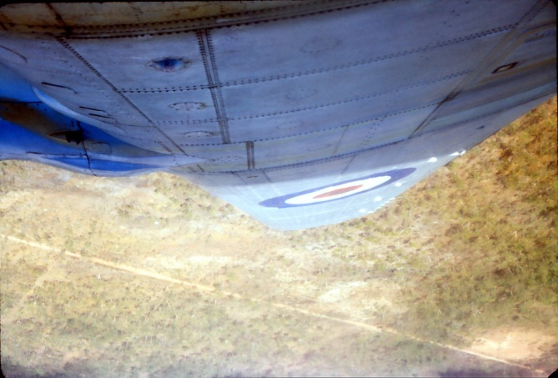  Approaching Darwin | Darwin, after dodging in and around the clouds, was a welcome sight, and after landing in intense but bearable heat, we quartered in the various accommodations provided. Officers and ORs were on the Station, while the remainder went to Darwin, and its hotel, £7-7-0 for bed and breakfast. For the 14 people and two children who stayed there it was £83 for the night.  The air station runways and facilities are being expanded. While drinking in the mess (which was well appointed) we spoke with one of the construction engineers.

He was here when the Japanese struck, and saw £3,000,000 worth of plant and buildings destroyed in 20 minutes. The daily 12 noon raids became too much for most folk who cleared out for Katherine about 300 miles away. He eventually took all construction machinery down there. People were giving their cars away at this time because the road ended at Katherine, and flying was the only way out.  Darwin has nothing much of interest in it. Supported by a large beef industry until the 1920s it now has a lot of Government employees, and is a strategic point from a defence point of view. | 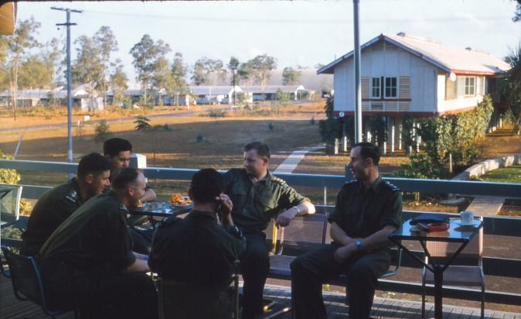  Darwin Officers Mess (Clockwise from right-George Finlayson; unknown; Brian Martin; Allan McDonald; Eddie Te Moananui; Morris Kenny)

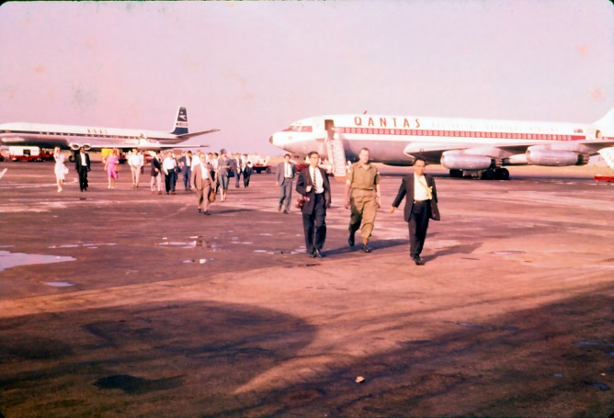  BOAC Comet and QANTAS Boeing 707 on tarmac at Darwin Airport | QANTAS and BOAC of course land here. After us an RAF Hastings (en-route Christmas Island to Singapore) a BOAC Comet IV, a Boeing 707 and a Viscount (ANA) landed, the first two taking off quite spectacularly.  After yarning with RAAF officers in the lounge, and storing away advice and information on commerce in Malaya and Singapore, sleep came amidst gentle night noises interspersed with the occasional roaring of jets.  The monsoon season (or rather the wet season) begins here in October, and the very short brown
grass which sparsely covers the reddish ground grows almost overnight 8 to 10 feet high. The houses are on 6 ft piles to provide ventilation and stop snakes, vermin and insects, and the walls in the officers’ quarters were just louvres, allowing free air flow.

DAY 3: Friday 9 September
Woken by the scream and roar of a Boeing 707 jet taking off, and we waited until about 0915hrs until the ORs and marrieds arrived from the hotel. Breakfast was not until 8am for them and the hotel would seem to rule the town as far as times and costs go.

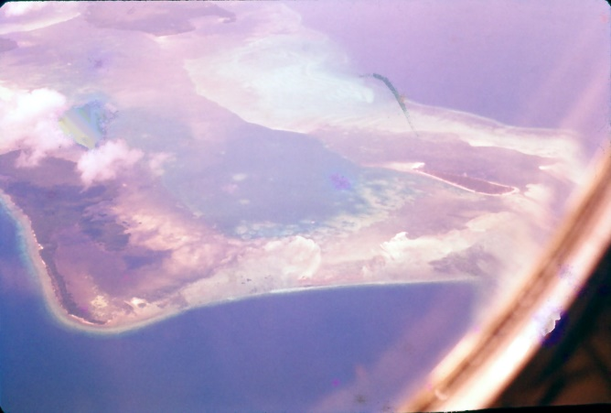  Atoll near Timor | This trip, Darwin to Singapore, was most interesting. Though cloudy over the sea we saw Timor quite plainly; white and earthy beaches, jungle or rather timbered hills which appeared quite open like the Australian gum country. Then lots of small islands surrounded by coral reefs, which at differing depths allowed the light to reflect many hues of green. Some were just horseshoe shaped atolls of coral submerged at high tide, but again showing the various colours arranged in a most attractive display.
Then Borneo and square miles of rectangular areas of cultivation which were in uniform green and edged with jungle, being adjacent to each other. These were just distinguishable, and huts could be seen in the clearer areas. Some areas of 3 to 5 acres appeared to be recently cut jungle, with brown dead stick-like trunks scattered everywhere.

The plane bumped quietly through cloudbanks and up to the islands before Singapore, around which we skirted. Finally dozens of fish traps like vees with blobs on their ends came into sight. As we swept down and low over them we saw rows of stakes and the huts on poles over the cages or traps. These all faced in the one direction, more or less out to sea. Rain lashed down as the aircraft approached Changi. And then we were down, the rain over, and a humid overcast welcome to Singapore Island. Currency exchange, briefing, and then Ken and I off on a first-class road to Royal Engineers (RE) quarters at Gillman Barracks via Changi Town. The jungle and red earth was splattered with many huts, houses, odd roadside stalls and people lining the road. Population on the island is some 2 million. Circuses (roundabouts) occurred near small villages and were very necessary. The traffic – amazing – all the cars were new. i.e. models from about 1953-55 onwards, and though all drivers require a driver’s licence, there are no, or rather appear to be no, road rules. Passing on the left or the right – the first to a corner or intersection gets through.

We arrived at Gillman Barracks via a rather historic route, passing the escarpment where the last fighting against the Japanese took place, the road travelling across the Japanese positions, while on our right was the defended line. The last Company that held this line stuck it for two days before surrendering, and then were all shot by the Japanese for not surrendering earlier.

The RE Officers Mess was a palace compared to anything I had seen anywhere. Better than any hotel lounge in NZ with excellent service. Servant “boys” were on call for anything. The spacious rooms were fitted with large double bladed rotary fans suspended from the ceilings.

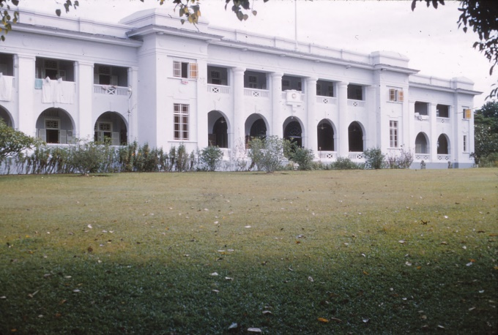  Royal Engineers Officers Mess, Singapore | 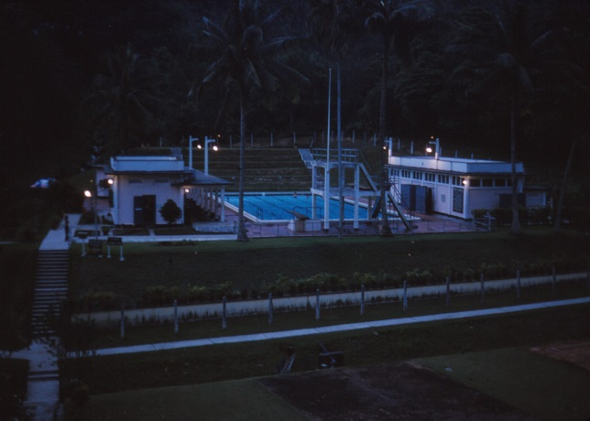  Gillman Barracks swimming pool – circa 1937

We went for a swim with the Engineer Colonel. Shimmering shades of the Colonial Days – these Gillman Barracks had a beautiful pool. Looked like a Candy Filter system, with the water chlorinated but not noticeable; sparkling blue, and must have been about body temperature. Warmest water I have swum in. Then dinner, and it was a really first rate meal. After soup, steak and eggs, sausages, chips and vegetables, there followed a variety of sweets. We helped ourselves from dishes handed to us by the serving “boys”. These servers were Malay, polite and formal.

Then taxi and up to town. These taxis are as funny as a play. Majority are Austin A50s, 1956 model onwards. There are also Holdens, Mercedes Benz, Peugeot and small Studebakers, the majority being diesels. They are mainly company owned, have SH plates (number plates reserved for taxis) and a little blue or yellow disc on grill with SH and a number. About every second car one sees on the street is a taxi, and they just cruise around looking for fares. Boys to old men drive, Malay, Chinese, Sikh, Indian. On top left hand rear is a letter H “Licensed to carry 4 persons” (or three persons if a Fiat or a Prefect).

Based at the Cathay Hotel Restaurant we then explored on foot. Beggar girls (well dressed) asked us for money. We walked down past bazaars and shops where we were asked to buy. Pimps pestered us asking if we want a “girl”. Refusal drew the response, “OK you want a boy then”? We sampled the smell of the portable eating places. Garlic and other aromas showered out at various places, but there is this peculiar smell everywhere. It was OK when it was faint, but sometimes it became overpowering. What I called the “Malay taste” even tainted the European food which we later got on the rail journey north to Taiping.

On to the Raffles Hotel area and past the Britannia Club where an armed holdup had taken place the other day, bandits throwing pepper in the eyes of occupants in vans. They were caught. We walked on into China Town which we found out later was out of bounds because persons are likely to be beaten up and robbed. We were in well-lit areas, crammed with cars, people and children (this is 11:30 at night). Ken Oakenfull asked one little girl what time she slept, and she pointed to his watch the hours 3am to 9am.

The schools in Singapore have two sittings daily, 6am to 12pm, and 12pm to 6pm. All the school children are very neatly dressed and carry neat little bags. The Malay Government in the Federation is making Malay language a compulsory subject. The schools are large and education is a big thing with the people here.

Singapore Island has three airports – Changi for military transport aircraft, the International Airport with a 3 mile runway for large overseas jet passenger aircraft, and the RAF bomber fighter command at which 41 Squadron NZ Canberra Bombers are based. This 35 mile east-west by 15 mile north-south island has numerous military bases which employ 45,000 people, i.e. locals, and feeds possibly 250,000 via economic transfer.

And so home in a taxi after visiting the Cathay Restaurant and Bar just for a look, and to bed, dead tired.

DAY 4: Saturday 10 September
Today we went to GHQ by bus and collected a £37 clothing allowance and after some advice on buying things and not being too quick to make purchases, we dived into two taxis and were off to Lien Wah in North Bridge Road. We explored this road pretty thoroughly until nearly lunch time, returning to the mess for lunch. We then looked through the bazaars near the camp and ended up taxiing to Raffles Place where Robinsons, the big department store, is located, along with many very impressive buildings. From here we went down bargain alley which was an amazing place. Very narrow and completely crammed with goods and people; one had to crouch to get through under hanging handbags, dress materials etc. Everything was sold here.

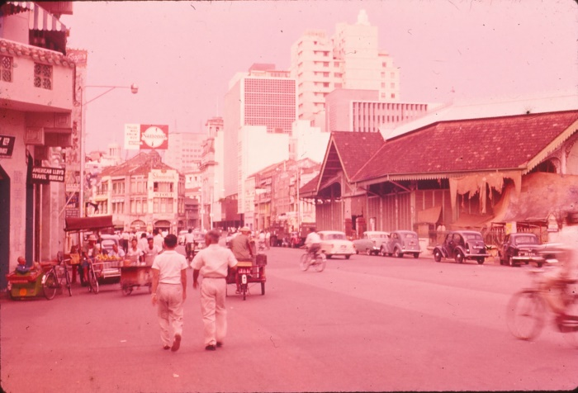  Singapore Buildings | 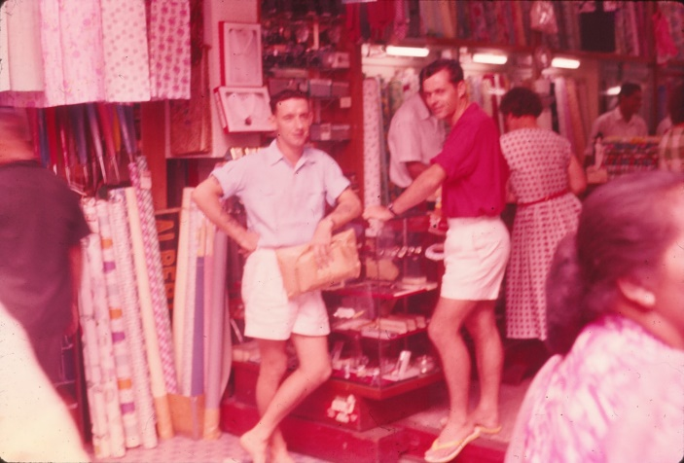  Change Alley (and two of the guys)

And the toys were most amusing, clever and cheap. Peddlers near the ends of this alley tried to sell us post cards, jewellery and watches. Old ladies were selling bananas. I bought a suitcase and we loaded it with things. We also had gone through Orchard Road near Tangs and saw Chinese women helping on construction work. At the One Price Store I saw a Chinese girl with a cross on a chain around her neck, but I never asked her what it meant.

After tea we were taken to the railway station and boarded the Southern Cross Express to Kuala Lumpur, departing at 2200hrs. We had very good roomy sleeping cars and a buffet car for meals. Following a steak and pineapple dinner (with the Malay taste in it) it was off to bed.

DAY 5: Sunday 11 September
The morning was bright and clear after a very comfortable night. These trains glide away from the stations so smoothly you cannot feel any movement at all. We had breakfast in the buffet car and enjoyed the scenery rushing by; deep tin mines and acres of tailings; paddy fields with young rice poking above the water, buffalo wallowing in the mud; fields being ploughed by one man and water buffalo with an ancient plough, wooden type; rubber plantations with tappers at work.

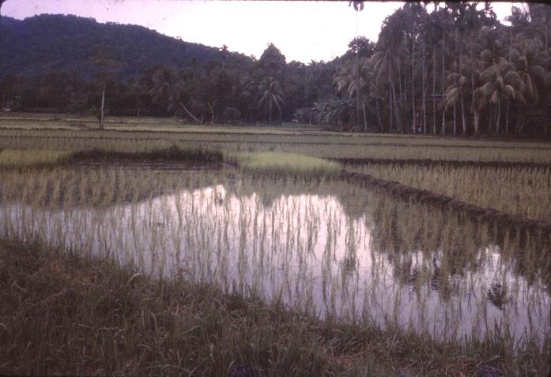  Newly Planted Paddy Fields | 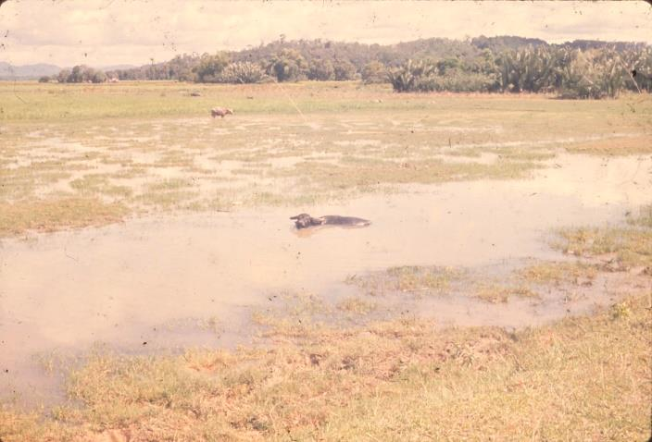  Wallowing Water Buffalo

Then we arrived at Kuala Lumpur. The station was quaint architecturally with various spires and minarets on the roof. We climbed into another train here, an air conditioned buffet car which was quite luxurious. We spoke to an RAF helicopter pilot who was returning back to Butterworth following a jungle survival course. He has been flying for NZers on operations. We seem to carry larger all-up weights than other Commonwealth units.

Meals were on hand all day and we lived like kings. The windows had a special tinted glare proof pane of glass that got rid of the glare and made viewing the countryside most comfortable.

One of the Sergeants had purchased a $340 camera, and coming through customs had to pay $90 on it. Our chaps were a little wary and one actually put a big bluff over on a camera he bought that day, and though the Customs man made no secret of the fact that he thought he was lying, he got away with it.

We arrived at Taiping at 1500hrs and drove to Sabroan Camp and settled in. After a clean-up we dressed in civies and met many of the officers in the mess. There was a wait until dinner at 2000hrs, which being the second Sunday in the month was Curry Macan, in which all officers wives and friends of the unmarried officers attended. The Curry Macan was a huge bowl of rice, curried meat, prawns, cut up sausage and chicken which was very nice. Other dishes included cold meats and salads followed by a fruit salad dessert, all served buffet style. Then drinking and dancing till late, but as we were pretty well played out we sneaked off to bed.

[The map extracts on pages 11 and 30 are taken from the 1958 Shell Map of Malaya and show the main areas covered by the tour of duty with 2 NZ Regiment (Sabroan Camp in Taiping), the Jungle Patrol location in the Sungai Ringat area (east of Grik), and 11 Field Squadron Royal Engineers at Butterworth.]

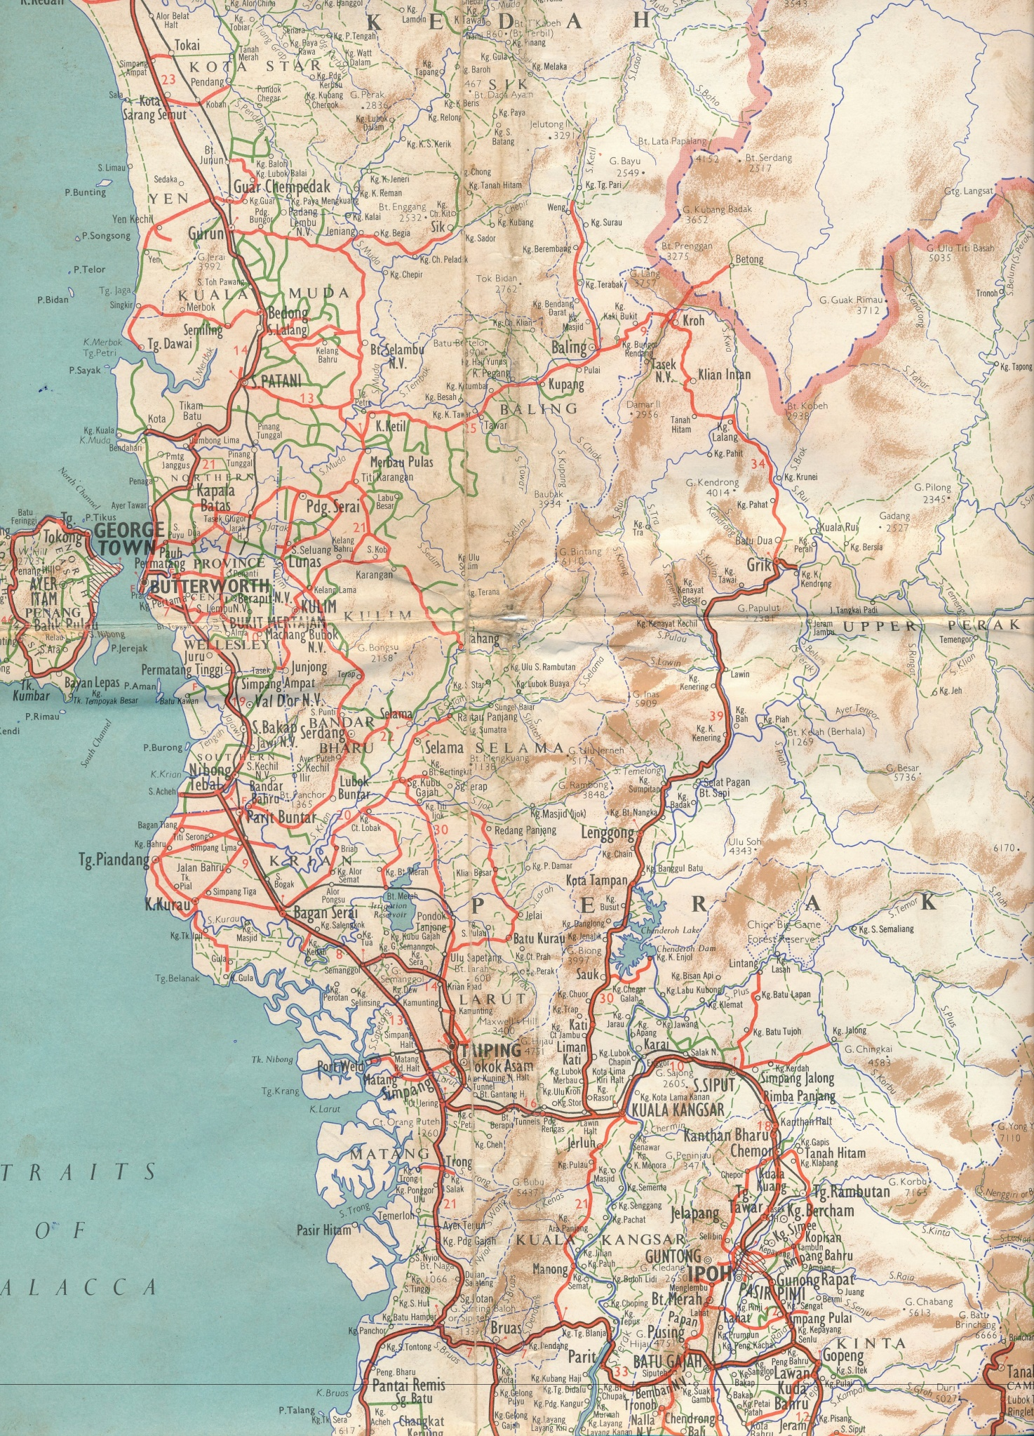
KRUNEI – “Hobart” base for helicopter troop lift
North to ALOR STAR bridge demolition recce
NZ Regt Rest Camp on the coast at Senangiri, 10 miles South of Pantai Remis
IPOH
PENANG ISLAND
BUTTERWORTH –
11 Independent Field Squadron Royal Engineers
GRIK – jump-off point for Jungle Patrol
TAIPING – home to 2 NZ Regt at Sabroan Camp
MALAYA MAP – The Shell Company of Singapore [1958]

PART 2: JUNGLE TRAINING at SABROAN CAMP, TAIPING
[DAYS 6 TO 36]

DAY 6: Monday 12 September
A hot sunny morning and we drew loads of gear from the QM store. What a load. In addition we had a talk from 2IC HQ Company, Captain Morton, and were measured up for our tailored stuff. We also had a tour of the camp and saw its layout, and spent most of the afternoon sorting gear.

Late afternoon we watched the daily football game which seems to take place about 1700hrs in the coolness of the evening. Then a buffet tea which was got up for some RNZAF chaps who were flying up in a Bristol Freighter and did not arrive because they left too late to land at Taiping. It was much enjoyed by us – most tastefully done.

During our tour of the camp we also went to the Infantry School where various courses are run by the Regiment. Lt Huia Woods, who is OC Trackers, showed us the dogs, Labradors for tracking, and Alsatians for patrol work. (These dogs can smell a CT or any danger ahead, and can freeze and point to men in an ambush, and have done so often. They are used to warn patrols and are very effective.)

The dogs are supplied by the British War-dog Unit and are usually one-man dogs. Their handlers have to be interested in dogs before they are picked from volunteers. Dogs are looked after very carefully and are cleaned daily, cages sited in cool shady places, clean meal dishes spit polished (to combat disease) and they are fed meat of quality as good as the men get. They also have special foods. All are examined weekly for disease and a Sergeant of the Royal Army Veterinary Corp supervises their care. They can get ticks on them and flies may “blow” any cuts that, unseen under the hair, result in maggots which hatch very quickly, climb under the skin and a few days later a big chunk of rotting flesh will fall off to the extent that it has been known for a fist to be put into the side of a dog. This can be cured though. Another thing that troubles them is leeches which crawl up the dogs noses and can be a nuisance if the leech dies. Need tweezers to get them out.

Dogs are well looked after and, if necessary, if they take ill in the bush they will be flown out for treatment.

Near the dogs was the Sarawak Rangers Camp. These are natives of North Borneo – Ebans are their name. They are small brown men, like South Sea Islanders in a way, and they are used as trackers with patrols in the bush. (the Chinese JCLOs that accompany them are usually able to speak several languages.) They are very good because the jungle is their home. We met their cook who had a tiny monkey as a pet. The “boys” had killed its mother and eaten it recently and now were going to raise the baby and when fat it would be eaten.

DAY 7: Tuesday 13 September
Yesterday while drawing clothing the Padre, Major Green, came and introduced himself to us and I asked him if he knew Mr Somerville which of course he did as they were trained together during the war. When, with our new outfits, we changed into our shorts, we certainly looked a lot of lily white babes compared to all the other troops in the Regiment.

This morning we were all given a welcome by Colonel Aiken, the Battalion CO, who explained the set-up regarding our training, of which we were aware, and wished us well and hoped we would observe as much as we could to take back with us. Also we would see the country which would be good for relationships between the two.
After that we saw a Sycamore helicopter (known as “choppers” around these parts) land on the football field. These and the Austers of the Recce Flight are used extensively by all forces to take troops 2 and 3 men at a time in to LZs (landing zones) for beginning patrols, and similarly to bring them out to road heads at the completion of missions. These machines (the Sycamore) had wooden blades on the props and after two crashes in as many weeks due to the blades fracturing, and the grounding of all of this type worldwide, they found the wood was splitting and now they put an hourly life on them and replaced them all when the hours run limit was up.

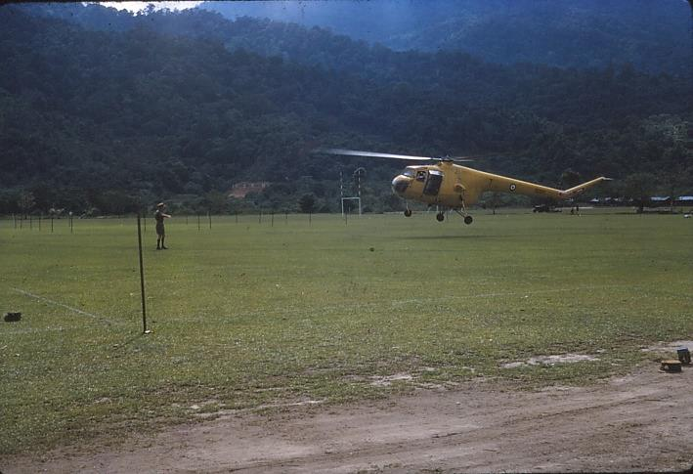  Sycamore Landing at Sabroan Camp | 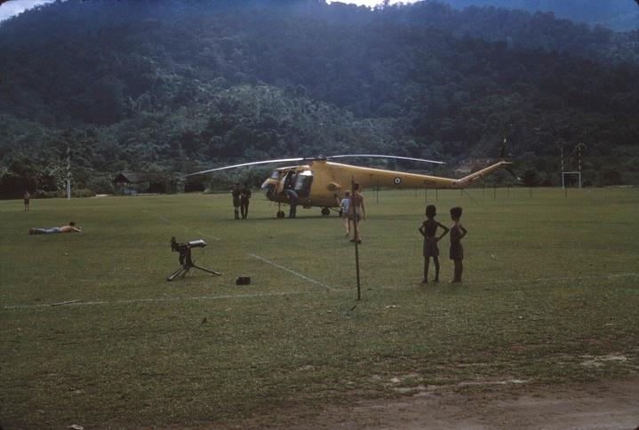  Landed Sycamore at Camp Sports Field

At the next lecture Captain Marty McLeod, the Battalion IO, gave us a picture of the Intelligence and Operations situation. (Marty was a bachelor with an MGA 1600 and an Alsatian bitch which he looked after like a kid). FARELF is acting in an internal security role patrolling against a very elusive enemy of whom no siting has been made since November 1958, apart from SEPs (Surrendered Enemy Personnel). The CT tries to avoid all clashes with the SF (Security Forces) and is on the run into the deep jungle back of the Thai border. Here they are hoping to consolidate and move into closer liaison with the aboriginal people. Their top man is Chin Peng, head of the Malaya Communist Party and leader of the Party’s guerrilla insurgency.

Just a few weeks ago a large 150 strong patrol of Malay and Thai Police ran across a very up-to-date camp for 300 with parade grounds, sports facilities, good accommodation, and surrounded by fortifications. A few days later they came across a camp for 100 along similar lines; it still had warm food in the cooking pots, showing the CT were only an hour or so away.

Our task is to win over the aboriginal people who have been wooed by the CT ASAL groups who live and intermarry with the aboriginals so that family ties will prevent betrayal to the SF. These ASAL groups organise food growing and supply, and what we call “food lifts” making it very difficult to learn who is doing it. The political view regarding these aboriginals is that they are a simple people and quite harmless, and are not to be interfered with in any way. If anyone does, or shows signs of threatening violence, they will run like frightened tale-telling school kids to their local affairs officer who will report to higher-ups and severe ructions will occur.

However, the Army treats these “simple” folk a bit better. After much bribing and many cigarettes later (the aboriginals love these, and even toddling kids love them), the Pengulu (aboriginal for headman) will say he saw the CT go “that-a-way”, and in hot pursuit the patrols will shoot off. However, three weeks later the patrols return disgruntled at seeing not a sign, and the Pengulu will say “So sorry, I really meant that-a-way” (a different direction) and so on.

Patrols of British, Australian, and NZ units are now all in the north seeking information and preparing for a Brigade Ambush Operation around a food lift by the CT from a “Ladang” (aboriginal village settlement) which has been deserted after failure of an ambush at a food drop. During that ambush the aboriginals packed up and set off into the forest in all directions with dogs which smelled out and sprang all ambush positions over many miles, during which (in the resulting confusion) the food drop was accomplished. The policy of denying supplies to the enemy and not allowing him to settle down means large forces against a few men, maybe a ratio of 200 to 400 to 1 (my estimate). As far as casualties go it is very bad if more than 1 SF is killed per 20 CT. Police patrols are notorious for casualties. Five were killed recently charging a CT camp when they fell on bamboo stakes. Another point on casualties is that at the beginning of the emergency when the Aussies were here they killed five of their own men before they got one CT due to faulty ambush drills. Also one chap was shot on the Penang Ferry when a cobber remarked to him that his magazine was still on his rifle. The chap removed it, put forward the safety catch, pulled the trigger and shot his cobber.

Anyway, in the afternoon Captain Duffey of the Army Medical Corp gave us a lecture on diseases. Leptospirosis is a waterborne disease, passed via animal urine into streams from infected areas, and has to enter via a cut, or be taken internally. It will cause a very ill person. Watch cuts and scratches and do not swim in still water, but in water running swiftly, even if dirty, and always sterilise drinking water. Malaria is carried from human carrier by anopheles mosquito to another person, and all aboriginals are riddled with it. Paladin tablets (two) are to be taken daily when in the bush. They are to be continued for 28 days after return to NZ – one chap who forgot ended up in hospital in Papakura.

Amoebic Dysentery is very unpleasant, and good personal hygiene will lessen considerably the chance of catching this.

Then the last disease is Venereal Disease or VD. Two main types are:
- gonorrhoea which is a pus discharge from the penis 9 days after intercourse, and requires treatment for quite some months; and
- syphilis which is sores on the penis, which disappear after some weeks of treatment, but may later on in life say 10 or 15 or 20 years, make a chap mentally ill, physically out of balance, and also may cause rotting of face and skin etc. – a most ghastly effect.

Very often VD has effects later in life, the consequences of which will not be foreseen. We were told “officers never get VD” which effectively was a warning. Condoms are handed out to ORs.

In the morning we had quite a good look around Taiping at shops and town facilities and got our bearings.

DAY 8: Wednesday 14 September
We started the day with an opening address which explained in part how what we were being taught was Anti-CT Operations which differed from jungle warfare in that we were chasing an enemy who would cut and run on sight. No shots had been fired since late 1958. Thus the alertness and aggressiveness of chaps deteriorated without action, and this means that training has to be carried out pretty thoroughly on return to camp.

The rest of morning we treated our equipment with water proofing plus a preparation to protect from scrub typhus, followed by two lectures, one covering animals in the jungle, the other a medical lecture covering snakebite. If a person is bitten by a snake, kill the snake, make a cup of tea, and drink it yourself. Usually snakes are OK. If bitten by a poisonous snake the person will be dead in 3 minutes anyway, so the above approach is the drill (Malaya and Singapore only).

We visited the museum for a couple of hours in the afternoon. It was a usual museum, and gave a good idea of animals of the jungle; birds, elephant heads, tigers, snakes, lizards, monkey, cats and so on, plus arts and crafts, ancient cave dwelling relics, and also houses of various areas. Opposite the museum was the jail which has the top of the wall covered in broken glass. Did rounds of the shops after this and found them most interesting. Came across some little boys playing cards, and they were very photo shy.

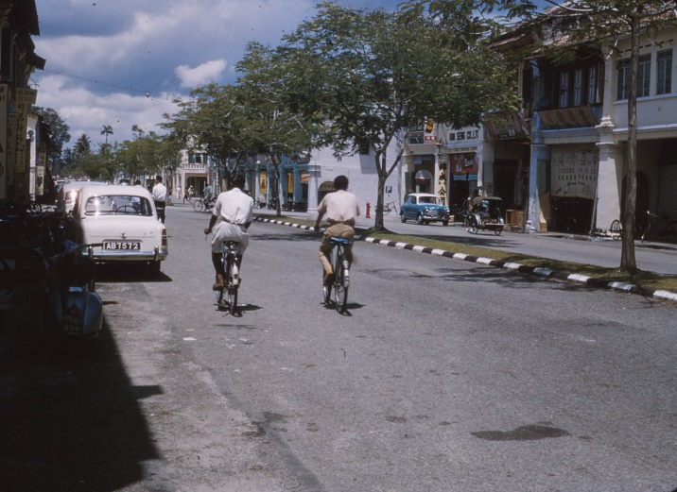  Main Street, Taiping | 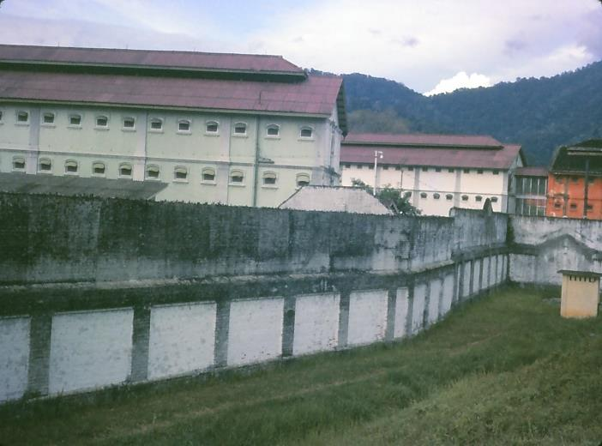  Perak State Prison (Broken Bottle Topped Wall)

At night we went to visit Mr Rosie, the WO1 of Regimental School, and at his home we heard Mr Bickers who is the Headmaster of the local Boys College. He has been in Malaya 11 years and speaks several languages – he spoke to us on the people.

They were originally aboriginals who had Arabs introduce them to the Muslim religion. Tin and rubber are the mainstays of the economy, with 60% of overseas exchange being in rubber. This was a most informative talk and I only wish I had taken notes as I am writing this a week later.

DAY 9: Thursday 15 September
Today was a real work day proper. SLR weapon training, and lecture and practise on patrolling with the afternoon looking at the jungle fringe.

DAY 10: Friday 16 September
Today we got sunburnt during weapon training with Stirling (novel methods of quick aiming, semi-duelling etc). We then practised movement and concealment in the bush.

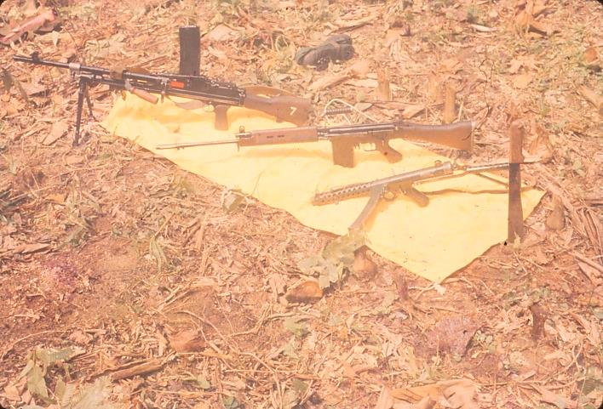  Jungle warfare weapons-7.62 Bren, FN SLR, Stirling, Gollock | 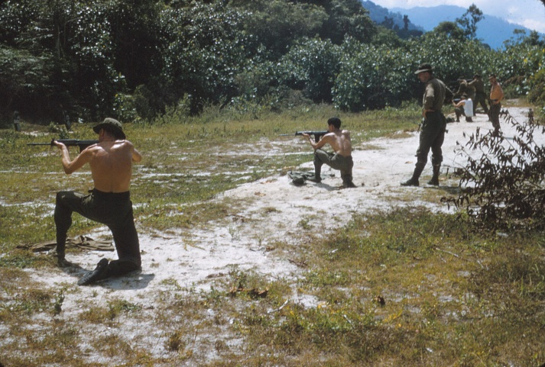  Weapons training at 25 yard firing range, Sabroan Camp

DAY 11: Saturday 17 September
After zeroing our rifles we had the rest of the afternoon off, so I just washed clothes and read books all day and wrote letters, and the other boys went off to Penang except Eddie, Morris and me. The doctor (Colonel Hallwright) and I went and saw a film “Danger Within”, a story of a prisoner of war camp. Very good acting but with the whole camp escaping was rather improbable.

DAY 12: Sunday 18 September
The Garrison Church service at 1000hrs was attended by mainly British soldiers and families and was run on Anglican service lines. Faith – being trust and confidence in another – was discussed by the Chaplain, a large well-built man. The NZ Regiment service at 0900hrs I missed. I went along to the Garrison service in open necked shirt, but as I approached I noticed the men wearing ties and tropical suits, so I beetled back and changed quickly into a tie and then joined the service just in time. The afternoon I spent writing home, and sleeping, and the latter gave me an unpleasant head and tastes. However after tea, and perusal of the local papers, I dropped this feeling and then out of more or less plain restlessness went to the movies with Eddie and saw the “Marshal of Dodge City”, a cowboy film of usual plot which had a play on religion that was hilarious to the audience, but rather pathetic to me – old Pa Kettle played the Parson.

Major Green the Padre was in the mess until nearly mid-night while I finished my letter home. He was recording some music on a tape recorder. This seems to be a very valuable and useful piece of equipment and I think I might just get one.

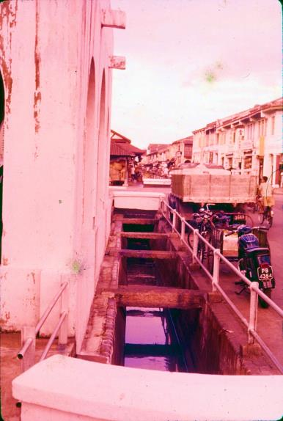  Monsoon drain | 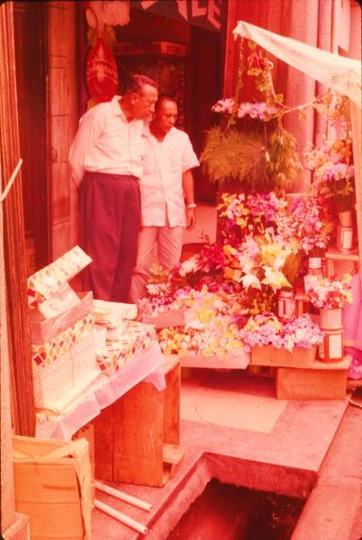  Street gutter | Allan, George and Brian arrived back from Penang around midnight and apparently had chummed up with three Chinese belles and spent the weekend around restaurants, hotels and bars, with glimpses of a brothel or two under a cover charge. Also they had a meal of crabs and snails by the water or harbour-side parade. They did not otherwise see much of the city.  An observation I have made is the similarity of construction of shops and verandas and the street gutters in all the villages and towns and cities in Singapore and the federation.
This is probably the result of British administration. Actually the thick concrete lends a certain amount of coolness to these places.

DAY 13: Monday 19 September
A Stirling and Bren shoot commenced the week with novel practices (shoulder, kneeling and standing from 25, 20, 15 yards and hip from 10 yards) climaxed by a hip shoot automatic from 25 yards on which a prize was contributed by all at a 50 cent rate. Allan McDonald, after a shoot off, scored 17 out of 20 which was very good.

Before lunch aspects of IA (Immediate Assault) drills were discussed. I took notes on the four of these. The usual 2½ hour lunch break was a further opportunity for sun bathing. Up to the rubber plantation and we saw a most useful demonstration of IA drills for Immediate Assault (head on contact), Immediate Ambush (splitting CT first) and Anti Ambush. Here we are learning to kill. We must treat CT like animals because that is exactly what they are. They will kill you if they feel they are likely to lose their lives. They will not sell their lives cheaply. Watch them like hawks and do not take any chances; if they show any dangerous tendencies, shoot them. However, there is no excuse for cold blooded murder. One English Regiment had caught two CT and when the CT showed them where their packs, belts and weapons were, the troops dressed them up and shot them and put in a story of shooting in self-defence. The Aussies caught a prisoner who refused to divulge the location of his equipment until he was actually in the chopper and taking off, because he knew of the above incident. The CT will never take prisoners. One Fijian Sergeant (despite the heat generated when six Fijians were ambushed returning from a football game) used to run his CT down and club them and bring them back alive. However this weakness of his led him into ambush and he was killed. The CT had come to know of his methods.

An SEP (Surrendered Enemy Personnel) will usually be very boastful of all the sorties he has taken part in, who he was protecting, and their strategy and movements. They are quite proud of their efforts, especially ambushes. It is recorded that one SEP took a photograph of a Maori scout from 5 feet as a patrol walked through an ambush, so well were the CT hidden. The reason the ambush was not sprung was because the SF looked so aggressive. On another occasion an SEP had followed a patrol for 3 weeks a short distance behind the tail-end Charlie before giving himself up. Another SEP told how an SF patrol (Kiwi 1st Battalion) was resting having a quiet smoke in an area where 15 CT were in ambush and a rifle was on every man, but the CT leader called it off and the Kiwis went on their way unaware of their reprieve,

The CT take meticulous care in detail for ambushes. Four to five months planning is often the case. The purpose for their ambushes is to:
- obtain food and supplies;
- boost morale of their men;
- initiate new members to action;
- make presence felt politically.

One ambush in Kedah took four months planning in which ditches with sharpened bamboo stakes were prepared, and traffic movements plotted and predicted. Two groups are set up – the Fire Group which springs the ambush, and the Loot Group which sweeps in, kills the remaining SF and carries off as much booty as possible. One such ambush was sprung by felling trees front and rear of a convoy, and struck the largest haul going into the area for several weeks. It was most successful from a CT point of view.

Another well planned one took place where a large bank was at one side of a road. On ambush the SF took obvious cover under the bank and the CT above dropped dozens of grenades on the SF wiping them out. THIS IS OUR ENEMY.

DAY 14: Tuesday 20 September
All morning we sweated at a modified Cowboy and Indian game and practised IA drills until we shook off the Cowboy and Indian stuff and did it seriously. The afternoon up the jungle base was poor shooting from me, but I was satisfied with my observation capabilities. We individually stalked slowly along a jungle lane with the staff supervisor behind us pulling on hidden ropes which enabled wooden panel silhouettes of CT to pop out from behind trees to the side, or pop up out of a bush patch in front. We fired live rounds at these as targets. There was also a game of spot the leech, a fascinating little devil. That evening the film “Odds Against Tomorrow” gave rise to an interesting reminiscence on the psychology of our environment.

DAY 15: Wednesday 21 September
Today’s lecture on orders was pretty basic and necessary stuff for a troop commander to understand. We had elementary map reading and study of maps of jungle areas. Then it was an easy afternoon on weapon training discussion and demonstrations of Flare Pot and Spotlight rifles for night ambush work, plus two inch mortar flares and a Very pistol. (I managed to souvenir a parachute from the Very flare in a hunt through bush)

DAY 16: Thursday 22 September
The morning saw us experiencing various “going” (the range of undergrowth) in the jungle and we carried out a short compass march. In the hot afternoon sun (between ices and soft drinks from the $60 a week “Magnolia” ice cream boy) we shot up targets at 25 yards.

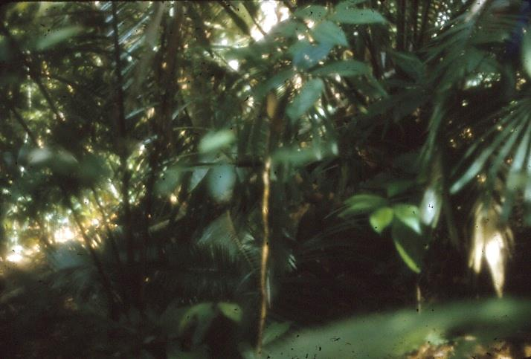  Jungle undergrowth (with Trevor Williams sitting in ambush) | 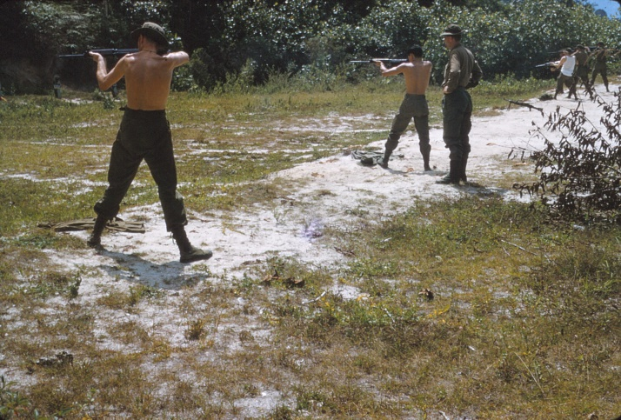  Shooting up targets

DAY 17: Friday 23 September
Some of the boys have been playing it up recently doing all the hotels and bars on the pretext of getting to know the people, and feeling a little sorry for themselves the next day. We had a strenuous day on the IA circuits, with practise improving our reactions at every incident. It was most worthwhile.

The evening we spent down town shopping, and I bought several books, collected passport photos for driving licence application, and enjoyed the interesting sights around.

DAY 18: Saturday 24 September
After a quite wet jungle shoot up in the morning we had a really heated discussion within our section regarding the method of shooting in the jungle lane. [I was possibly trying to justify our lower scores by saying our method brought more certain results by firing using a rough alignment as soon as seeing the target and then following very quickly with an aimed shot from the shoulder].

Tom Turner, Brian and Allan went by taxi to Penang. I hope they are satisfied with their visit. George Finlayson was going by large Chevy (diesel) taxi to Ipoh so Eddie Temoananui and I went along for the ride. It was 8 dollars each for the trip and well worth it. The driver set a good pace 50 – 55mph, and we buzzed through all the little villages at at least 40mph (30mph limit in them too) with very frequent blasts of the horn. There was always a cyclist visible on the road somewhere, and more usually groups of them, and alternate braking and horn blasting by two cars facing each other and approaching each other through a lane of cyclists would cause cyclists to take to the berm. The seal is about 18-20 feet wide and the berms about 10-15 feet with very adequate watertables. Most of the repair work was done by hand placing of stone and generally the roads are of a very high standard. Large numbers of lorries (no doors on cabs and always a man on the tray), mainly diesel engine with vertical exhausts above the cab, were flying up and down the road at speeds in excess of those they should be (indicated by a neat plaque on rear “Maximum Speed Limit 35mph”).

The road passed through cultivated lands, a lot of very clean rubber estates of large acreage (as far as the eye could see up lanes of rubber trees), and quite a bit of rice (paddy) in which water buffalo were grazing, or wallowing, or working. Hens, bullock carts, women in black with bright coloured head shawls were often seen on the roadside, with the railway and its white rock ballast always on the side. Gunongs with steep jungle clad sides would stick up jutting abruptly from the paddy, caves showing in their sides. The earth, where carved by human agencies from the hills, was bright reddish-orange, and the jungle clad hills, steep and often shiny under lifting veils of misty cloud, formed a backdrop and skyline to the ever changing scene.

Kuala Kangsar, on the banks of the Sungei Perak, is a neat little State Capitol. The riverside jetties and the ferry boats taking my mind back to the movies I have seen of Africa and its jungle rivers, hot ,dirty and with swampy grasses fringing banks and jungle.

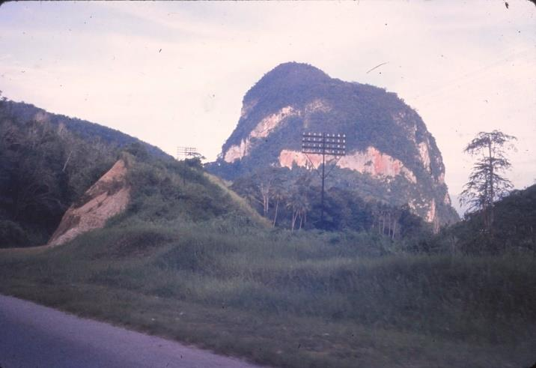  Gunong near Kuala Kangsar | 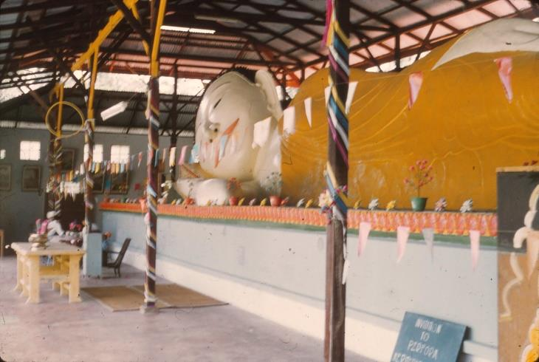  Reclining Buddha near Ipoh

The Gunongs near Ipoh had many visible caves in them around their base, and opposite the United Ice Factory in Kuala Kangsar road, 3 miles from Ipoh, we inspected the Reclining Buddha. Buddhist history was briefly described to us by a yellow robed priest. At 76 feet long the 1957 pattern Buddha was quite impressive, even the inside of the statue. Going inside we viewed pictures depicting Buddhist history on the surrounding walls. Many of the incidents depicted were similar to happenings in the life of Christ. The Virgin Birth of Buddha was portrayed (more legend than fact, because Buddha was actually a Prince), his mother conceiving him during a sleep involving a dream of a huge white elephant.

After being brought up in the palace, he married, and after the birth of a son decided to set out with an aide to see the outside world. He was shocked at the state in which he found the people, many poor, and in need of care for sickness, and he decided to devote his time and his life to the relief of the burden of his people. And thus it was he tasked himself to a fast of many days, in which he mastered the art of contemplation; he somehow attained a halo, and was refreshed by a special food delivered by a special messenger (compare Christ’s past before his ministry and saying the Word of God was his bread). He taught doctrine to his followers, he had access to the gates of Nirvana, the Heaven of the Buddhists, and he spoke to a rich young ruler who was converted. He died, and was buried in a vast ceremony, and that seems to be the end. Many of his sayings (which are similar to many of Christ’s) have been recorded. He is revered as a great teacher, not worshipped as a God.

One of the pictures on the wall showed how a woman very much desired a son, and the Gods said it would be given her if she made a special porridge. This she did by milking 500 cows and feeding the milk to 200 cows and then feeding their milk to 100 cows and so on until 8 cows received the milk and they in turn gave highly concentrated milk. This was stirred up by her, and various other things added (including gold dust) which caused the mixture to give off a most delectable odour (supposedly).

A most fascinating place.

Then on to Ipoh with its parks, grand buildings in several places, and very modern theatres. Home in the usual speedy horn blowing, cycle passing, chicken scaring, peasant cursing our slipstream, ride to Taiping, the view being much appreciated from the opposite direction, and with high-speed Ektachrome exposing at 1/250th of a second on any passing interests.

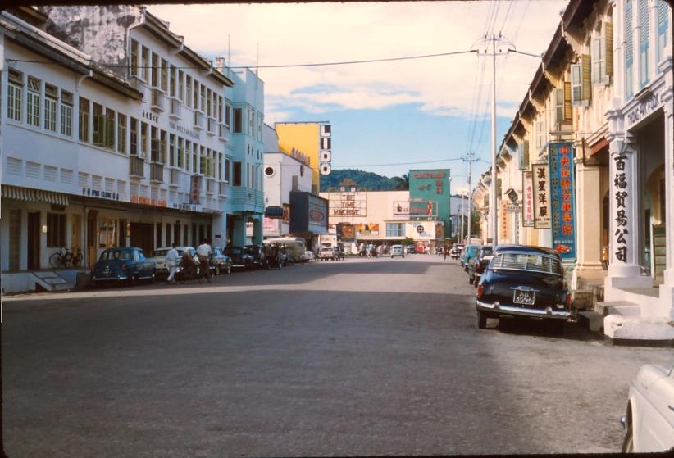  Ipoh street with downtown movie theatres | 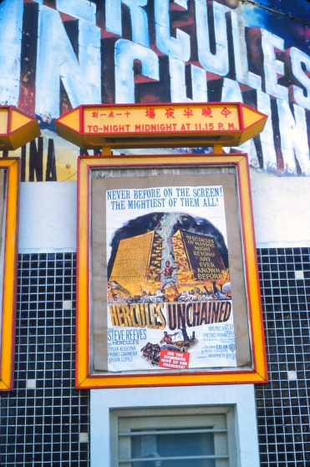  Ipoh – Cathy Theatre. “Hercules Unchained” Tonight midnight at 11:45pm

DAY 19: Sunday 25 September
Morris struck a chance ride yesterday to Hobart near the Thai border where a training camp is established. The Company in training was putting on a bit of a show for the local populace and Morrie spoke to some of the Malay Police there who have been over the border and seen the CT setup. The police are armed with automatic weapons that have no firepower from penetration point of view while the CT are armed with the latest American weapons and ammunition bought off markets in neutral countries. They may strike again at any time; the police are sure they will.

“Solomon and the Queen of Sheba” was the topic of the padre’s talk at Church Parade. If we desire wisdom and understanding, and make these our aim in life then riches and happiness will follow. Thirteen or fourteen chaps including the CO and Adjutant of the Regiment attended. Reading, writing took up most of the afternoon until tea, then arrival of several officers who are to do a camping course, pre attending staff school. After tea a film, “Kind Hearts and Coronets”, a classic British comedy.

DAY 20: Monday 26 September
A brilliant day to see the Kamunting Tin Dredging Company in action. Whites were very comfortable for this and we enjoyed it. We visited the dredge with its 8 cuft buckets, and operating in a 3-shift 24 hour day, 7 day week with 4 hour maintenance stops twice a week maybe. This 32 year old dredge still looks quite modern because its plant is kept up-to-date.

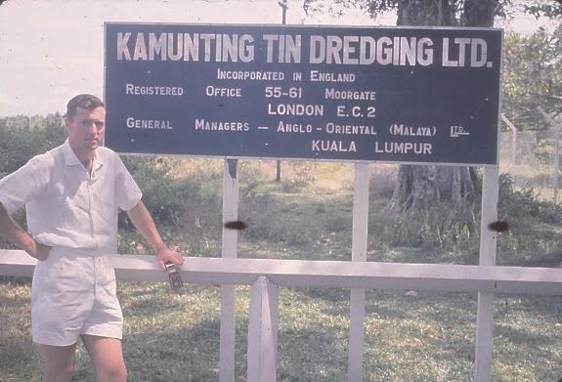  Tin mine visit | 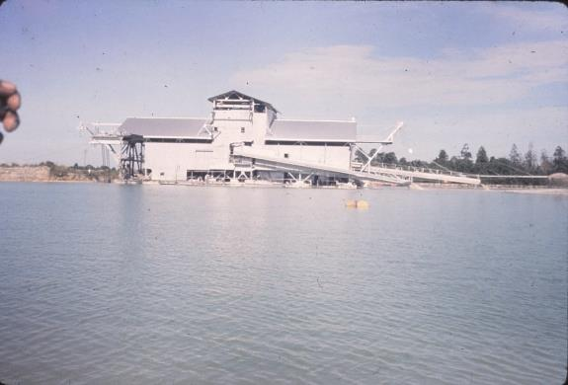  The dredge after 32 years operation

We watched it bite into the banks of the lake (19ft deep – others can bite to depths of 54 or 96ft up to 104 ft) taking grass and all. The 19ft one is able to eat up primary jungle no trouble. We saw a snake swimming in the water attempting to escape, and with the giant devouring the ground the snake was trying to reach.

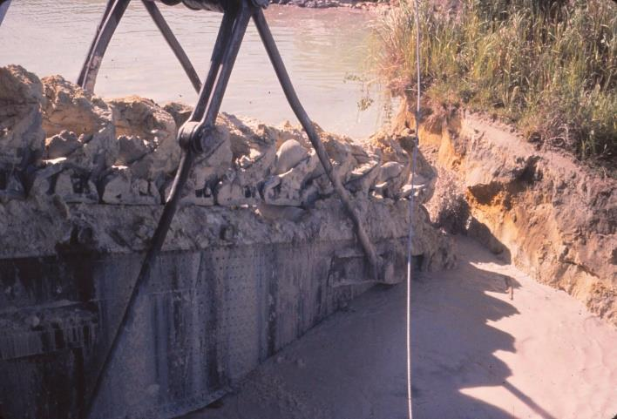  Dredge boom and buckets | 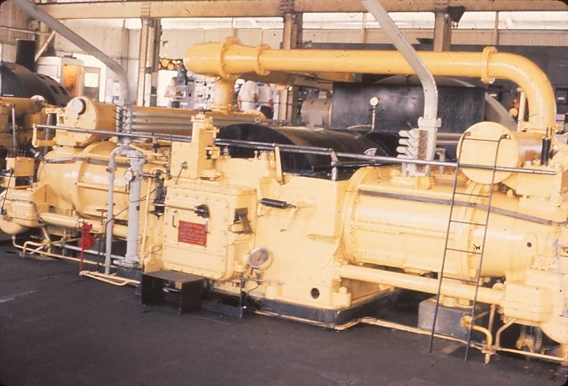  Dredge power plant

Depending on the grade of tin being dug, it is only economical to separate out the courser ore. This comprises some 1¼ lb per cubic yard of spoil dug. It costs about £2,000 per day to run the dredge, with electric power delivered from the Company power station (diesel generators of 2200 volt 331 amps) which had supplied up to 18 dredges pre-war. The dredge when finished in one spot would be dismantled, relocated and ressembled, taking 12 to 18 months between shut down and restart.

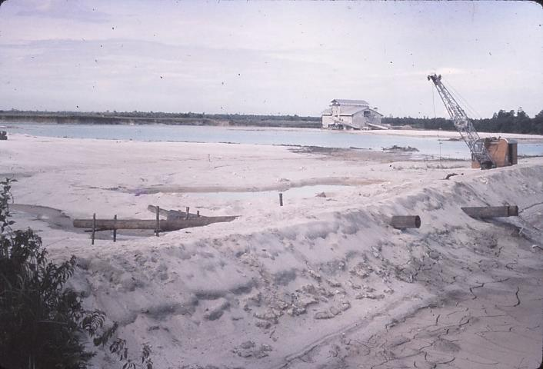  Company dredge and tailings | 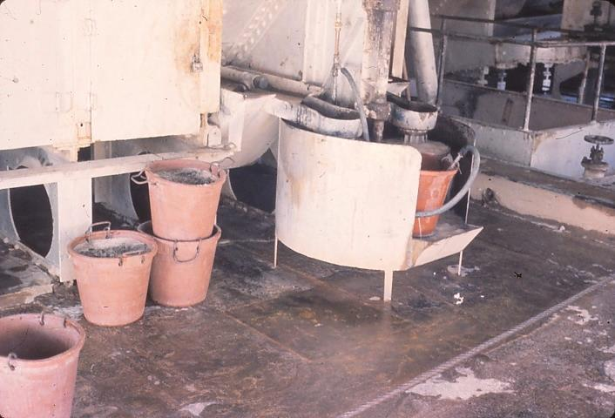  Daily haul of tin concentrate

The land was leased from the Government and the area we saw had been sugarcane plantation. The clay is dumped on the bottom of the pool, and silt and sand on top. A slime was spread on top of this by a dragline system and humus thus returned to the surface, and land restored for cropping. About 18 months is the average time for land to be out of production. White dredge masters supervise the Malay and Chinese workmen.

The tin is in a 20% concentration with sand and other minerals and is collected in rubber buckets from the dredge, about 180 lb per day. This is refined to around 80% concentration in the purifying plant, then bagged and sent after assay to sale and on to smelters overseas. The land is drilled for preliminary investigation, yield and economics assessment of possible production being obtained from the drillers. Most dredges work on the same principle, and differ in size, that is, capacity of bucket and boom depth. This one was clean and tidy. The companies have their own small gauge railways to serve the dredges and carry away tin. The workshops are very big for KTD, as big as the nearby Hume steel workshops – one machine that was most impressive was one akin to a paper punch we use to hole papers for filing – this one did the same for ½ inch steel plate. Phew!

In addition to the large company-owned tin mines there are small private tin company operations on the plains.

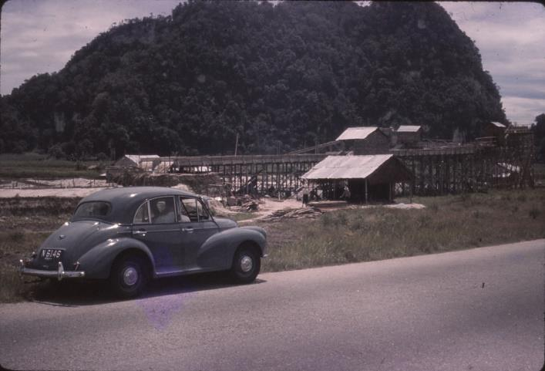  Chinese private tin mine between Kuala Kangsar and Ipoh | 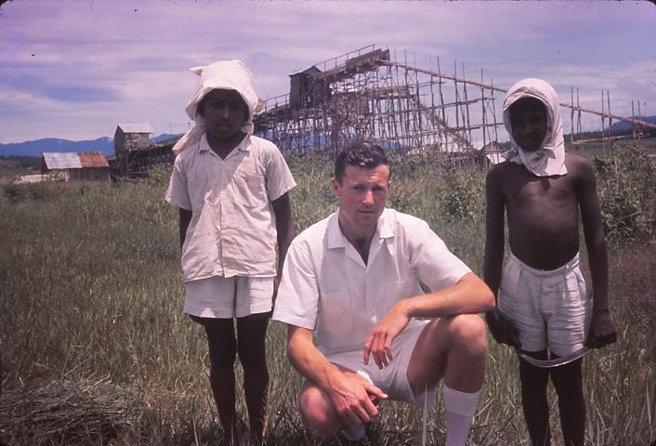  Lathan and Dan had been cutting grass on the roadside verges

That afternoon we had a lesson on Patrol Bases, and how they are recce’d and set out in the field (with a practical exercise thrown in). George and I then went downtown for some film and later, while in the bar, there was discussion on many of the tales of CT habits and practices we had picked up from yarns around the place. Monty said that the only information which we can accept as correct is that which we hear as a result of briefing by the staff here in the Command Post. This, of course, is naturally sensible, because a lot of rumours and second hand talk gets around, impressing those who do not know what is real and what is not.

DAY 21: Tuesday 27 September
The navigation exercise began with the selection of a route to a hut shown on a hill (and of course with “arguments” as to the best route; up ridges or alongside stream beds). However, the compass march went smoothly, systematically and scratchingly (those vines), with welcome breaks for lunch. We then had a change of command through some really tough country, including large boulders with hollowed out animal holes underneath (have no notion what animals). This sort of exercise is a very interesting introduction to jungle navigation. The No. 1 section went out via the clear country (having been misled by RF instructors). However it was a most useful day.

DAY 22: Wednesday 28 September

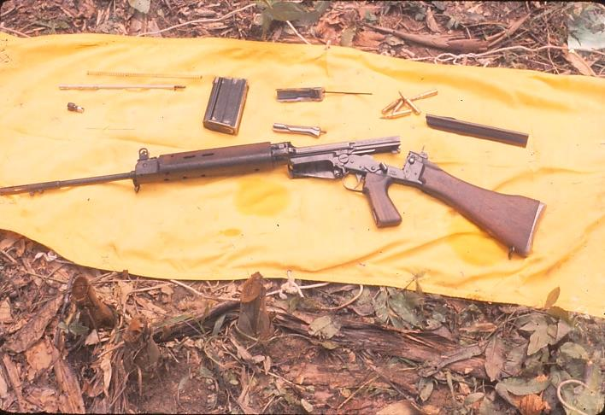  Belgian FN SLR rifle stripped for cleaning | Cleaning rifles is a menial task but most important in this climate. Rust from sweaty grip forms very quickly. A lecture on the contents and use of medical kit was informative, though of course hard to remember, but the identification of various items should be easier now.  The afternoon we spent packing and receiving orders for our first night in the bush. Quite an interesting procedure.

DAY 23: Thursday 29 September
Exercise Home Run. We moved as a platoon patrol up Sungei Rantin and carried out camp setting up procedure about 1015hrs. Vines cut after an encircling search, latrines dug, lunch and bashas set up, wash, a period of rest and then tea (meat, veges and biscuits followed by delicious rice pudding with rice lemon spread condensed milk and raisins). Hot tea was a most satisfying drink, but although I felt full, I remained dry-mouthed. Sleep in a hammock was quite pleasant.

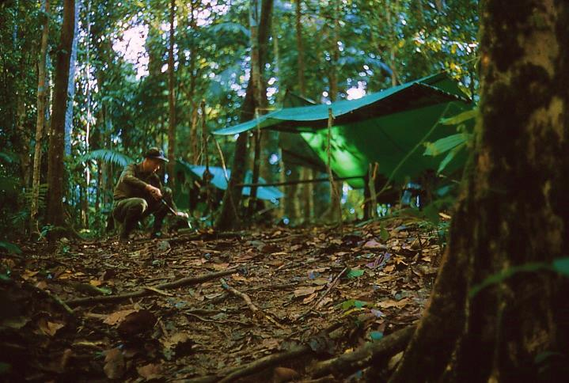  Preparing first meal at basha on Exercise Home Run. | 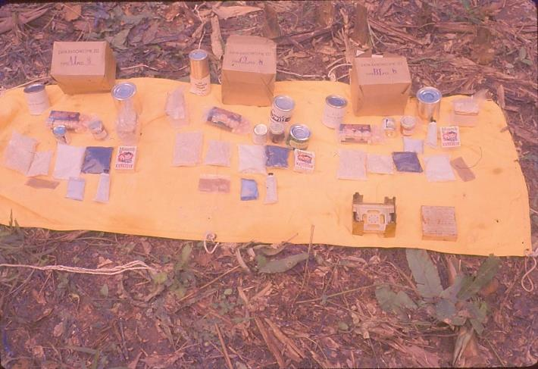  Ration packs AL, CL and BL have differing menu makeup

The jungle in darkness is like a carpet of dull stars due to fluorescent decay showing from thousands of grounded leaves. Overhead pinpoints of light float hither and thither through the darkness. Mike Pearson woke me for sentry duty at 0300hrs, and we got lost trying to return to camp centre (where the sentry sat during night watch), and had to use matches to navigate 10 paces.

DAY 24: Friday 30 September
Rain, heavy but useful in that running from my plastic basha cover to my mess tins I had sufficient water to wash, shave, cook breakfast and refill my water bottle for the day’s adventure. This began at 0930hrs, with No. 1 Section under Ken Oakenfull at 0900hrs. Well, we climbed and found ourselves where we did not expect to be, looking down on a pipeline. Following this for some 500 yards we wrongly (little did we know) identified a creek and climbed and then climbed again until wearily reaching a watershed at 1235hrs. Legs done in, we then replenished our water bottles and I consumed the remainder of my rations while many of the others had plenty left. Crossing streams we headed generally south, brightening the outlook by keeping out of the jungle and thus avoiding vicious prickly attacks in efforts at pushing past “hold me back”.

One last spar with a clear spot and we heard a vehicle – and that really gave momentum to our effort. So close and yet so far through baluka vines. Phew! We crawled to the road totally fatigued at the 3¼ mile peg, and schemed how we could navigate unseen to our destination at the 4 mile peg via the edge of bush when Mr Rosie came around a corner and said we had done satisfactorily. Well, we walked back to the bottom of the hill and to bed early, but No.1 Section never came in.

DAY 25: Saturday 1 October
Morning and still No.1 Section had not come in. Were they still out in the bush? Is someone hurt? Well, we stood by speculating on all sorts of weird fates for them. However, it turned out that with several members being pretty exhausted and slowing them up they did not progress to plan. So they based up in the usual drill and spent a very pleasant night out, reaching the road at the 3 mile peg ½ hour after setting out this morning.

During the afternoon Eddie, George and I investigated Taiping’s temples and Lake Gordon and walked for miles (it seemed) around. Saturday night was a dud picture at the Globe though quite interesting, plus a listen in on a chat with Mohammed Nasr Tiaub, 2nd Lt of the Malaya Regiment. He had some tales to tell, of Malay soldiers’ attitude to young officers, to drink, and of the Thai Police equipment, American aid, their patrols, and the political attitude to the CT problem.

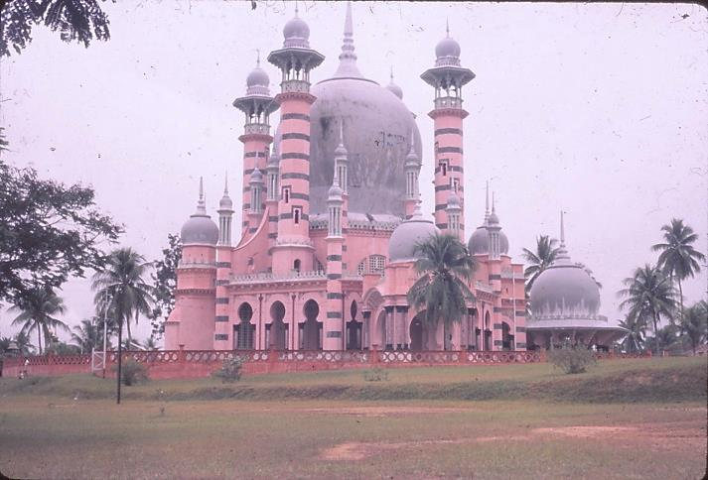  Sultan of Perak’s Temple | 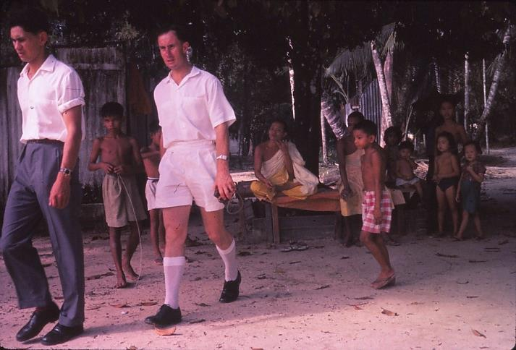  Eddie and George after speaking to a cigarette smoking young monk

DAY 26: Sunday 2 October
Today Eddie, George and I with Peter Reid boarded a Morris Minor under George’s control and off we went in overcast weather on a filming expedition. Slides cover most of the tour through rice fields to Kuala Kangsar (the river and temple) then on to tin mines, Cave Temple near Ipoh and at 1330hrs lunch in a Boston bar followed by a drive to outskirts of town and a look around market areas. After a Knickerbocker Glory Banana Skyscraper at the Magnolia Milkbar off home at the high port and looked around Instana Perak, a magnificent building, before proceeding back to camp.

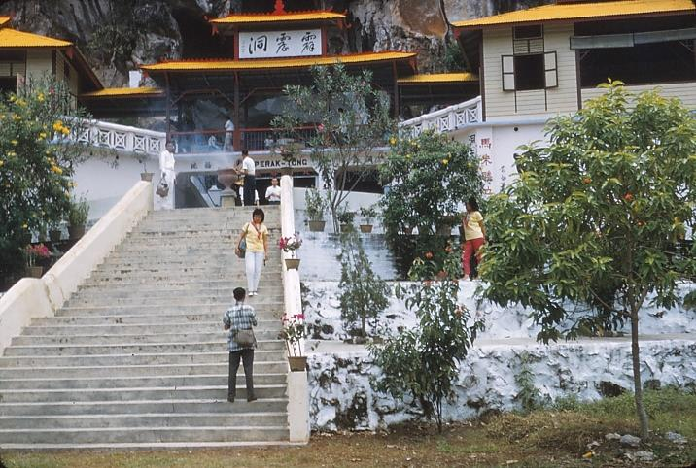  Cave Temple near Ipoh | 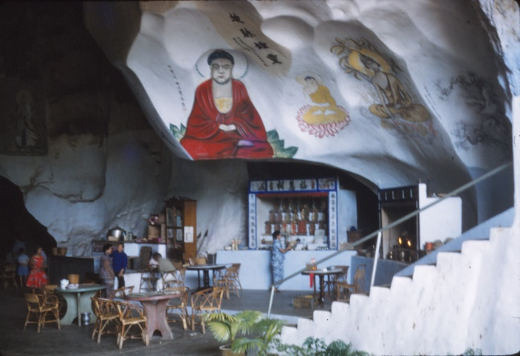  Cave Temple interior

Local children gathered around us where ever we stopped | 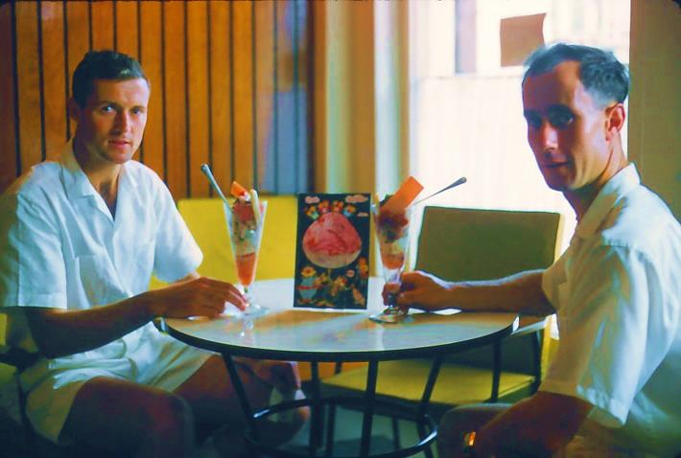  George and self with Knickerbocker Glory Banana Skyscrapers

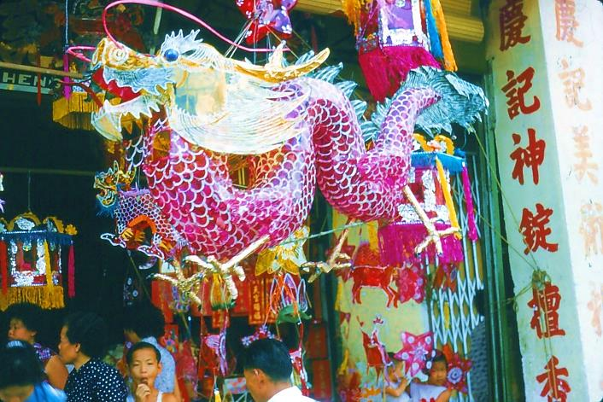  Ipoh toy shop | 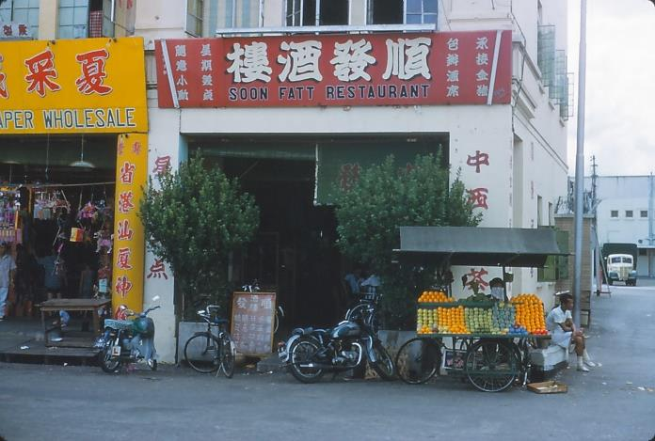  We preferred the Ipoh Malaya Cold Storage ice-creamery to the Soon Fatt Restaurant

After tea we went down to the Malay Officers’ Mess and met again Mike Nasir Rahman and Major Burke, Commander of the ASC Malay crowd. He was a prisoner in Greece during the last war, and had some interesting tales to tell. The Malays and several RF chaps, Neville Kidd, John Mills and Allan Armstrong spoke about the CT situation during the emergency, how the RAR (Royal Australian Regiment) went into the jungle and thought the battle was over when they arrived. One patrol went round in a circle and the leading scout shot up their Tail End Charlie. Also they fought battles between themselves in one incident. Thirteen Aussies and one aboriginal was their casualty list for no CT.

DAY 27: Monday 3 October
After a lecture on ambush drills and a practical demonstration of an ambush, we discussed CT practices. In ambush one man may feint to draw fire if an ambush is suspected. They are very cunning. After lunch and a rest we then set up an ambush and Morris, Allan and I planned as CT. I spotted the other side and gave the signal to clear out and disperse. I called Allan Steel over for a confab as the whole operation seemed a little tame – however, it turned out I had been seen and would have been shot if it had been for real. At night there were no lectures, so reading world news in Time Magazine.

DAY 28: Tuesday 4 October
The morning lecture was on Patrol (that is Ambush) Orders, and then we did a recce and a plan of the ambush area. After lunch we wrote trial orders and received actual orders.

In the evening we rushed tea and then eight Sergeants and Officers from the course were entertained to a slide evening by Mr and Mrs Rosie. The slides were mainly local and were very interesting. We had a pleasant supper and yarn afterward. Brian and Morris were not in when we bedded down about 2230hrs.

DAY 29: Wednesday 5 October
“Brr Brr Ringggg” went the alarm. Then a surprised voice said “Is that the time to get up”. Another voice said “Yes” and the first voice exclaimed “Hell! I was just going to get into bed”. It was Brian, just returned from all night around the bars.

Phew! So 0500hrs and off we dressed and went to the ORs’ Mess for cuppa and toast, then 0530hrs away to ambush and set ourselves in by 0630hrs. Out for three hours it was 0930hrs when Officers were relieved and the ambush went on by Sergeants till 1100hrs when we again relieved the Sergeants. Finally we were out at 1415hrs for lunch, cleaning weapons, and then glorious sunbathing. The “CT” did strike but again our chaps let them get away.

A pleasant afternoon sunbathing and letter writing at night.

DAY 30: Thursday 6 October
Discussed the ambush, cleaned weapons, discussed CT anti-ambush drills and after injections and FFI went to NAAFI and read rest of the day. We had the usual Thursday night film called “Privates Progress” about a timid English varsity student’s innocent experiences in intrigue during the war. Afterwards the mess had a party that went on well into the early hours. The injections we had today (TAB III) played up with us all. My arm is not bad, but Morris’s is really sore. Most of them had a poor night’s sleep. I felt good and slept well.

DAY 31: Friday 7 October
This morning we discussed the exercise to end the course, and the Medical Sergeant talked with us about First Aid. Snakes, and then treatment of cuts and a man getting shot and impaling himself on a bamboo stake (much blood and gore). About this stage I took a peculiar giddy turn which passed quickly, and with much yawning. After a short rest was as good as gold, and handled shooting the rest of day (sleeping at lunch time), drawing ammo and rations for the exercise, then down town and collected slides of which there were 22 good ones. Then tea and flicks, “The Hanging Tree”, a very good drama of the outdoors.

As I write at the moment I am watching high drama on the ceiling. There is a large 3½ inch praying mantis in the room and our little resident “Cheeko” is stalking it. These little lizards are very brave and will bite at insects larger than themselves. This one has now had a good look at the green praying mantis and is thinking better of it. Toads and cicadas play a background chorus to the sounds of the night.

Today we looked over the Overseas Radio in Taiping, and the owner offered us cigarettes then drinks, beers for Brian and Morris and orange for George and me. Morris played his 7-8 year old son at chess, and the boy beat him in about 10 minutes. The owner showed us a transistorised battery operated tape recorder by Sanyo at $465 – like a Morris Minor compared to a big Chevrolet Impala. Pushed to the limit the older type of tape recorders can just average 200 to 4,000 cycles, whereas the small Sanyo has a large range of 40 to 12,000 cycles (the human ear can hear up to 16,000).

DAY 32: Saturday 8 October
The briefing by the Brigadier (that was to have been held last Saturday and postponed because of No.1 Section’s overdue-ness on the navigation course) was taken this morning by Brigade Major, Major Basset (who, incidentally, is a Kiwi). He first of all gave us a picture of the Commonwealth Brigade Group, and showed how much it was an integrated unit, with not only three battalions [English Third East Anglian, Royal Australian Regiment, 2 NZ Regiment, and also Gurkha and Ulu Senoi Ra groups (Ulu being trained aboriginals, originally trained in weapons and patrolling) thus making five nationalities] but also the teeth arms which are integrations of parts of Commonwealth Forces. For example the 11th Independent Field Squadron Engineers have 3 English and 2 Aussie troops. Artillery, ASC and other Corp are all integrated.

After that he outlined the history of the campaign against the Terrorists mentioning Operation Jaya then Operation Bamboo. Operation Jaya was run against the CT organisation by the Police, Security Forces and Civil Authorities, the Food Restriction people and Aboriginal Department, and was overseen by a War Council centred in the Ipoh area. However this appeared to be a false alarm operation as nothing came of it. But Operation Bamboo is however having much greater success. The whole show is run by a War Council with District Committee representatives covering all administrations attending. Now the emergency regulations are no longer operative a special Act of Parliament has made emergency laws under civil power which are just as strong. Unearthed by intelligence some 458 CT camps have been pinpointed in Thailand with 25 camps located via recce by Auster Aircraft in the most southern part of Thailand. Laws permit only Police parties to enter Thailand, and hence Malaya has a large Police Force which is trained like an army but actually is poorly equipped and often not of very high morale in operations against the CT. These camps were to be cleared by a helicopter lift of Police on October 12th with Third East Anglian covering the escape route into Malaya. [This operation was a secret when we were told – we were not to speak of it until that date.]

There are about 65 Chartered CT in Malaya but only about 29 of these are apparently active. The Brigade Group is concentrating around ASAL (12 groups) in the area of Ali’s Ladang as a centre. NZ in the centre and South, Aussies in the North to the border, Malay Regiment in the border zone (Security Zone) of Perla and east of this, and also on the East Coast at Kelantan. A 12 mile Border Security Zone either side allows Malay Police 12 miles into Thailand (or 25,000 yards). Ali’s Ladang seemed the most prominent contact point recently. Tet Meou and Heng Ho are the major CT characters being sought, each with a party of three or so others.

This briefing over we studied the map and learnt that the Royal Engineer Squadron was due back on the 11th October from Borneo to build a road from Grik to Fort Kema. Several Forts in the jungle acted as War Committee meeting places during the Emergency and also places of security. We spent the rest of the day sorting and packing gear for departure tomorrow for the exercise. Wrote several letters.

DAY 33: Sunday 9 October
At 0730hrs we en-trucked for Exercise Home Base and patrolling back of Speedie Hill, arriving at 1200hrs and setting up camp. No encircling vine and Tom Turner in charge. Tom was a bit Regimental and everyone childishly complained behind his back, but he did OK. After the usual rain as we fixed tea, we had a most interesting night watching monkeys swing through trees, and talking about tiger. I saw a snake swim fast downstream at the water point and disappear under a rock at my feet. About 4 to 6 feet long and grey with darkish markings on its back. It was forking its tongue out after it saw me and skidded under a large rock in the water. That night noises filled the air, stars shone through the leaf canopy, and fluorescence carpeted the floor. Queer rustles disturbed the night but try as I could to think of tigers and so on I could not scare myself. The jungle night threw a cloak of neutrality about me as a sentry in mid-hours of the night. I thought of all back home and all that might be happening here. Often I think of 4½ hours ahead of time and of what folks are doing back in NZ. Memories make the hour’s sentry duty pass so quickly.

DAY 34: Monday 10 October
Today our Section did a patrol up Speedie Hill until about 1515hrs and after seeing monkeys and glimpsing the plains below we had good lunch and dry out by a rocky stream. The ground was steep, and we were continuously surrounded by little flies. We got soaked by the afternoon’s rain coming home only to find the other Section (which had been clearing an old DZ) sheltering.

DAY 35: Tuesday 11 October
A short Section patrol around the DZ. Saw a turtle. Marched out and had a swim at lunch, heading home to Sabroan Camp at 1430hrs and found we were to be put under command of B Company and to go into the “bush” on Thursday.

Did last minute shopping and had our end-of-course party at the Churches place near the Buddhist Temples. Everyone drank and sang and the bath was a sight filled with bottles and cans and ice. George Pearson brought a little Chinese girl along after a while and Brian and Des and Ken brought 3 girls from the Green Valley. After 0415hrs George, Allan and I went home following a good cake supper.

DAY 36: Wednesday 12 October
Quite a day. Tom Turner slept in for our closing address at the school. Even we thought it a great joke on Tom. The party had been too much for him.

We had clothes, rations, ammo and FFID (physical fitness and disease inspection). Then a briefing by Major Poananga the CO of B Company. They are going to push against Bak Juli and Bak Ryan after final clearing of platoon areas are complete, and we are to cover a likely escape route to the south which is also a known courier route. Pack inspection (boy are they heavy; 5 days rations) and bed after last scribble home, and Peter Reid showing slides. Phew! Tired. Had a quiet night.

PART 3: JUNGLE PATROL, PERAK
[DAYS 37 TO 61]

DAY 37: Thursday 13 October
Breakfast 0415hrs and on to vehicles and 0450hrs out the gate. Arrived at Grik 0800hrs and at Kuala Rui into boats and a most exciting trip up the Sungai Perak, which was low. We sheered three cotter pins (on the propeller shaft) and in the middle of a rapid the boatman dived overboard with a mooring rope while the motor man (40HP Johnson which sounded like V4s) shouted at him. For the shallow sections where the draft was too low for a loaded boat, we all disembarked and walked up the shallows while the crew dragged the boat over the river bed. Lunch at Ali’s Ladang and then off to base up the Ringat. Phew, it was hard walking, really hard, and hourly stops were most welcome. Camp at 1515hrs and had a quiet night.

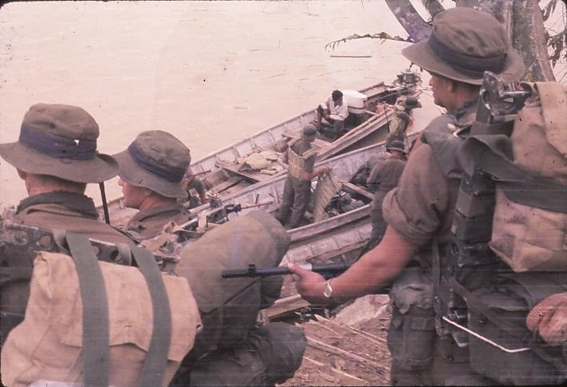  Boarding boats at Kuala Rui | 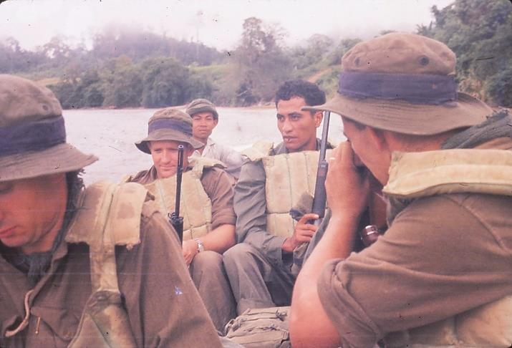  Travelling up the Sungai Perak

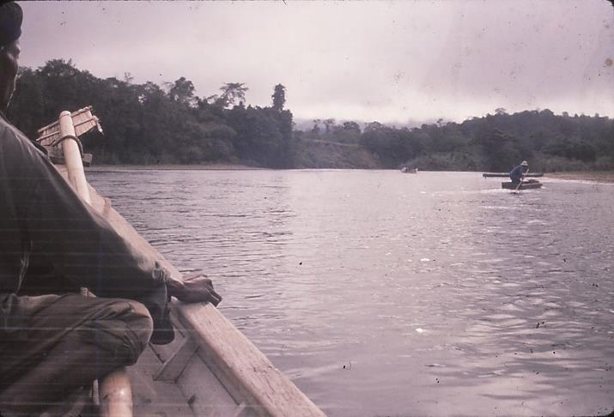  Fisherman scattering out of our way | 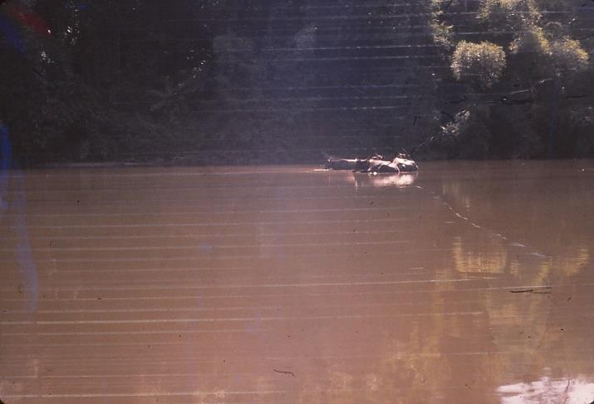  Water buffalo on the Sungai Perak

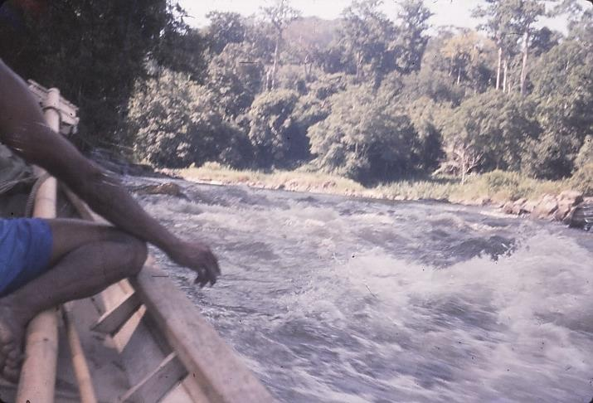  Navigating rapids | 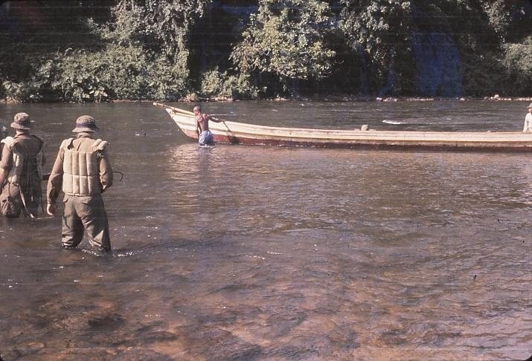  Disembarking to pass through shallows
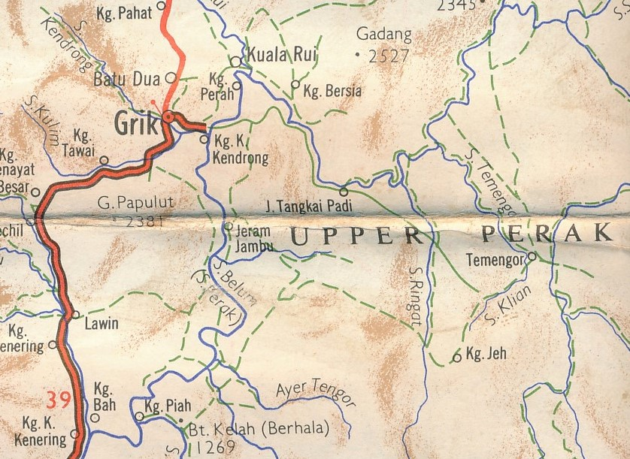
Kuala Rui boat boarding location
General area of our patrol responsibilities

DAY 38: Friday 14 October
An all-day grind, with stops most welcome. This is real hard work. At one stop a snake launched itself out of a tree in front of me as we rested, and dived into the creek bed. No rain again today. Lunch at the bottom of a steep gully. Ken Oakenfull does first class job as Sergeant.

DAY 39: Saturday 15 October
At 1130hrs after two beaut hills and a gorge which really shook us, we reached the Jopai. Lunched and arrived at 4 and 5 Platoon base after a further 35 minutes’ walk. Based up and rested in the afternoon.

DAY 40: Sunday 16 October
Gear in order, drew rations, and had briefing by Bob Burt of 5 Platoon – most interesting. Packed amidst rain after our own orders given for four days patrol. Cleaned camp and built a handrail for a log bridge (my first jungle engineering exercise).

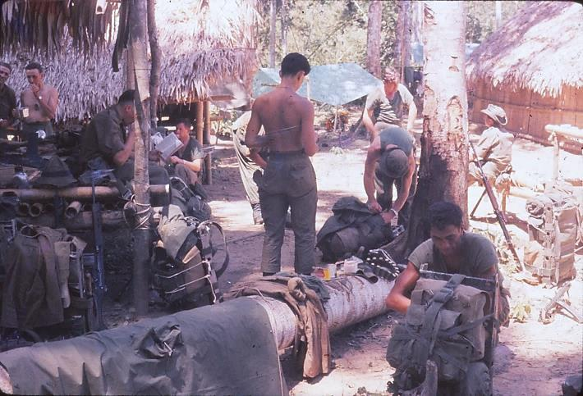  Rest up at Ali’s Ladang | 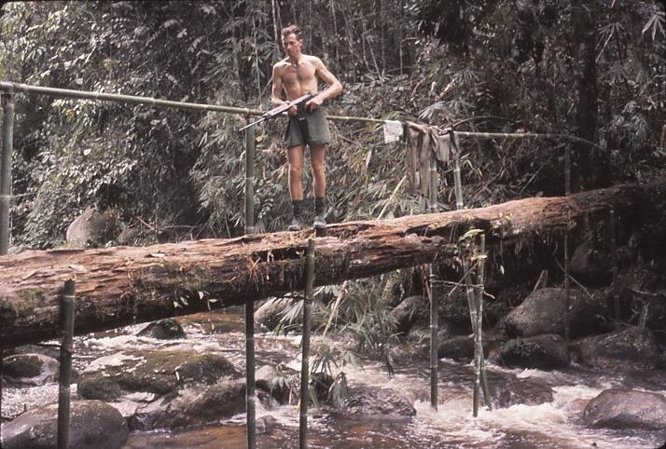  Checking out the handrail

DAY 41: Monday 17 October
Our group marched out with Bob Burt plus five of his chaps, but leaving behind Allan with boils and also George Pearson (his crook leg took him back to Taiping). We moved up a ridge towards Jo Pau and Duablas to the main ridge by B. Rajan and down into headwater of Duablas to base up after short Section patrol. (Eddie has crook hands).

DAY 42: Tuesday 18 October
Climbed out of the valley, turned south and up a huge hill so that we looked down on Rajan before moving down into the valley and west side at the foot of Rajan. We based up in a wet hole. Followed 10 to 14 day old elephant tracks through some of worst bamboo and vine country I have seen. Slow progress.

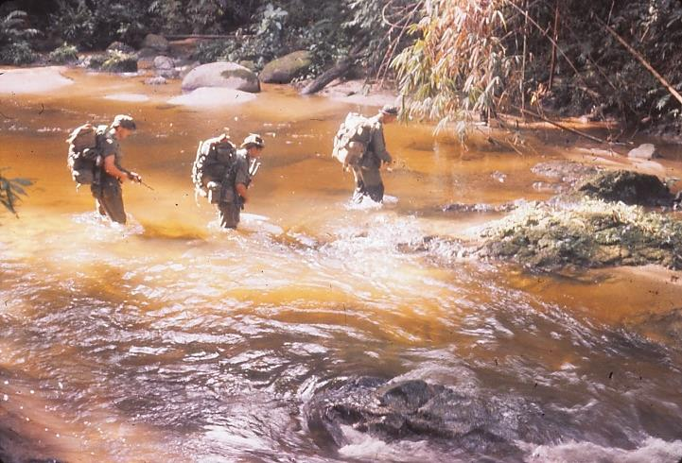  Crossing the Sungai Ringat | 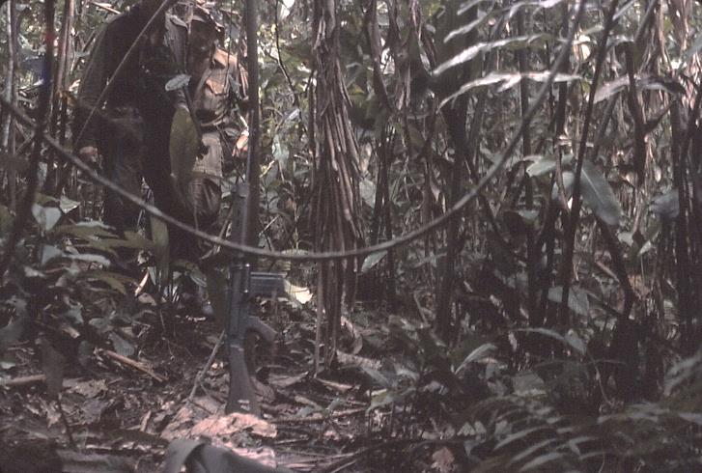  Watch out for barbed vines

DAY 43: Wednesday 19 October
Patrolled with Nig, George, Jack Hay and Ken. Located hockey boot tracks. Camp again, that is returned at 1300hrs, and reported when Mr Burt got back in. Cold night for most chaps. I was a little cool. Talked about aboriginals (Tamea is the race). Children work from 3 to 5 years on and accept adult responsibilities. They are treated as game by the Malay. Some of them in the back country have not even been contacted by anyone. They are frightened of tigers.

Our patrols have passed one tiger, very smelly, sleeping after eating pig. On one occasion about 7 to 9 elephants passed a patrol that moved off the track to let them by. But 200 yards behind a tusker was coming and the patrol turned and met him head on. He ran at them, they fired an FN automatic rifle (about 7 shots) a Bren and a Stirling but made no impression on him before he bolted off the track.

DAY 44: Thursday 20 October
Packed camp and investigated and searched for tracks. Apparently one heavily laden CT had dodged us as we came down. [Saw tiger tracks (apparently) in creek sand by camp this morning.] Left the West ridge and skirted round to warn a party moving up the ridge toward us. CT can move in the jungle without breaking a twig as they part vines and crawl underneath. Very clever. You should have seen the tracks we made coming through – looked like a herd of elephants sliding and crawling through bamboo, vines that are tangling, and very steep slopes with the main ridge in places only 2 to 3 paces wide which goes on for miles with a steep drop either side.

Usually tracks are on ridge tops, which are cleaner but can be very tangled with vines everywhere. Down into Jopai Valley after no more tracks and really cracked the pace home. 4,000 yards in 2½ hours along a flat stream bed, lifting leaden feet (boots full of water). Pleased to see camp and had a good tea and a first class sleep.

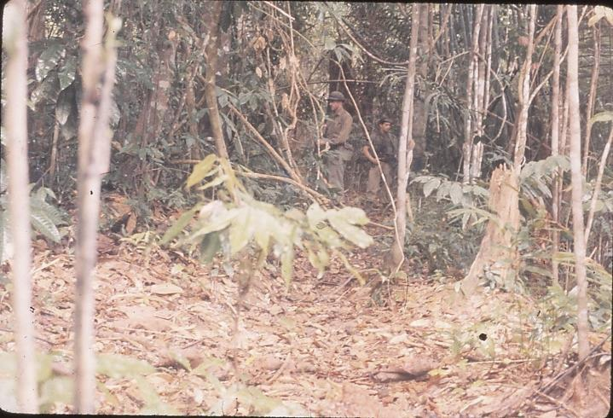  Ridge top patrolling | 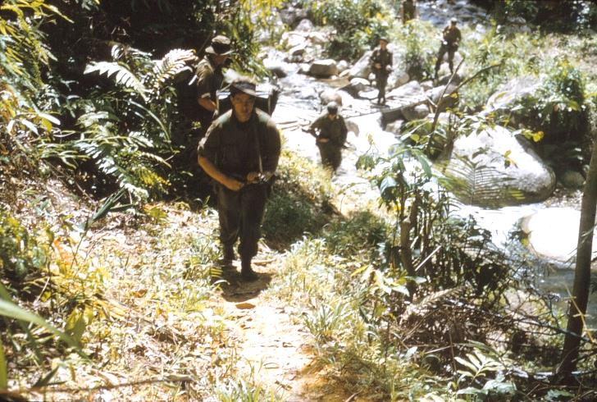  Stream crossing on patrol

DAY 45: Friday 21 October
Took 1½ hours to clean rifle and ammo because they had been wet for two days continuously. Hot morning. Cleaned gear and dried all equipment out, including camera (which had film that stuck). [On daily patrols we get soaked with sweat, so after returning to camp at end of a patrol we wash all our clothes in the stream at base of camp, and hang up overnight while we sleep in dry clothes. In the morning we dress back in the wet clothing which rarely has time to dry overnight, but soon steams dryish as we patrol]

A Bristol Freighter airdrop gave us a share of fresh rations. Steak, spuds, cabbage, margarine and bread. Boy, what a lunch we had. I had steak roasted (fat and all was delicious, though tough), chips fried, bread, margarine (about ½ an inch thick on bread), jam and tea with an orange for afternoon tea. It was delicious.

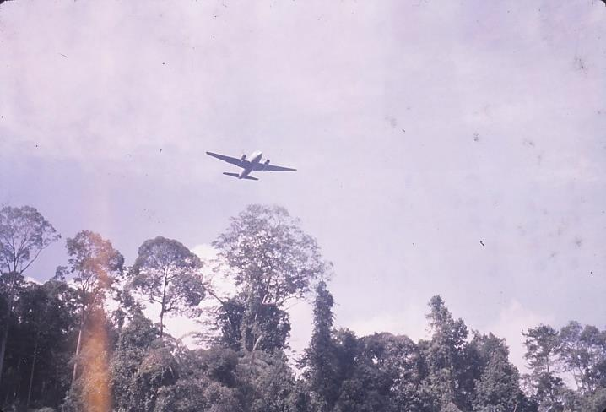  Trial run on airdrop | 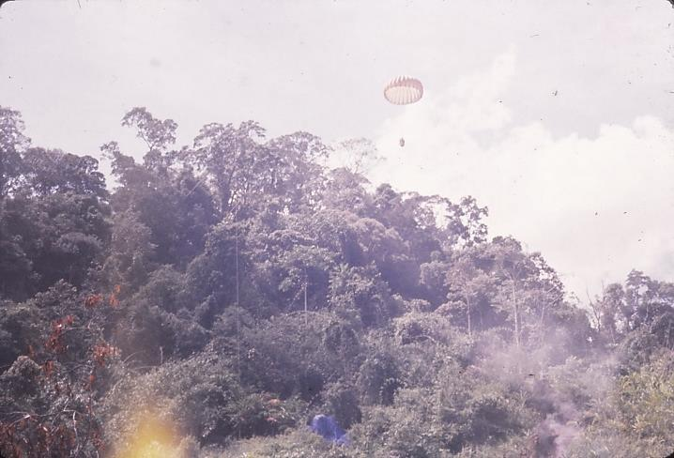  Pink parachute with supplies – blue parachute landed

Rain heavy at 1500hrs as usual and cleared at 1600hrs, and now packing for last go into bush to clear DZ and LZ for our drop. The work is hard but fun. The spells are much appreciated and we needed today to get our gear in order again. Chopper landed and took a malaria case off about 1630hrs today. Now to packing. [Brian fell out of his hammock while I was on sentry during the night. These nylon ones can be a little unstable if one does not set them correctly.]

4 Platoon surprised four aboriginals during their patrol, and they rushed off leaving two spears and a long blowpipe. They can hit the centre of a match at 15 paces with one of these blowpipes.

If one keeps very still in long grass one can see all sorts of insect life. Peculiar looking flies and insects and a lizard a foot long, green and very quick moving. The Ringat river is not very big, yet in 2 hours with heavy rain up country it can rise 18 inches and then quickly start going down again.

DAY 46: Saturday 22 October
Packed and away after Allan McDonald arrived from Ali’s Ladang with mail. I receive letters from Isobel White and Don Crampton. Allan was done in at Jopai last night at 1900hrs with chaps carrying his pack, and slept on the ground. We marched to the Residency 1 to 2 hours up the Sungei Duablas where there is a good chopper LZ. Many butterflies brightened our stay there for lunch. Then up a southward tributary to look for a suitable LZ and DZ. At 1600hrs we finally decided on one after searching around an area from 1415hrs, and then based up.

By strange chance I was cleaning my weapon at stand-to and missed catching the round as I opened the breach. I felt around the ground but could not locate it so opened the breach ½ way and could not feel it, so let the action forward, pointed in air and pulled trigger. The weapon discharged, so by some fluke the round had re-entered chamber – gave all a start.

[On an earlier night Morrie had the same thing happen to him. As all rounds fired during our jungle assignment had to be accounted for by a full report as to the circumstances shots were fired, these inadvertent firings were reported on as ammo used to shoot down marker balloons sent up for air drop location and which had become tangled in the jungle canopy.]

DAY 47: Sunday 23 October
We got stuck in and cut the DZ today. Hard work and by lunch time we really made a hole in the jungle. Golloks or parangs can make quick work of large trees

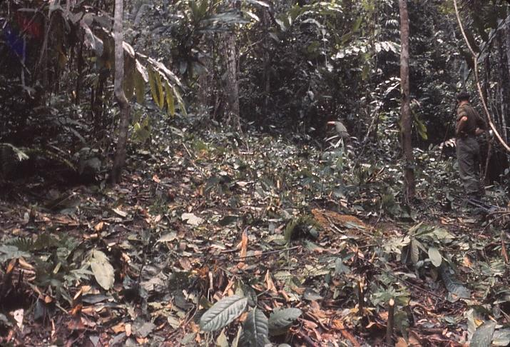  Clearing undergrowth at DZ before felling trees | 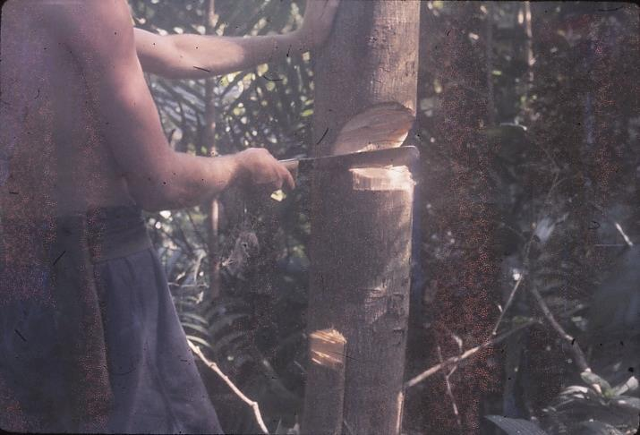  Notching a small tree

Most chaps seemed to make hard work of them, cutting too narrow a notch. After lunch we spent on camp works till 1530hrs though most of the boys seemed to go to bed – the organisation was not as strict as necessary. Cleaned my weapon and did some housekeeping and waited for the Auster with some explosive.

DAY 48: Monday 24 October
Morrie would not ask via radio for axes so we could get stuck into and clear trees, and we just waited around till the Auster came and dropped a pink parachute off the DZ down by the stream. Nig and I recce’d an LZ on the ridge above camp while Jack Hay (who has done a demolition ticket but not used explosive since) and Ken started on trees. I asked Morrie if I could assist them and he said no – he wanted the chap with the ticket to do it as Morrie was responsible if anything went wrong.

I never said anything, and then Morrie and George had a look at the proposed LZ on top of the ridge. Two really big trees, but otherwise OK. Very flat pad on ridge top and able to fell trees all around. They said no go, the two large trees could not be felled, and that was that. Actually I can understand them being a little cagey re the LZ. The valley is practically out, and the hill we are not sure of, and we do not want to make any “blues”. Besides, 40lb of PE 3A, 15 No. 27 detonators and 10 primers plus 40 ft of cortex and 20 ft of safety fuse were not enough to do both the DZ and the LZ, especially as we have no axes. Anyway, Nig and I were chopping the side of the hill when “Booom” echoing all around and tree No.1 crashed down, 30 inch diameter and 3½ lb of PE (plastic explosive). Ken asked Morrie if I could help then as it would take too long otherwise. So then 4 other trees were felled at 1200hrs. At 1145hrs Brian, Eddie, Allan, Bob Gilchrist and Peter Reid arrived under the guidance of Rea Ellis.

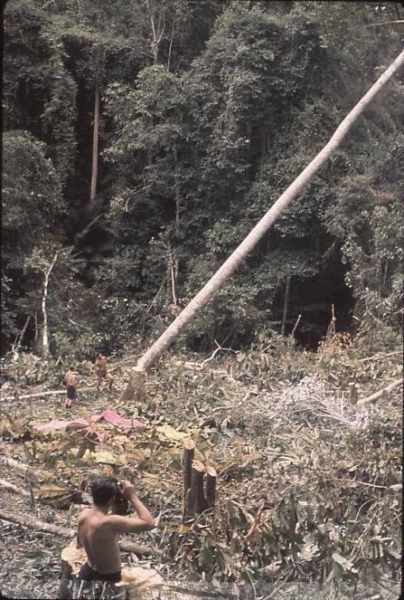  Tree felling using gollocks | 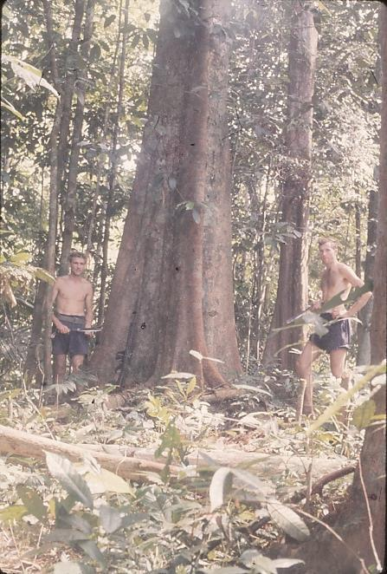  Typical trees in the DZ area – Ken at left, self to right

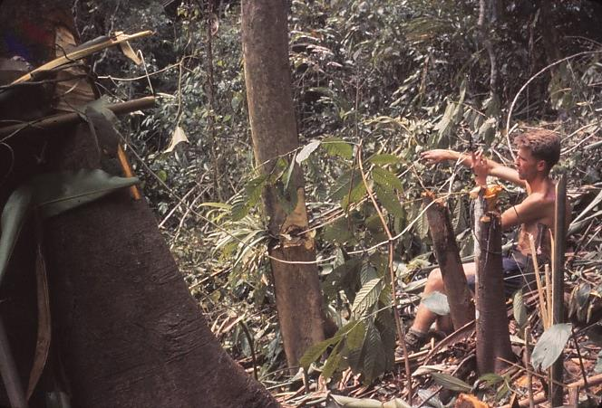  Ken connecting Cortex | 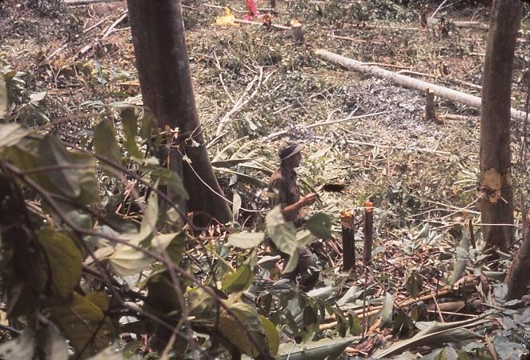  Self inserting detonator into primer

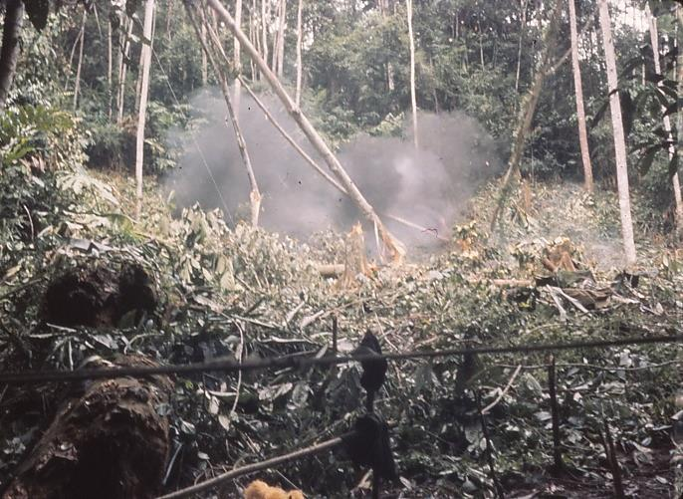  Triple felling with PE explosive | 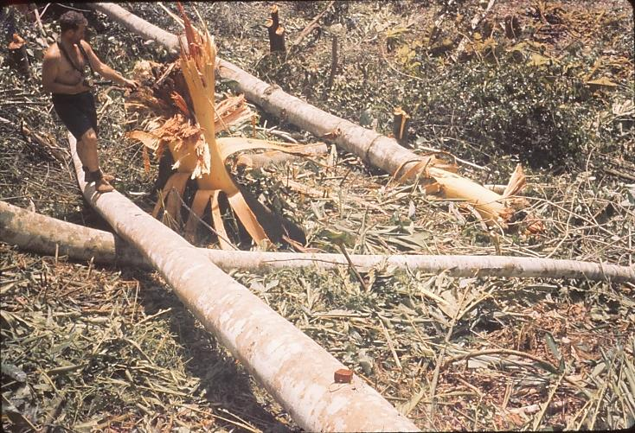  2lb of PE on an 18inch tree

Altogether we felled 11 trees and three of them were double attempts using as little as ¾ lb on 15 inch diameter up to 2 lb on 24 inch and two charges of 4 lb and 3 lb on a 30 inch iron bark. This split it in two directions at the base, but never made any impression on it except of course powder marks and a hole 6 to 8 inch deep in trunk, splinter shavings up the sides, and the land clear of leaves and tree bark over a 20 feet diameter around the felled stump. That ended the day and so we ate.

DAY 49: Tuesday 25 October
We had morning orders now Brian was here. Ken gave out detailed tasks, and Morrie set out the locations for the airdrop expected today. (Ken was bubbling, not quite boiling, all yesterday at the inactivity of some of the chaps over the past two days, and he did have some justification). Chopping merrily away at the few remaining smaller trees, Jack, George, John Ovens and Trevor waited on the Hill. 1015hrs and the Valetta was behind our gully dropping to 4 Platoon. Then 1040hrs dropping to us and running NW to SE dropped a red chute (NAAFI) in the gully over our ridge. The next, a pink chute (rations), landed in trees beside the bashas and uphill of same, while the third one with supplies (green chute) landed in the same place and slid down through the trees. Finally our ration packs in a yellow chute landed on the ridge (in the trees) so all our cutting was for nix – well, not really (at least we had sunshine into the camp). Off we went and smilingly led the supplies to the storehouse being constructed under Ken’s supervision.

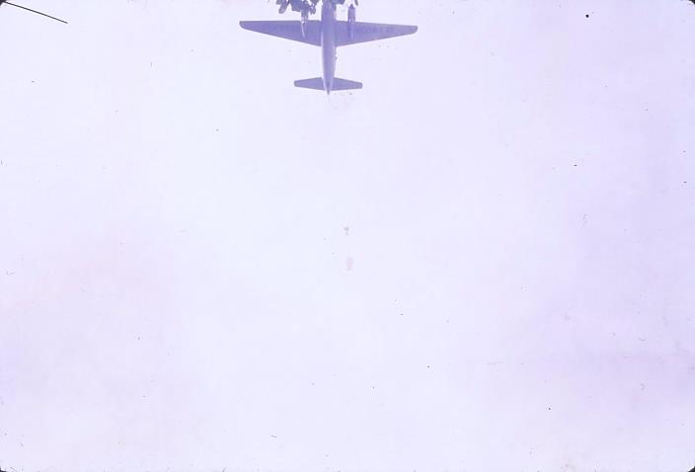  Pallet and pink parachute leaving plane | 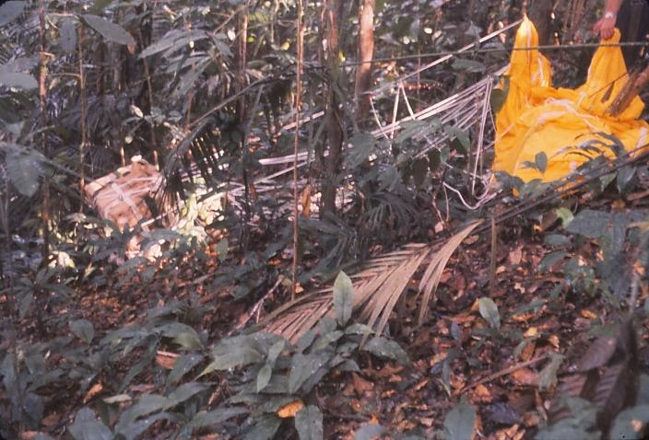  Yellow chute dropped outside the DZ

At 1130hrs Ken and George sorted clothes and fresh rations and then at noon we were all into cooking our lunch using carrots, potatoes, beans, onions and beef. Cooking fat was used for roast beef and potato chips. We were issued with margarine, jam and ¼ lb bread each. It took a long time to cook the meal, and I had mock turtle soup before the main course, followed by bread and jam to finish.

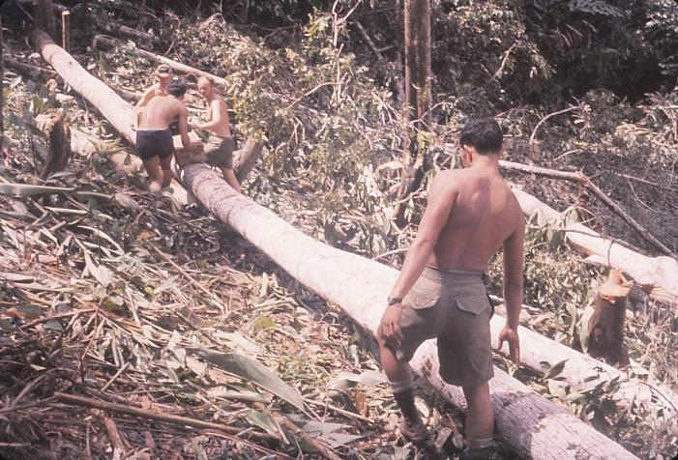  Rations being ferried down the ridge | 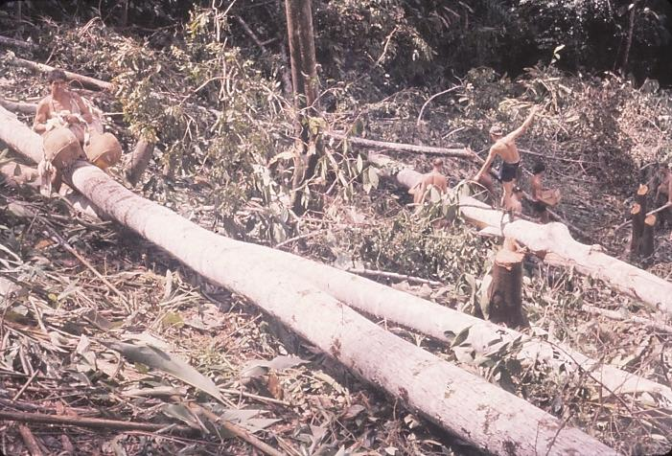  Rolled chutes being recovered

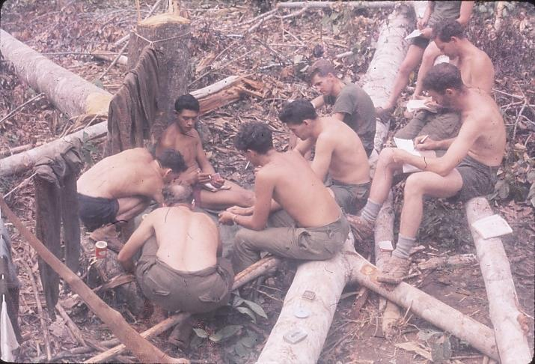  Resting up with a card game and reading mail after the airdrop | It is great how the conversation centres around food these days. Actually I am getting loads to eat, with six extra rice packets and two tins of frankfurters from Trevor. Then our NAAFI and stores were given to us, and we were all happy. So we spent the afternoon organising our gear, sheltering from the rain (which at last was settling into a daily routine, usually in the afternoon or early evening and getting usually very heavy for ½ to 1 hour during the period it is on). [Afraid this log book got soaked with sweat on way in from Ali’s Landing to Ringat camp.]  I waterproofed my gear and refilled insect
repellent, had rice, fruit, chips, steak (casserole) and a juice pack for tea, reading then slept. The dreams one has in this place are most realistic, and the nights are full of them. Some are very vivid.

Memory of names and aboriginal place names is hard to retain. While I remember, Aolang was an aboriginal who got shot when he tried to take a shotgun from an ambush interception near Ali’s Ladang.

DAY 50: Wednesday 26 October
Yesterday I changed film in my camera during the air drops and in the dash up the hill (to the chutes) I dropped the cassette in a white container. It took a ½ hour search before I found it pressed into the ground where Jack had left the parachutes during the morning’s work. Boy, was I pleased.

The radio cannot transmit, so the airdrop return was taken by Eddie, Rea and Jack to the Ringat camp at dawn. Nig, Des, Mel and I escorted George to the Residency so he could be picked up by chopper to attend his exams on Friday. From 0745 to 0820hrs we waited in the heat for the helicopter. The butterflies, so colourfully numerous and varied at our last stop here, were not present in great numbers. However, a couple of warblers or something made very loud noises in the jungle across from the LZ pad. They were very like the kids whistles which have a trombone type action on them. They were having a great time.

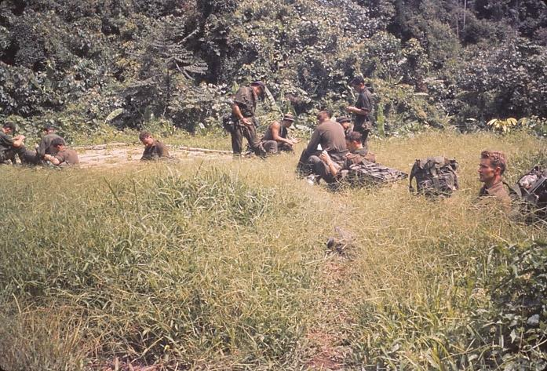  The Residency LZ used for helicopter lift-outs | 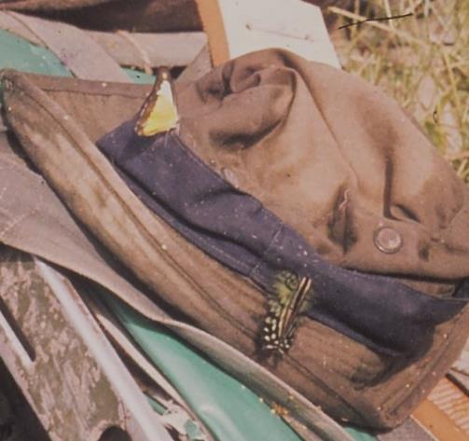  Butterflies at the Residency

Meanwhile “tiger” leeches and ordinary type leeches were vying each other for our blood while we read and waited. The leeches cause much clotting and bleeding in some cases and none in others. Coming into this base at 1150hrs I had the back of my arm covered in blood from elbow to the tip of my little finger. And my legs yesterday had a couple of beaut blood clots on them.

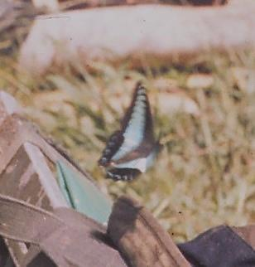  Another Residency butterfly | 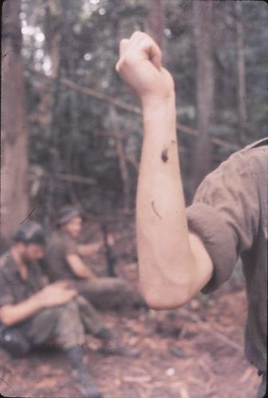  Leeches creep up on us while on patrol

The chopper arrived at noon, circled our DZ, returned to us and settled gracefully down. While prompted by Nig I gave the pilots the necessary signals. Nig had done it before and knew the hand signals to use. After the chopper touched down (engine running and blades rotating) George jumped on and Nig passed gear up while I dived for my camera and started clicking. Nig gave me the thumbs up sign, and I realised there was nothing in the book about this but I stood there and when the pilot gave me the thumbs up Nig signalled me to wave him up, which I did. Then I dived for my camera for the take-off. It was a pity it dulled over very noticeably as the chopper arrived, and I only hope 100th at f5.2 was OK.

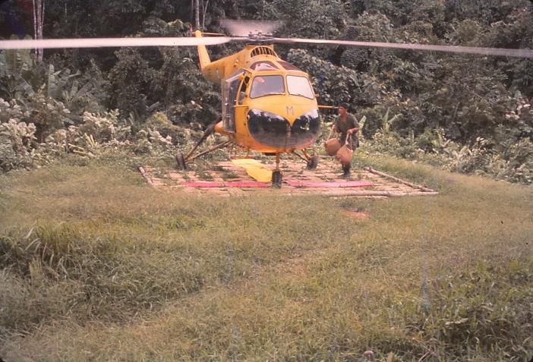  George aboard, then loading parachute packs from the supply airdrop | 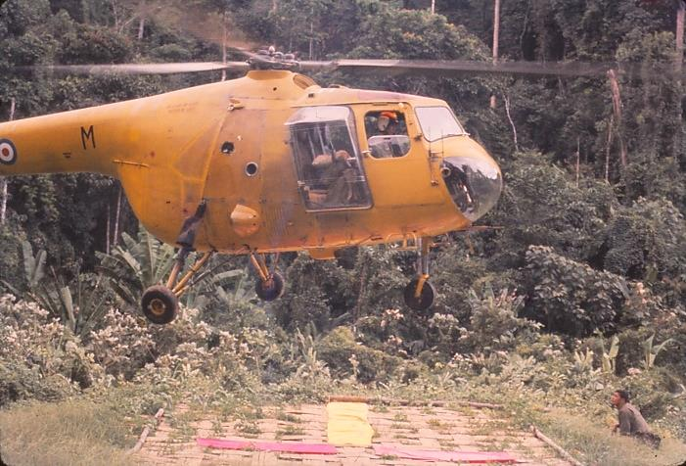  Take-off from Residency under my directions

Home in very quick time and arrived in camp 1230hrs as the rain started in earnest. Deep fried chips and frankfurters went down very well.

On the way down we were walking along the Duablas when George brushed an overhanging branch, jumped 6 inches in the air and turned shouting “Wasps!” He passed me and Mo splashing up the creek before we realised what had happened. I looked at the branch and did ditto, with Mo then following me. [The drill during a wasp strike was for everyone to scatter, then as fast as possible return to the last rest stop location. There we would treat any stings, and after re-grouping, resume patrol.] George was stung several times in the face. What with wasps, wait-a-while (barbed vine), atap, mud and slush, and slippery hillsides there was no wonder we gazed in envy at the six vapour trails that arced high above the jungle over us – Sabre Pilots in training. Also, the chopper pilot and his yellow and red crash helmet seemed in a position of greater nobility than us; of course, who would not be a little envious.
But when one weighs up their various responsibilities against ours, maybe we would rather be soldiers in close contact with terra firma. But we did wistfully remark as we climbed down the bank into the Duablas “well George will now be approaching Grik”. [George I hope will get a cable away in time for Allan Blaikie’s wedding.]

The mud around the camp gets deeper with every rain and with every person who walks up the track. So the work party put in log paths on the various tracks. I added a log floor in my basha, and this made quite a difference. A spring clean helps to make the time useful and also brightens things up.

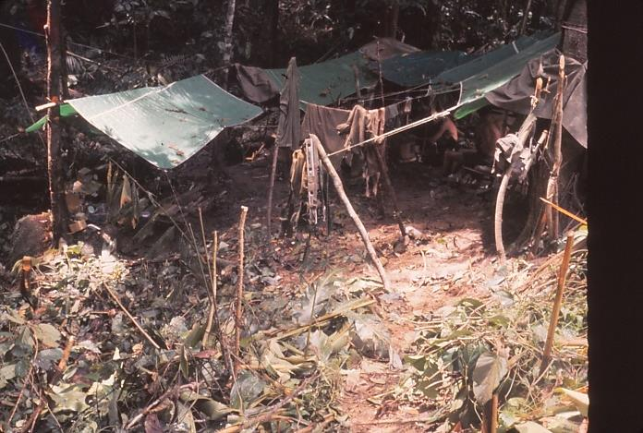  Basha’s at camp | 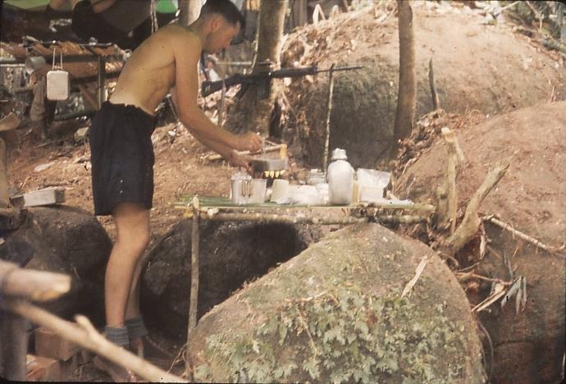  Cooking dinner in my basha

Boy, was I tired after a good tea of my share of fresh rations – tinned beans, bacon, luncheon sausage, and I cooked a cheese sauce with it all. Then a dessert of rice and Carnation Milk. Sentry duty 2000hrs till 2100hrs and then glorious sleep and more vivid jungle dreams.

DAY 51: Thursday 27 October
Eddie, Jack and Rea brought back a signal of our tasks from 5 Platoon Camp. They were not very happy at the way we left the camp last Saturday and Bob Burt was not too pleased. We are to do patrols, and accordingly at 0815hrs Nig Tuaka, Des Tuahine, Mel Jack, Trevor Williams and I took off up the ridge back of camp, travelled South East then East, turned South at the ridge top and dropped to a creek running West. Hello – nothing on the map. We climbed a ridge to the South and went South, then West, North West, North and swung down East and hit another fork in a stream running West. Again did not comply with map, so followed it west and struck a North/South junction, which turned West of North and then struck, after 20 minutes, a North bend and then a waterfall 10 minutes south of Camp. A complete puzzle. So we had lunch in camp at 1230hrs. Brian’s five returned at 1400hrs having also found streams running the wrong way on the map. The ridges we moved on were flattish with good tracks and lots of atap. One ridge (South one after climbing from the first stream fork) had impala tracks that looked fresh, also had a lot of fallen timber on the atap which was still very green. We saw large ½ inch to ¾ inch ants carrying dirt out of volcano like hole 3 to 4 inches across. Heard monkeys in the trees. Saw a small transparent body, red head and legs, and long almost crab-like front legs spider-thing ¼ inch diameter on my shirt and picked up a feather about 24 inches long with rings like a peacock in it.

While sunning myself after lunch of rice, tinned fruit and chocolate I heard peculiar noises like a cross between a tummy-rumble and a drum which were reciprocated by another noise close by. Must be another bird. Bamboo we often hear snapping and splitting with rifle shot like sounds.

An Auster dropped a pink parachute with supplies we did not get earlier, such as boots, soap etc, and it landed right in the DZ. The radio, which is now working, was then in bits so we could not reply to him, and as the chaps were caught unawares (time being 0840hrs as we climbed the ridge) he circled awhile before we acknowledged him with smoke, and he sent down a curt note with the chute “balloon” (which had broken loose when launched) re “smoke” and “wireless”.

The pilot’s card gave his grid Reference for locating us as GR119499, but as he had to fly around in circles trying to locate us via balloon and smoke he then indicated on the note our actual location (“You are at 128507”). No wonder we had navigation problems on patrol that morning – we were in the wrong valley!!!.

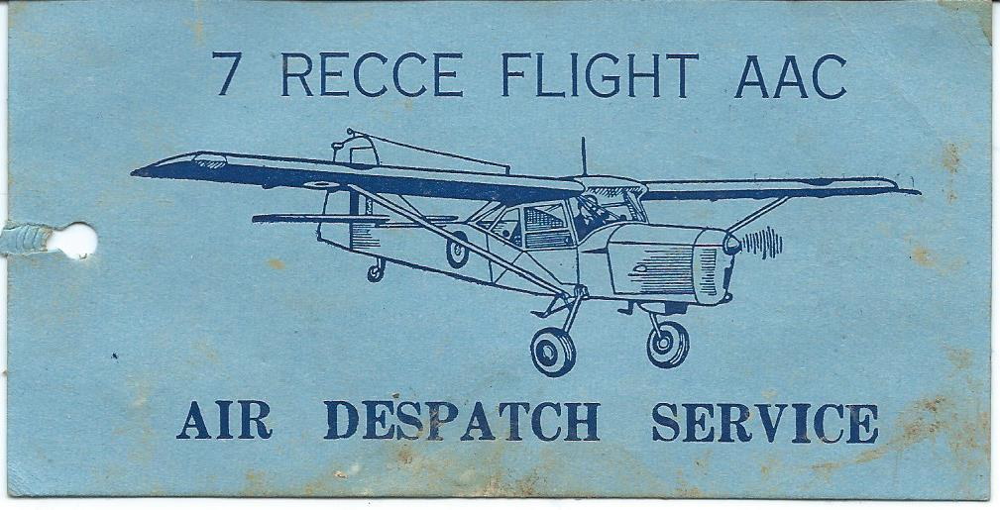  Auster Pilot’s Job Card | 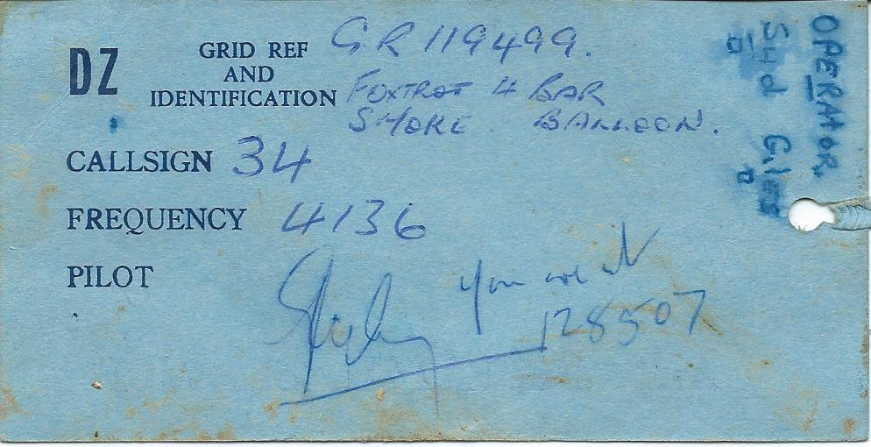  Note on reverse regarding our actual location

Anyway, we are now up to scratch on supplies.

As we had tea, just finishing, it began to rain, and rain it did in true monsoon fashion as we really had expected since we came in. It went on for ¾ hour by which time the creek rose by about a foot. Darkness and bed with trees dripping all around. I was not on sentry tonight and boy did I sleep. The hammock gets more comfortable every night and one does not like getting up in the morning.

Saw a couple of ants fighting the other day, one holding the other’s feelers in his mandibles. I see a couple in front of me now in an apparent death lock. Also saw a slim smooth black and yellow sectioned worm thing about 1 inch long which had a flat yellow semicircle for a head, and could raise its body and search around like a leach, though it did not stretch. It had no legs. There are several sorts of frogs which chorus stridently when the rain comes. Brown horny tree frogs, then green frogs and ordinary brown frogs.

DAY 52: Friday 28 October
A wireless message gave our position as 1600 yards North East of where we thought we were. The Auster must have confirmed this and when we recalled yesterday’s patrols we agree exactly and it all falls into place. We are now too far east and even below the 50 gridline of our area to do patrols readily, and if Bob Burt calls “Tiger” (code word for them having flushed CT from B Region south and us to put in line ambushes over main the ridge) then it will take us more than 6 hours to move into position.

Today we went up through square 25 and into 29 and 30 on ridges with Ken as additional man in our patrol. We tracked SF tracks and ran into Eddie’s patrol (Morris again remaining in camp and Brian also staying) coming back down the ridge that we were going up. They were trespassing a little and headed off west while we pressed on and ended up by the word “Jungle” in map square 29. Lunch, then confirmed our position by recce, and headed homeward, slipping up once and going too far north but getting back on track and sliding home in the rain to wash my clothing.

Allan McDonald is getting a lot more boils. We have requested medivac, and also advised we are shifting our location.

While we were tracking Eddie’s patrol this morning, some large monkeys spotted us and started a fearful “whoop, whoop” and shook trees above us and threw down nuts before scarpering off 50 or 60 feet above our heads. One large chap seemed to have grey fur, black face and hands and a long tail. Later six hornbills went “whoosh, whoosh, whoosh” over us – large birds, long legs, black and white with red beaks and part of the head. Wing span must be 3 or 4 feet. We saw a nest above us as we had lunch, and two of the birds landed in the trees only to fly away together when they spotted us.

Spent the evening washing clothes and myself and sheltering from the rain while reading and eating tea.

DAY 53: Saturday 29 October
Today we sat and just rested in camp. I filled up the latrines and rubbish hole, and dug a new latrine. It rained around 3 to 4pm. Very heavy. I took photos of weapons and ration packs for use back home. Weapon maintenance with careful cleaning took 1½ to 2 hours so my rifle is spotless now.

Yesterday Morris borrowed my Bible to read Psalms and we talked about Jewish books. Talked with Jack Hay re welfare state back home and what it may lead to. Spent 0300 to 0400hrs on sentry last night and thought of home and the annual childrens’ mission and many things. Reading John at the moment – very refreshing. Today reading Digests and a Political Dictionary.

Saw a hairy caterpillar thing this morning, furry side flashes, head feeler, leggings and a tail. It had white and brown whiskers. The jungle is quiet during the day but at night we go to sleep with a deafening noise ringing in our ears, frogs croaking 10 feet away and cicadas and grasshoppers screaming from all directions. It is great how we sleep, mud all around in a wet stream bed miles from a house and in the wilds as it were with never a care. As we line up for morning HFID or crouch over our cookers or mess tins scheming our menus and brushing off the little flies that get in everything and over oneself in the hotter parts of the day the remark is passed often that we look like POWs. The HFID inspection involves our Medical Corp representative (S/Sgt Trevor Williams) checking us for ticks and other jungle greebies by us dropping our trews and lifting our scrotum for him to inspect the hidden places.

The camp is getting more churned up every rain, and the rubbish and latrine holes were in a fly infested mess this morning. I Instigated their filling in to cut out the public health nuisance (did I say before that it seems funny that I am a public health engineer in aspiration, and dig the latrine most times). The chaps have an apathy towards these things and seem to need to be driven to do a decent job. Inactivity browns me off and I suppose I have got to allow that other chaps may not by nature want to be as active. It is great among this crowd of 15 blokes that we do not get each other’s goat. I think now that we are in the bush, some of the boys are being shown up for how their background has affected them in their attitude to living in such conditions. They are not at all bad. At least I enjoy being given plenty to do. However the slack life one can have here seems to suit some blokes.

Rain, tea, and glorious sleep till 0400hrs when I was sentry. Gazing at the star filled sky, so friendly in the night that try as I could I could not conjure dark shapes into bears or tigers or aboriginals. I saw several falling, or rather shooting, stars. Again tonight the deafening chorus of jungle sounds rents the air at dusk. It turned off at 0400 in the morning, and became a steady hum in the background of sound, a buzzing in the foreground and middle distance, with a “hoo-hoo” sort of cross between an owl and a pied stilt going on regularly, continuously. There is also a regular chirp.

Not so much fluorescence in this part of the “woods”, though what glows most is whole logs, a thick look of dull light. A branch cracked again a few feet from my basha and Trevor’s about 0300hrs. I never heard it. It was annoying to be woken at 0400 as I was dreaming of a fire that I was rushing off to put out. However, Eddie was sitting under Brian’s hammock on sentry when Brian jumped right out and landed beside him. Brian was dreaming he was sailing a spinnaker on Evans Bay and he got caught by the jib and flung overboard, or he had to jump overboard.

DAY 54: Sunday 30 October
Into my clean jungle kit washed and dried day before yesterday and the whole party off except Allan (boils), Giles (radio operator), Trevor (crook legs) and Morris (who had a pain in the groin. He seems to have had something wrong every patrol and there may be a little bit of feeling about that from some people. Anyway that is not my concern.)

In one hour we reached the top where Eddie had turned back on Friday, the elephant clearing in the atap. Out came the cameras and I took photos of the tree where the elephant had scratched itself. Just before we reached this point we came across a cluster of five hairy caterpillars similar to last day, only shortened coloured green brown and red with fur on. Jolly interesting. If these contact the skin they will cause a blister that will run.

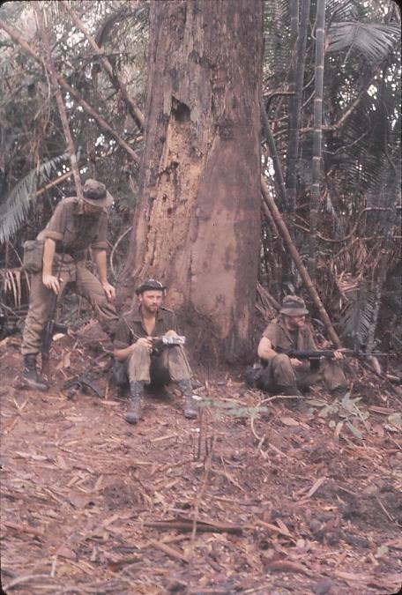 | 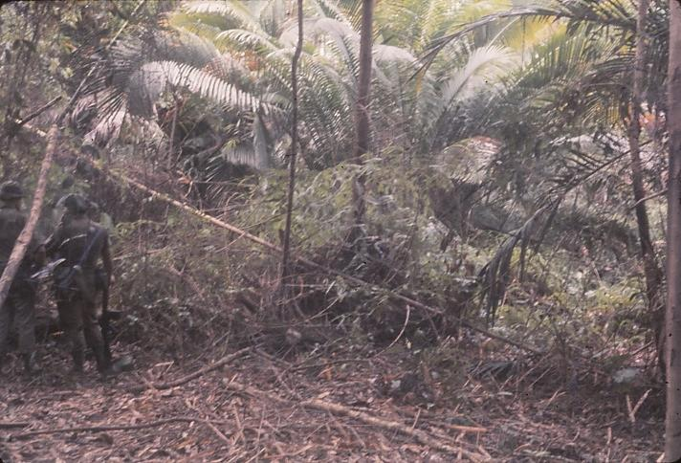  Above: Impenetrable atap fringing the elephant clearing  Opposite: The elephant back-scratching tree with Brian discussing our position on the map with Ken, and Jack Hay keeping watch.

Then off we went down and along the ridge. Now while we were having the stop for smoko, Nig and Rea (the trackers) commented how quiet the jungle was, and it was too, very still, and said there must be something around. Well, we had only gone 10 yards down the track and bingo, a paw mark as big as a fist in the mud. Tiger! This was good. It was very fresh, last night or early this morning, most possibly the latter. The mark was as big as a hand laid back of palm on ground, with fore, middle and fourth finger knuckles pressing into ground with these indentations as large as plums. We followed these prints right past where we had lunch on Friday, and after a spell there (1015hrs– we had left at 0800) we pressed on. Then Nig thought he saw a foot print a day or so old, but there were a lot of sladang (buffalo) prints about and a few yards on we saw the tiger prints again. [We had also seen pig or impala prints on Friday a few hours old.] We then found a place where the tiger had stopped and relieved itself, covering its droppings (which looked very fresh) with earth scratchings just like a cat would do. Then lunch after seeing hornbills in about a group of 5 or 6 pass over with rhythmic swoosh swoosh.

We took off on fan patrols, Nig and I with a section on 24 square and confirmed that we were up a tributary of Duablas and saw fairly fresh elephant prints and scrapings where they had ducked under logs moving along streams. Eddie and Rea saw a hockey boot track which was old and after searching for a short time (which was in rain that had kept up since noon) we gave up as the rain came on heavily. The heavy rain persisted all the way home (1¾ hours) then into camp down a mud slide by a waterfall and whoopee – wash and tea (which I am going to eat right now).

My word the mosquitos were bad on the hill today. They get right through trousers and shirt. Also little sweat flies which swarm off logs buzz around when stripping off for some sun and they tickle the back like what-ho (but are quite bearable). Then a bee like our honey bee (though does not appear to have a sting) buzzes around too and can be annoying. However, after some time you get used to them and it can be quite comfortable sitting sunning and reading with an occasional wave of the arm behind the back to swat the insects away.

Anyway, wet clothes off, tea cooked and eaten, then “stand to” after a general chatty gathering by Rea and Eddie’s basha at the top of the camp and then the second paludrine for the day. As the darkness deepened during stand-to, which had developed into a sit-to for me, on my seat under the plastic, looking out on a very good field of view over my arc, I felt a gentle nuzzle at my left buttock and thought “Hello – a pig” and shifted slightly and put our my left hand. Then it moved and in a split second I also did, at first fearful, and then as it scuttled away from me fearless and a laugh on my lips as I shouted “Lookout Ken – a monster lizard”. The lizard, an iguana, was a beaut and all of 30 to 36 inches long and dived under Ken’s table. Ken jumped up and dived behind the table flashing the torch as I said “It’s under the table” and a hissing noise came from that direction. Next second (all this happened in a few seconds) it scuttled straight down at Trevor in the light of his torch which came on and Trev moved like greased lightning kicking over table and rations, while the poor lizard dived under some slats on his floor amid our cries of “Lizard, Lizard” and our near hysterical laughter at the humour of it all, and Brian’s gentle “Shsh not too much noise” while he tried to figure it out. Then it dived down the creek bed and we saw no more of it.

Laughingly we had the whole sequence of events out and recapitulated on them. Trevor was very smartly in bed and said he got a hell of a fright as he saw this thing coming straight towards him, and he moved mighty quickly. Bed and then sentry, which I spent meditating and enjoying the jungle night and never noticed the time pass, so quickly did it go. When I first looked at my watch the hour 0500 had come and I woke Allan and his boils.

Today when Eddie’s patrol struck the footprint they were so keyed up with safety catches off that if a leaf had fallen off a tree it would have been shot to pieces.

DAY 55: Monday 31 October
At 0845hrs I was in wet clothes and waiting to escort Allan with a patrol to medi-vac him from the Residency. Brian sent a patrol under Eddie to look up the Duablas where we had intended shifting camp nearer to our designated patrol position. Rea (who was met at the Residency on his way out for a course by a Patrol of 5 Platoon) led them. Allan and John Ovens with Allan’s pack and Ken I with clothes and parachutes respectively took off. By 0950hrs we reached the Residency with Allan managing to limp along gamely, though he suffered when he stopped with stiffening limbs and a chronic headache. We met the 5 Platoon patrol who told us we should receive a radio message advising we were to move to their camp for night of 3rd November. On the 4th we would move in one day to Ali’s Ladang over Kewa, then Brian, Eddie and Jack Hay were to stay at Ali’s for a further 10 days because their Armoured Corp attachment had not come through. Gosh, they will be pleased over this. Training arrangements did not work out (the units applicable to them being in Hong Kong, and politically this was out for them).

Rea left, we set out the marker panels on the chopper landing pad, sunned and aired ourselves and read. Mo, who fell headfirst into the Duablas off a log on the way down soaking everything except his camera (which was well protected), dried out his gear and cleaned his rifle. And so lunch time rolled around, then 1300 or 1330hrs the rain came, drizzling, then getting steadily heavier, and we sheltered under Allan’s plastic and continued reading. I got stuffy, got out and got wet, then the rain turned off at 1500hrs, and 1600hrs came. We had heard a very faint plane, but it may have been a DC3 airliner. At 1600hrs Ken and John set off to camp to return with rations and be prepared to stay the night with Allan if the chopper had not come. At 1635hrs we heard a chopper and leapt for joy. Allan was in pain at this stage as he had been all afternoon. Then the sound died away, and I thought surely it must come. At 1640hrs it did. Smoke bomb away up, Mo and Allan waited, and the chopper circled twice and without any ado approached straight down the valley, and quickly set down obeying my signals for the touch-down,

Then gear loaded, the pilot grinning, the other soldiers help in Allan, me bent double skirting those vicious slicing tips to get them behind me, the pilot waving and me waving up and then diving for my camera, the chopper lifting, then 3 feet off the ground he turned clockwise and Allan faced us out the left side and waved and then Mo screamed “Take tail” and flung himself flat. I looked up and ditto smartly as the spinning tail rotor swung a few feet above our heads and the ground, and the chopper sank to 2 feet above the pad and then soared off. Phew!! That was exciting, not frightening. Too busy getting as close to Mother Earth as possible to be scared, and through it all the pictures I took had not registered as the camera had a jammed film. Dash! What a nuisance.

However, we packed up and tramped off leaving behind the landing pad (and the very large buffalo prints made this morning) and this picturesque valley clearing. The Duablas was high and I stepped into a hole up to my waist, wetting everything. Camera I retrieved with dripping waterproof bags, and it was OK. To camp, tea and a dry night, with peaceful sentry duty.

DAY 56: Tuesday 1 November
November! The year rolls on. Bob Burt and patrol returned last night, and the radio message came yesterday re the expected move, so Brian said we would have a two day stand down, which though it might be boring is only as boring as one makes it for oneself. So, into the sun with our clothes and a good day it has been too. Cleaning spotlessly my rifle and ammo, writing my diary and spending 1½ hours teaching Bob Gilchrist (the RA corporal and an Express Company delivery man in Christchurch) and Mel Jack (ASC corporal and Sun Insurance clerk for Christchurch) compass and map reading. Mel in the morning, while we were cleaning gear together, told me quite a bit about himself. Most chaps will open out as you get to know them. I guess it does them good to reminisce aloud re their affairs at home, not private ones but usual things though one often gets a glimpse at personal things in their background and so on.

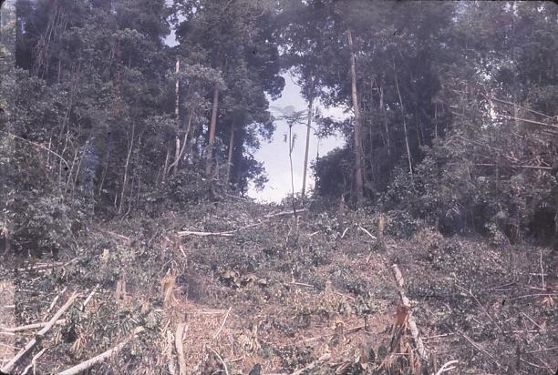  The Bay Window on the ridge above the DZ | And so we rested, let the sun at our bodies and chuckled over a message from Bob Burt, “make sure all tins are buried, and the camp tidied up” And the lads sunbathed and talked of home. The usual “Does anyone know what happens when we ------“ and some event 4 or 5 weeks away is questioned sort of talk occurred. Morris was in the sack, resting all day I guess. Jack, John, Trevor and Ken cut a bay window in the trees on the ridge, and Brian made a flute of bamboo.

My pocket New Testament is a sodden mess after yesterday’s dunking in the Duablas.

Well tonight we talked after tea about people dying, accidents and first aid, had stand-to, and watched the moon rise over the ridge as we talked about aircraft. And so 2100hrs to sleep ---- glorious sleep. [Trevor said the in morning he was sure he heard an elephant in the trees above Jack’s and my bashas. We never bothered to look for footprints.]

DAY 57: Wednesday 2 November
At 0335hrs as I walked down from the store to Brian’s basha to sit sentry out, Eddie got up thinking he should be on and chatted with me till four. John Ovens got up and sang out for the time and then went back to sleep. However we got lambasted for talking during the night though no one accused me because I must have been speaking quietly, and Eddie’s voice carries. Anyway a fine day greeted us. Double porridge, biscuits and jam and tea, then tidy the larder, wash mess tins and Ken and I attacked some more trees. We practically have killed the jungle with wholesale slaughter, trees feeling the fury of sharp gollocks and determined and jubilant choppers. The Bay Window was opened a little more, all to expose a fern against the sky for a photograph. Also we chopped and fiddled around for 20 minutes to get a picture of the large buttressed tree on the top of the ridge. The camera is now working OK if I take the winding gently.

So again we sunned ourselves. Cleared the camp up and dug new holes and read. Lunch was pineapple, rice and raisins and milk plus biscuits and jam and ginger beer to drink. We all washed and chatted and read and passed a pleasant afternoon. I am glad of the rest as from now on it will be work aplenty.

The night was pleasant, our last night at this place. No elephants or tigers, although I gazed at the Bay Window hoping an elephant would cross it. No such luck.

DAY 58: Thursday 3 November
Burnt the remaining rubbish, broke camp and ready to move 0815hrs though left about 0830. At the junction of the stream with the Duablas Des Tuahine found he had dropped his Bren magazine and we had to find it. It was located 20yds downstream of the DZ. The rest stop was for ½ an hour while the search went on and then again a stop of a few minutes at the Residency before tackling the 2 hours to 5 Platoon base on the Ringat. Phew – and did our packs seem heavy. On the way we saw fresh elephant tracks come into and out of the stream bed almost as if they had turned off the track when they heard us. There was surface water draining into bucket size foot impressions in the soft mud, so we presumed they were stealthily hidden in the foliage watching us pass by. We saw quite a lot of evidence of their browsing off the long green leaves bordering the stream throughout the last part of the trip down to the Duablas.

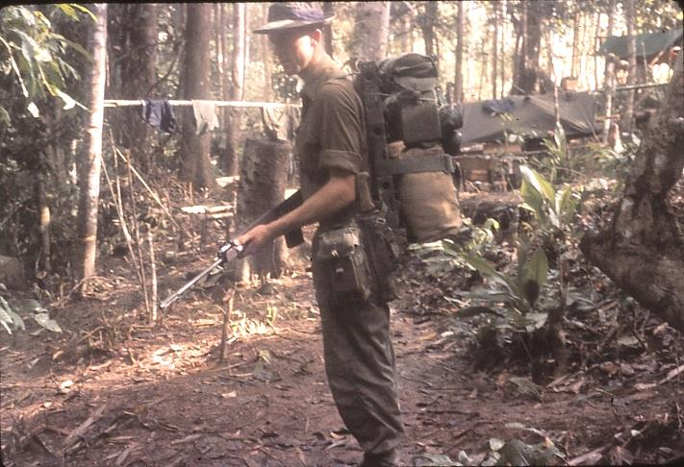  In full kit arriving at 5 Platoon Base | We crossed the Ringat and made double time to the 5 Platoon base where we had a long lunch from noon to 1345hrs. Mock turtle soup was there for us and I continued reading the novel “The Trees” which I am trying to get finished. It is most interesting, about Northwest American backwoods pioneering and how the forest affected their lives.  We were very pleased to get our packs off at the Jo Rai and bash up during the late afternoon. Not carrying such a load for a week or two makes a big difference. The night was
warm with no rain. Most of the chaps slept fitfully, but I was OK. The signals we have been receiving recently regarding our departure have been changing continually as to what happens to the Armoured Corp boys.

Today on the way out we saw a large grasshopper (body 2 inches long with ¼ to ½ inch diameter, feelers 2 inches long, large eyes, and legs very long and muscular) with a leech fastened to its body. Apparently it could not move because of the leech.

DAY 59: Friday 4 November
Today the big climb today over B. Kewa. At 0730hrs we were all ready to go. One of the 5 Platoon chaps who was with us, Steve, was packed at 0630hrs and then had a brew up while we packed. We had risen at 0600hrs. It took two hours up the hill, but Steve, who had developed flu overnight, cracked up and we split his pack amongst Eddie, Jack and I, and buzzed off after a rest. Then it was downhill with a few stiff uphill sections, but with morale high, our packs averagely comfortable and our map reading we thought was spot on. Lunch 1130hrs and reckoned only 5½ thousand yards to go. However the plain trail became not very plain about 1500hrs, when on stopping for a rest Brian got stung by wasps, and with surprising agility we hoisted our packs and headed along the ridge at speed. From then on with frequent stops for Brian’s stings on neck, there was much puzzlement when we discovered we had been moving West of North instead of East of North for about a ½ hour. Recces revealed nothing and an estimate of our position as only 1,000 yards from Ali’s Ladang, where we were headed, seemed to be wrong. At 1700hrs we knew there was something amiss, and after more travel NW we struck a ridge running west and knew we must be on the wrong side of feature 1380. So into a stream bed running nearly North till dark (at 1830hrs) where we camped all night sleeping on the ground (quite comfortable too). [Once again we were experiencing the disconnect between features on the map and features on the ground – third time this whole trip relying on flawed map reading!!!]

Today on the trail we saw fan shaped atap type leaves, pigs which were greyish, a dead monkey at the side of the track, large grapefruit, and lots of other large nut type fruits.

DAY 60: Saturday 5 November
At 0530hrs I awoke after a good rest, and in the dark we cooked breakfast and packed at first light. Doing some more map appreciations we all reached a definite opinion we were on the Mas, and about 1,000 yards from the Perak. Off we went, again in high spirits, leaving about 0645hrs. Our reckoning appeared bang on and at 0730hrs we reckoned 200 yards to go when the stream (which was dry) took a westerly then south westerly direction and thus foxed us all. Around ½ to 1hour later a conservative estimate and a new respect for this country put our position at where we reckoned we were 2 hours before, and at 0915hrs we wearily stomped out onto the road being built on the south bank of the Perak. While three chaps went to Ali’s to intercept the boats, we cooked, fed, cleaned our weapons and shaved and dried out. We were too tired to really jump for joy at reaching the river, but we were very pleased, and rather humbled I think to know the country got the better of us on our last sortie (shades of the Hunuas).

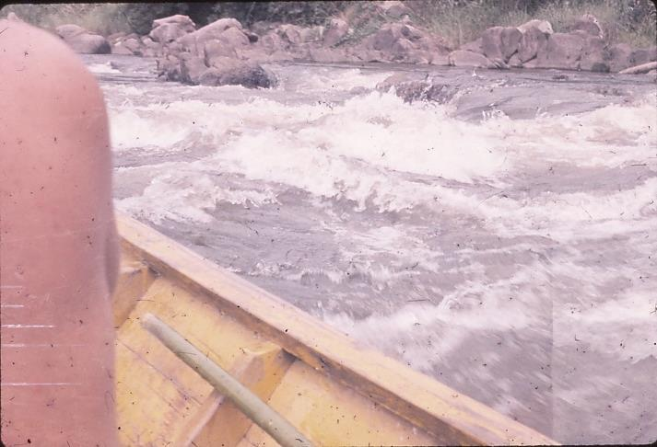  Shooting rapids boating back down the Sungai Perak | 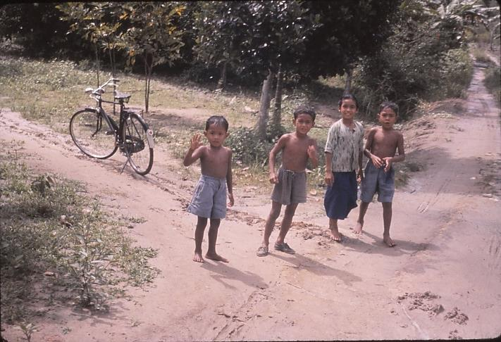  Roadside kids watching out for treats

The boat ride down the Perak was great – really great (seats were hard though). Aboriginals canoeing on the way to trade, aboriginal children swimming [they were Kadangs] and the backdrop of jungle hills was splendid. Kuala Rui, and the last few steps with packs on was really easy – then mail from home. Glad to get news, and what news. Cousin Colleen engaged and the Howe farm nearly sold. Into trucks and noticing the heat and smells once out of the jungle. We had a three hour trip to Taiping with lots of fun throwing sweets to the children on the roadsides. The kids knew what was coming and would run to the roadside and put up thumbs as we passed and yell out for lollies and cigarettes. Into Taiping and to Camp Sabroan in the rain.

Weapons in, meal (at 1600hrs) of salad, bread, butter and veges which was most welcome, handed gear back, and then sorted equipment to return. George and Allan handled our affairs and very well too. Paid $1250 plus $48 bush money. In the evening there was an engagement party in the mess and, only intending to stay a short while, it was 0230hrs before I got to bed after dancing and chatting with one of the school teachers (a single girl as all the school teachers are here), smoking Tom’s cigarettes and generally trying to be as pleasant as possible. However, these long hour’s social things brown me off. Fred Donnelly and Pat Manly were the engaged couple.

DAY 61: Sunday 6 November
Rush and bustle. QM, Arms Code, HQ Camp then morning tea. The CO, who wished us well, said he realised there were limitations in their organisation. However, we were here at the taxpayers’ expense and though we were here for a short time, the Army had claim on that time. Did we now feel we could run jungle courses for our units back home? In addition we have already seen and will get to see places in Malaya that they (in 2 Regiment) have not had a chance to see.

Monty debriefed us and we had a little moan session as one or two things about equipment and map reading came out (which seemed to me not Monty’s end of the stick). However, he said for us not to go back home and quote ourselves as jungle experts because it takes a lot more time than we have had to be that. But now that we have seen both good points and not so good points (the ones to avoid) over many parts of this game, we have plenty of material to work with.

Next our clearances were signed, then we sighted our personal reports. Ken Oakenfull was VG “Asset to course. Best student” and so on. He certainly fulfilled that in the jungle. Mine was Q1. “Quiet, conscientious student who shows ability to think clearly” or something and “should benefit by operations. Needs to be more aggressive in command”. Ha Ha – pretty fair report though.

Lunch, collected group photographs, and then packing. Sorted all slides, packed (other boys did too in order to catch the 1115hrs train south, Ken and I being only ones going North of Taiping) and wrote this up.

PART 4: CORPS EXPERIENCE WITH ROYAL ENGINEER SQUADRON, BUTTERWORTH
[DAYS 62 TO 81]

DAY 62: Monday 7 November
Fully packed and the Padre noticed me shifting my bags and asked if I needed a lift and I said I was being picked up to journey to Butterworth. He said he was going to Penang, and had instructions to take an Aussie Captain and Warrant Officer at 0800hrs to catch a plane. However it looked like it was Ken Oakenfull and me he really had to take, so off we went at 0830hrs. My, what a delightful morning, mild and light sunshine. Great to be alive.

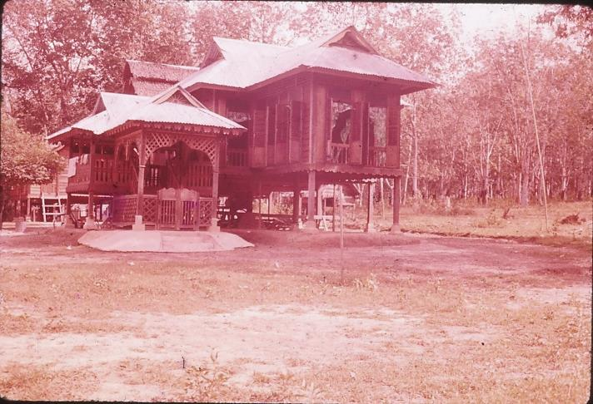  Typical Malay house on stilts | 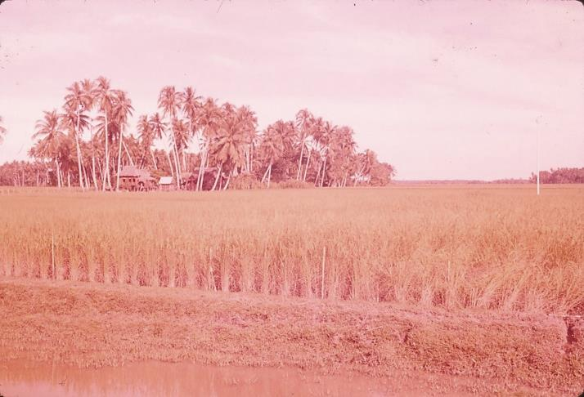  Rice ready for harvest

The road to Butterworth was through coconut, banana and pineapple plantations also cultivated atap with really broad leaves, and paddy fields way across as far as the eye could see, to the hills in places. The fields, road ditches, and around the houses were flooded with water from the monsoon rains. We see now why the houses are on legs or stilts. Many of the rubber plantations had water all around the trees.

We noticed one of the PME trucks in a monsoon ditch at the side of the road. This heavy laden truck had literally ploughed off the road and half buried itself in the soft earth at the roadside. It gave us an idea of what the going is like off the road. [PME is Perak Mining Enterprises which mine iron ore. They tear up whole hills which are just dug away without any overburden stripping. They have a fleet of over 100 of the latest Bedford trucks and transport iron ore from Ipoh to Butterworth where it is shipped to Japan. The trucks work all through the night, and usually have two men in each vehicle. There are two different companies which carry out this type of mining.]

Again the politeness of truck drivers on the roads was most impressive. They would put their hands out when they saw you approaching to stop you if another vehicle was coming towards them, and wave you on to pass when the road was clear. Usually the local trucks have a chassis and front window to which is added a local body with wooden seating for 4 to 6 people. Hence rear vision mirrors are nearly impossible to fit. By law they must always carry a man on the tray or on a covered truck he is perched on top, also on top of a heavy load. He watches the front of the road, and gives signals to following traffic, and bangs the cab roof or tray side to indicate to the driver there is a vehicle overtaking.

We arrived at Butterworth at the end of a court martial, and met Major Elgood the OC of 11 Independent Field Squadron who had rushed in off leave to attend it as witness to the character of the defendant. He said he had planned on us spending the first 24 to 48 hours around the camp area learning details of camp set-up, then during our posting for us to see Kedah roads, Tapong airstrip and Grik road jobs. Unfortunately at this time the unit has just returned from Borneo and is retraining, refitting and taking leave, and there was just not much work being done. Ken met the SSM and I met Captain Gerrard Noel 3 Troop Commander and had a most interesting morning. After lunch Gerrard, Tony Probert and I went into Penang in Gerrard’s car and shopped. I tagged along to get to know the Georgetown area, and actually had a very interesting afternoon (though it rained pretty continuously the whole time).

We had a call at the Malay Cold Storage Restaurant. The English usually have tea at 1630hrs (lunch is at 1300hrs, dinner is 2030hrs in the mess) and Gerrard wanted a cuppa. This “tea” is just cuppa tea and sandwich or cake. So we had it at the Restaurant. I had a Knickerbocker Banana Skyscraper. Saw Baptist Bookshop in Campbell Street opposite Hearne Motors. I also got many useful tips from the chaps about where to buy.

Back for tea, that is dinner, which was grapefruit soup, pork chop, gooseberries and cream eaten very leisurely. Then we had coffee and read the papers. Finally I got to my room (which is very well appointed) about 2200hrs and wrote some letters.

The batman service here is excellent. Sammy is an Indian “boy” (age about 32) and he does all cleaning, setting out clean pressed clothes daily, and takes complete care of all equipment and belongings.

DAY 63: Tuesday 8 November
I awoke with stomach trouble. Met Ken and talked with Tony (Staff Sergeant Wilcox) re UK National service and the reorganisation which is taking place in the Squadron. There used to be 1 Sergeant and 45 ORs per troop, now to be two Sergeants and 51 ORs (also with two officers I think it was). National servicemen are now thinning out. Most men are about 22 years old. They sign on for 3 years’ service in total but if wish to end at 3 years they can apply at 2½ years. If not they can serve an additional 3 years, ie 6 years, and at 5½ again apply if they want to get out, otherwise 9 years, 12 years, 15 years and so on. At beginning of their service they get a bonus payment of £150 which can be, and has to be, paid back if they wish to withdraw before the end of any three year period. National servicemen are on for about one year in an operational unit. They are usually a better class of workman because they bring their trades, which are their living at home, with them.

We then inspected the TO and spent an hour with Jeff Woolett the Plant Troop Officer (being an Independent Field Squadron). The discussion with him is recorded in a separate report.

At 1030hrs I really felt off colour and lay down till about 1500hrs when I saw the doctor at the MRS and gulped down some glug, and found my temperature was normal. With Ken and the SSM we sat in on a lecture-practical lesson on the Rocket Launcher – one of the platoons doing part of their retraining. Range work is not done with this weapon. General weapon training and range work is included in this retraining period.

I felt a little queer in tum again about 1530hrs but perked up 1630 and chatted over tea and sandwiches (which revived me no end) with Gerrard and Tony and edited slides and wrote letters for the remainder of evening, with of course dinner at 2030hrs.

An interesting point about the Gurkha’s – they eat meat on the hoof. It is killed fresh daily and is usually goats in this country (something to do with their religion). Major O’Neil told us at tea how he caught a dolphin with depth charges. 1lb of guncotton primer, a No. 27 detonator and a few inches of safety fuse which when lit was dropped in an appropriate place, and “poof”, he caught a fish after four goes. Indians would not eat it (considered “pig fish”) and its steaks were pretty tough.

DAY 64: Wednesday 9 November
Captain Noel, driver and WO II Ken Oakenfall and I travelled via S. Patani and Gurun turnoff over the Kedah road job that was completed in 2½ years by various Engineer Units working 6 to 8 months in the dry season March/April to September/October. 11 Field Squadron did 5½ months for 2 miles. We stopped often to inspect and discuss problems and take photographs. Lunch at the attractive Nami bridge was very pleasant, and we learnt a great deal about the road building task from Captain Noel’s answers to our questions. The trip to Alor Star and to Butterworth was very interesting. The road had passed through much jungle that appeared would be easily opened up for cultivation, though in the year since it was completed, not much has been done. Loggers have been extracting many of the large trees with their Ford and Chevy ex-army chassis-cab vehicles and it is expected the locals will then proceed in and clear smaller stuff and plant.

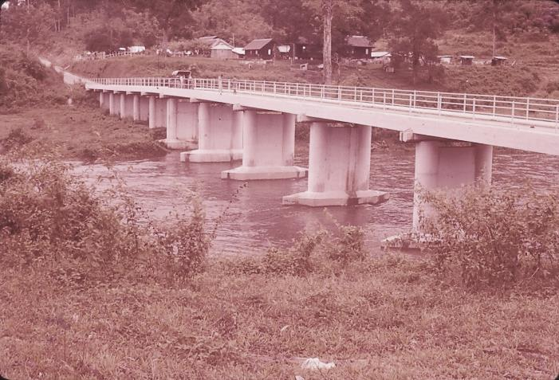  Nami Bridge | 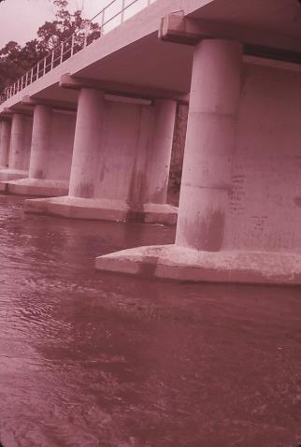  Nami Bridge
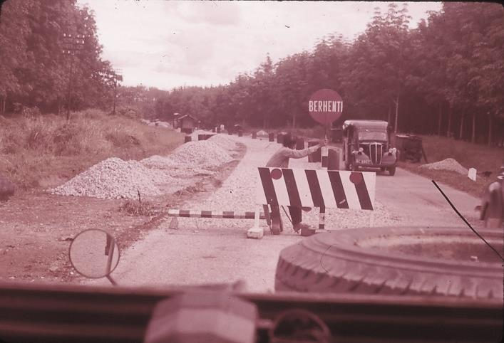  Roadworks north of Gurun | 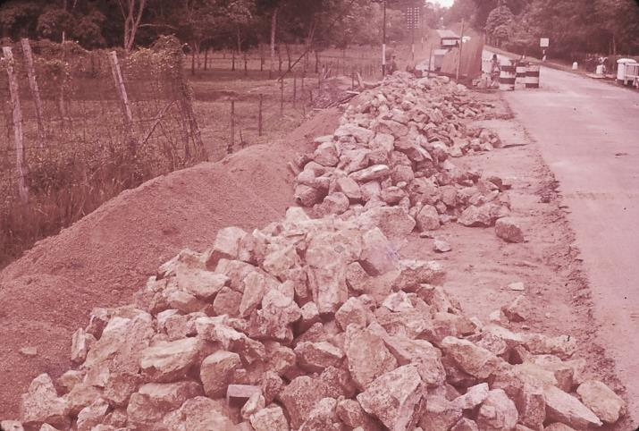  Typical road widening

With the sun setting over the island behind a bank of cloud, palm trees silhouetted against the sky and the surf lazily licking the beach, the lights of Penang gleaming across the channel it felt most pleasant. Then a leisurely six course dinner and now I am going to write some letters.

Saw a real beaut VW Camengia today.

We also saw rubber trees that had been uprooted by wind. They have shallow root systems and one tree falling can set off a chain reaction by knocking down an adjacent tree. One section of road near Sungai Patani was lined with frangipani, a bush that flowers continually the whole year round. It is an attractive bush.

Between Alor Star (which had a lot of filthy mud surrounding roadside shops, the mud pock marked with water buffalo wallows in places – though the town centre is OK) and Butterworth paddy and coconut plantations went as far as the eye could see. We saw a relic of the Japanese invasion at Alor Star, a demolished masonry bridge with an OS and DD bailey linking a lone centre span.

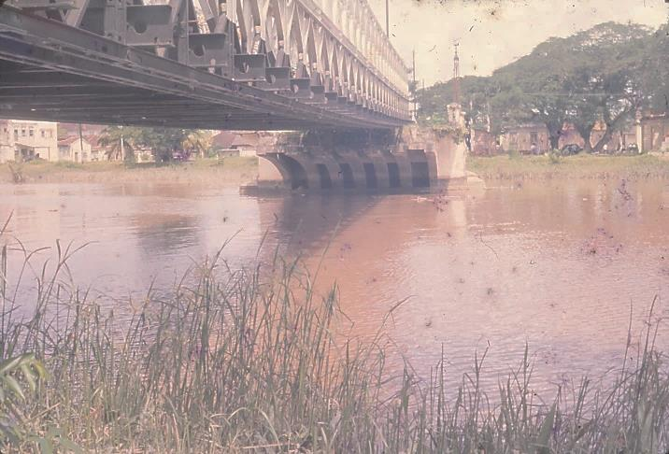  Alor Star – demolished bridge | 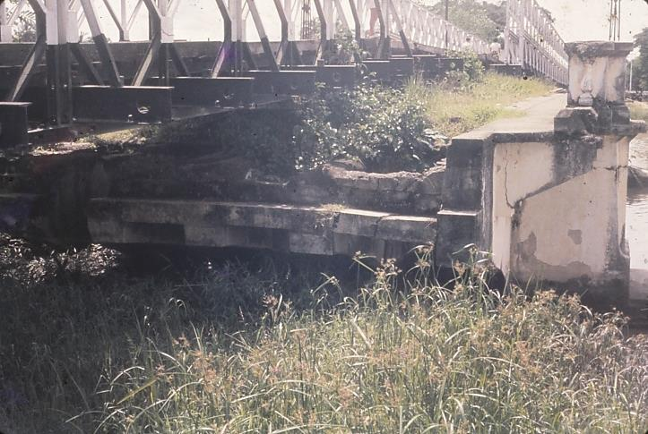  Alor Star – edge of demolished bridge
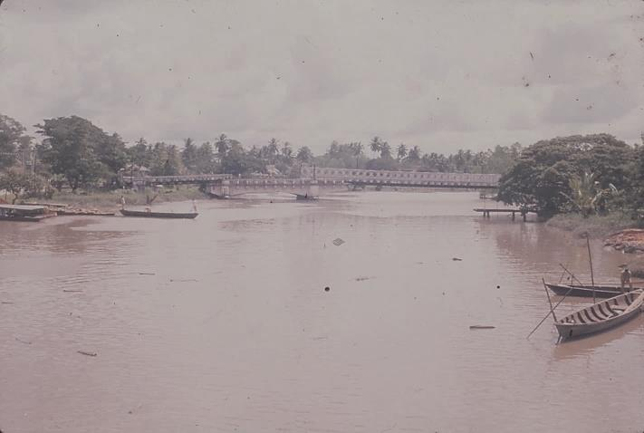  Alor Star – demolished bridge with centre span linked by temporary Bailey bridge sections | 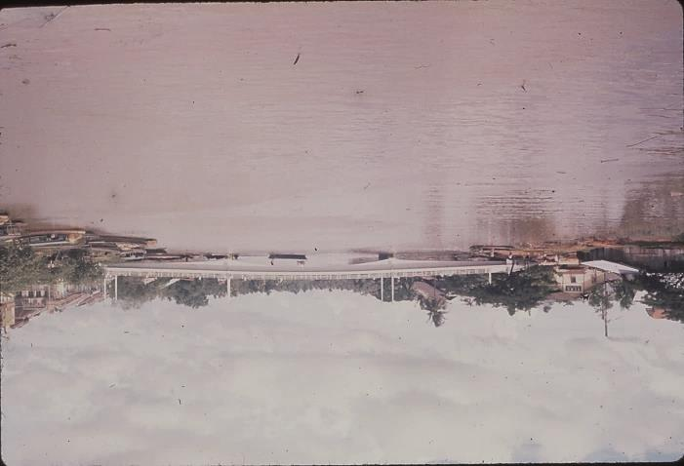  Alor Star – new bridge

On the jungle road we encountered lots of water buffalo and in places it very much reminded me of home, a road through the back country and cattle appearing out of the bush. We saw the only fence in European style at an Agriculture Centre other side of Naha – concrete posts and 4-strand barb wire. Also signposts on the road that had writing in the Romanised and the Arabic type Jawi Malay.

Hume Industries (Far East) Ltd supplied pre-cast concrete work (piles and pre-tensioned beam units) for the new replacement bridge.

DAY 65: Thursday 10 November
Discussion and writing on yesterday’s trip saw the morning slip away quickly, including reading the paper and my notes on the Kedah roads project. I also had a haircut (very thorough including hairs inside ears) from a barber who came to us, not us to him. Brigadier Binny the CE met us in the mess for lunch and I had a brief chat with him.

Gerrard is the messing officer here and he does an excellent job. The meals are of a very high quality, and though not as large as I am used to, sufficient to enable me to really appreciate the next one.

In the afternoon Ken and I visited Penang and did some shopping, which is wearying, until 1830hrs when we buzzed off to the ferry and luckily caught Gerrard returning home by car.

My word Penang and Butterworth, joined as they are by ferry, would be a delightful place to live. I would not mind it for a couple of years or so. The Australian Troop Commander Captain Laurie Wright returned with two sections today to do admin etc. It appears the Aussies are administratively out on their own as far as this unit is concerned, and Ken is digging up details on this. Also we struck the rumour here that a Kiwi officer and 15 men are to join the unit sometime. This is news.

Laurie’s troop is rebuilding the Grik jungle road, including bridges, and they are camped near the Rui which is to have a long timber bent bridge built over it. At the moment it has a triple SWR which can be used to take LR across by bolting special pulleys on the wheels and driving across.

In clearing jungle for the road it is essential to clear all overhead cover and sides to allow the sun to get at and dry up the surface. Otherwise continual rainfall maintains difficult working conditions for construction plant.

For the telegrams/cables I sent home on Monday to John re his wedding, and cousin Colleen re her engagement, I filled out forms printed in Malay which the Teller gave to me. By guesswork I made no mistakes. Also while standing outside waiting for a Land Rover to pick me up, a policeman walked past and with his rifle saluted very smartly.

The Malay women wear a dress, sarong on bottom, jacket on top, called Bakaya. The Sam Foo (a waisted blouse and trousers) is common with Chinese women as casual wear.

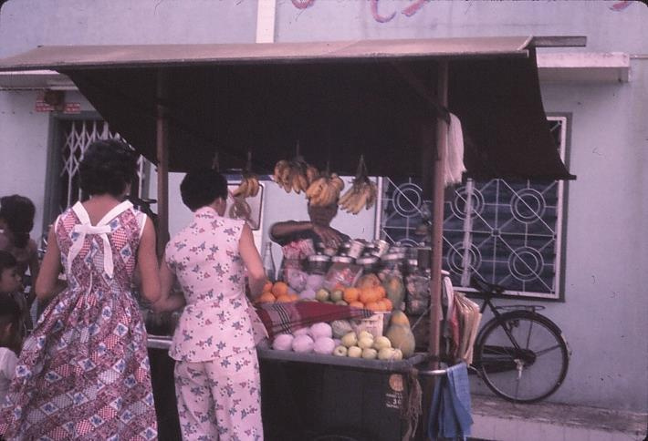  Lady in Sam Foo at portable fruit stall | 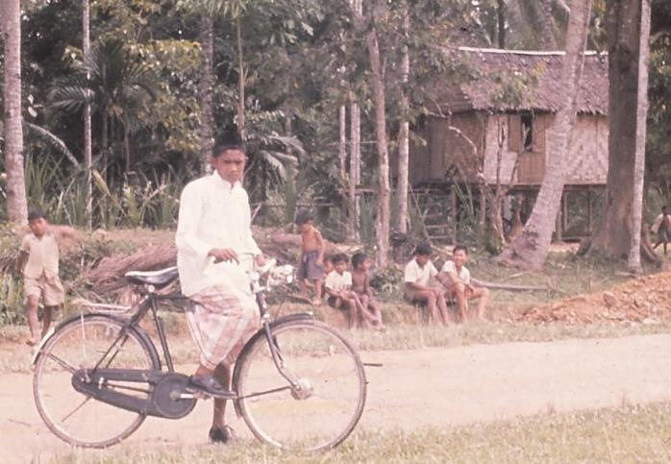  Malay boy in sarong, shirt and Songkok cap

DAY 66: Friday 11 November
Today I spoke to Captain Stewart Symonds about our future program and he said that our best idea was to report first thing Monday morning. Ken and I then decided to spend the rest of the day writing, and I duly wrote up the Kedah Roads trip, completing a pretty full report to HQ comprising 20 pages of material. The report writing and dealing with many letters took me till 0100hrs early morning.

DAY 67: Saturday 12 November
Until Brian Martin arrived with Trevor, George Pearson and Jack Hay, I completed postcards and letters, and did some sunbathing. A trip to Penang and shopping after lunch, for the boys the Peking Bar, for me the Cold Storage Depot. Then I really did the camera shops, and am very interested in an Elmo Japanese 8mm movie camera. Prices vary. After taking some photos and stopping at the Malaya Cold Storage again, I walked to the ferry and trishawed to the mess for dinner. David, Tony and I were the only ones in, and they invited me to attend the pictures in town with them. This we did and I enjoyed mixing with the crowds. It reminded me with all the flashing lights in Penang Road of being at home in Wellington on a Saturday night as scores of people were on the street; many shops open and neon lights everywhere (brighter than at home).

A movie short on the Malayan Congo Force Departure and Preparation brought home to me how much these people are so like us at home, their friends and families all living in an interlocked society, with people knowing others who know others and so on. And when their boys go away it is a time of national pride, and emotion too at parting, which means as much to them as it means to us. Indians and Chinese serve with the Malay army, and parting is just as dear to all races. The film was “Our Man in Havana” which was a farcical take off of the British Secret Service. A second call at Cold Storage, and then home on the ferry.

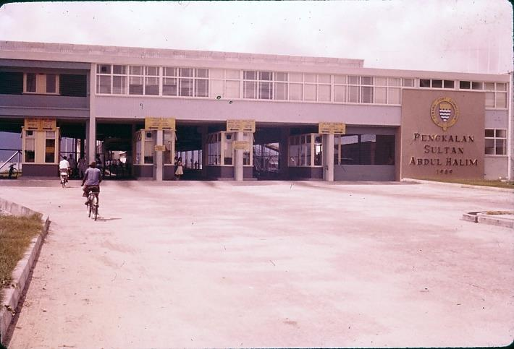  Butterworth Terminus for the Penang Ferry | 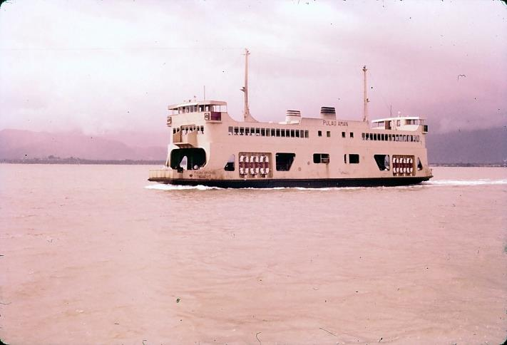  Passing an incoming ferry while enroute to Georgetown
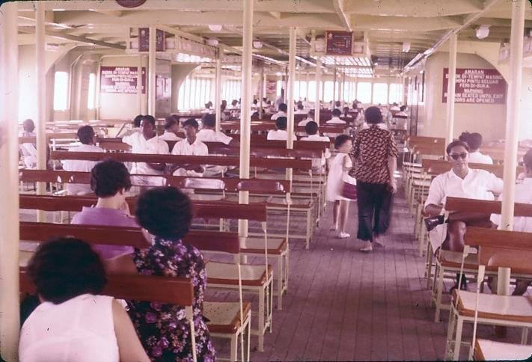  Passenger deck upstairs | 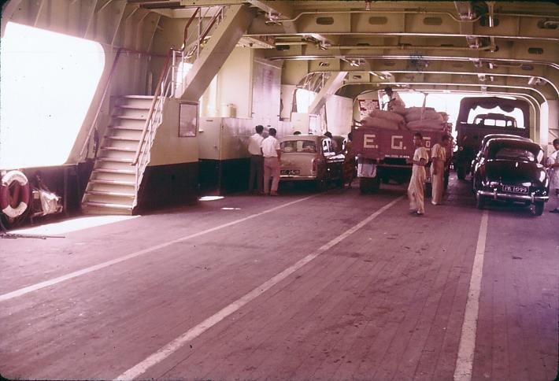  Vehicle deck downstairs

DAY 68: Sunday 13 November
Today is Sunday and wet. I awoke at 0800hrs, and at breakfast 0830 read the papers to see if any church services were on, but were all Anglican, and they only have them at 0800hrs for communion, children service at 1000hrs and Evensong on Friday night. The St Andrews Presbyterian Church was holding a Remembrance Day Service (the Parade was this morning) at 0930hrs and of course I was too late for that.

Laurie Wright had a misfortune with his car. Two motor cyclists were floating around him and he moved left to let one pass and he hit the second one or it hit him on the side of his car, and two Chinese, a girl and a boy, were knocked off and cut. The Police impounded both Laurie’s car and the motorcycle, and carried out questioning of all parties.

A European once was passing through a village and knocked over and killed a young boy. He stopped, got out, and a crowd immediately gathered and chased him down the street. He had to take refuge in a shop, and half the village gathered around and were going to do him harm until he was rescued.

The story is that if you hit anyone then you drive off to a police station or wait (shut securely in your car) until the police arrive.

After lunch, reading and generally resting. Then a cracker sunset with storm clouds up north behind the Mess, and I wrote a letter to Lexie Yarrall to tell her I would be in the UK next year and would look her up.

DAY 69: Monday 14 November
It was some time before I was able to get into see the OC on this brilliant sunny morning and he said he would like me and Ken to act as a recce group for the Squadron, first task being to recce suitable bridges for practice demolition, two of four types, and give DS solutions. Next he was arranging with 110 Squadron to chopper us into Temengor to do an airfield recce.

We ordered equipment, collected maps (Ken did the admin) and then set out on a planned route to do recces south of Butterworth. After a puncture we had a very interesting trip. Back at night and went through my slides, and then showed some to Ken and Tony. (Gerrard showed us his films last night – a movie, of all sorts of places where work had been done. It was very interesting, though I did hope that if I took any movie films they would be better exposed)

DAY 70: Tuesday 15 November
Today Ken, driver Marshall and I set off in cracker weather at 0845hrs and recced Merdeka Bridge, which took us till nearly 1115hrs. We saw noggies (local labourers) in 5 feet of water scraping sand off the river bottom by submerging themselves and then loading it into a boat, and dumping it on shore. Phew! Ken remarked on how people back home would comment.

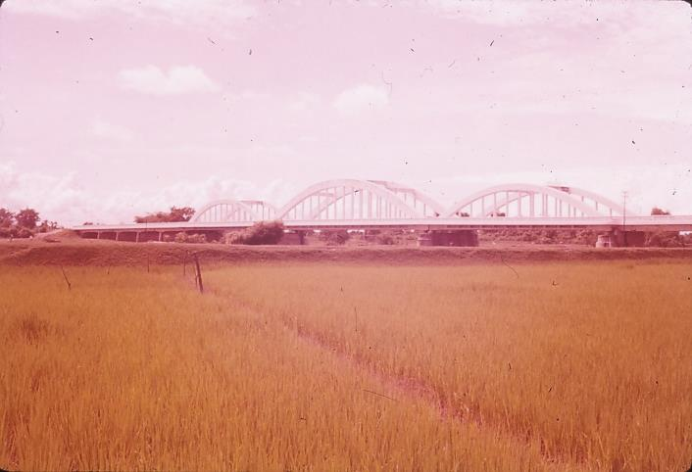  Merdeka Bridge | 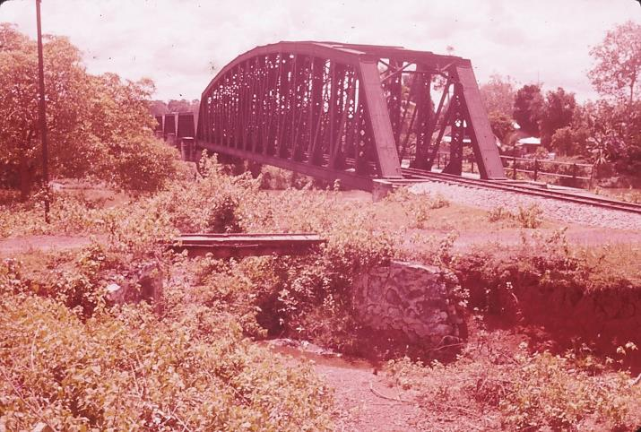  S. Muda Rail bridge at Pinang Tunggal

We went via a plantation to the 680 foot Rail Bridge on the river Muda and recced that before lunch. Then to Sungai Patani and then Sungai Sedim after Batu Pekaka Bridge on the Sungai Muda and had a coke at stall and shop by sawmill. Next we went to the Ketil Rubber Estate which was huge.

We saw much of the insides of rubber estates today, young, old, dirty, clean rubber. Thousands of acres of it. A great look at the country. Then in pouring rain, Jeniang and home wet.

I rushed into Penang to buy camera and camera gear, but only on the ferry did I realise that the Kodak shop shut at 1800hrs and I wanted slides to compare lens. So I did not buy the camera, just film for Ken, and came home and read a book and bed.

The people one sees in the ferry are very interesting, the whole range of ethnic types of which the country is made up. Some of the Malay families are very attractive people.

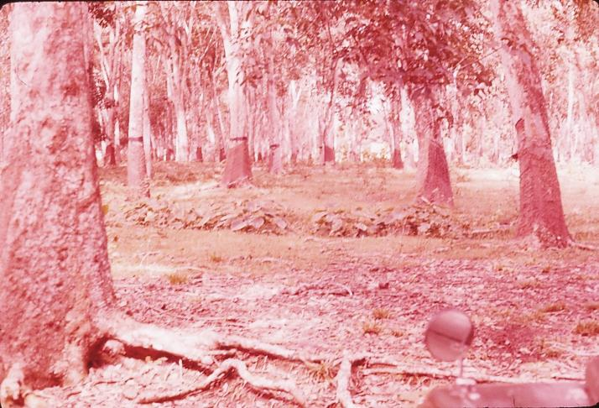  Old rubber tree plantation | 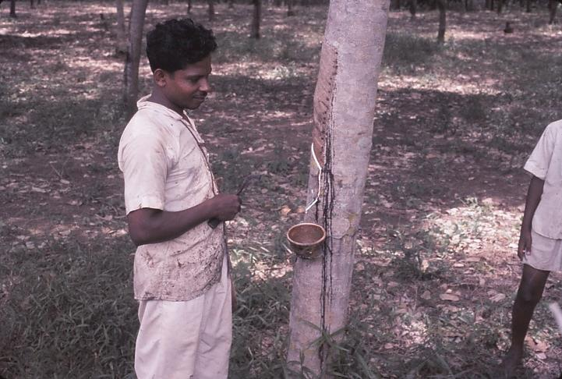  Tapping a young rubber tree

DAY 71: Wednesday 16 November
After spending the whole day writing recce reports we had headaches. Lumut, the NZ rest camp, is a very likely trip with Geoff Woolett, which I hope we get to. No further mention of the airfield recce.

Ken and I beetled into town, called at Redi and at Kodak and tried a Penang Special Knickerbocker. Then I ordered a suit, and bought a movie camera, gadget bag and tripod off the Black and White photographic shop. This involved some ¾ hour of discussion and very friendly chit chat and back talk, and Ken growling at me for being too easy on them – but I reckon I was not. Then we had an orange drink and after being offered cigarettes rushed to the ferry by running all the way. We had a terrific time with the customs for 20 minutes, explaining that I wanted a deposit slip for the customs duty so I could get a refund on the camera gear when I left the country. We had a great carry on, quite funny and very friendly, and finally he would not accept my $50 bill and asked for another one and we joked about all my bills and eventually we got home. What an evening. Then I spent till 0100hrs reading up about the movie camera.

DAY 72: Thursday 17 November
Today was another day spent profitably on recce reports, and this involved completing the drawings and descriptions of bridges including a schedule of all bridges we recce’d. Determining the method of demolition was most instructive to Ken, who learnt a lot. (As I write now – Sunday evening – I can hear drums in the Buddhist temple in the RE grounds beating just like the drums beating at the reclining Buddha we saw today). After work about 1700hrs I rang up Rev Lester Phankuck and he was delighted to hear a NZ accent again, and said he would pick me up on his way to Butterworth to do some shopping. While waiting on him I remembered the name of the hats that the Malay wears to show he is a member of the Muslim faith. Rather, we should say that the Songkok is characteristic of the Muslims. The Malay soldiers wear them and they are a deep reflective blue and very attractive. The Malay soldiers are very well turned out.

Mr Phankuck, or Lester, and I had a great chat about people we knew back home, Murray Pickering, John Croucher, the McIntoshes (I know only the girls). He was out here 18 months as SU representative, and at the end of that time did not find that it had the pastoral work that he felt he was suited to. It was a long time before he felt he was getting anywhere amongst the Chinese people. They will listen with rapt attention which one thinks is just great, but that is just their politeness – they could be miles away, never letting anything sink in. SU notes [printed in Mandarin (the principal Chinese language) in Hong Kong] were never very successful because people would take them, but subscriptions never seemed to get paid, and these could not be carried over indefinitely. Lester indicated there is a great opportunity for SU in the land, and for evangelism, but it is very tough work.

Later he was invited to Join CMS and act as Curate in Youth Work in the Singapore Cathedral which he did for the remainder of his 3 year period, and after holidaying (or taking furlough) in NZ he was asked to teach at St Marks Butterworth and is now Chaplain in their English School for local children. He does not speak Malay, and found this current teaching position suitable. I think he may have been asked to go to Butterworth from Singapore.

He found the church school quite High Church, and the attitude apparently prevailed that the school thought it was doing its duty if it taught just a secular curriculum to the young – no evangelism was carried out. Religious teaching was not to be carried out during school teaching hours, but only after school in voluntary groups.

The attitude of the Tamil 4th and 5th generation Christians is that they are proud of their Anglican heritage and feel they are a little more privileged than others. The Malay and Chinese outsiders view all Europeans as Christians, and evangelicalism (if we can relegate the evangelical message to another “ism”) is something different. Many are intellectually swayed by the gospel, but few swayed by the spirit.

Mr Phankuck is chaplain to the school and has opportunity to speak to groups and help with camps and other group activities. One is coming up at Port Dickson soon. Films and film strips on straight Bible teaching are very popular with children. Even Muslim kiddies go. Hours at school make it difficult to work in voluntary groups. There are two daily sessions in school, one from 8:30am to 1:30pm when the children come early after only coffee at home, and have a break at 11am for a meal (the school has a cafeteria). At 1pm or so the afternoon school arrives and starts at 1:30pm with new classes and teachers and goes on to 5:30pm. The SU meeting is held for afternoon school folk early, before morning school is out, and after 1:30pm the morning school members will come. This is very hard for them because the others rush off home to an afternoon meal and any SU-ers must go hungry.

Bible is taught in school as a School Certificate subject and the Muslims will even sit it and get good marks.

The poor people in the Kampongs will sacrifice anything to get their children educated. Education is the big thing, and the Chinese especially will go hungry if poor in order to send their sons to school. The Government trains the teachers for the schools and the pupils still pay fees. The afternoon school is private and fees of pupils pay teachers’ salaries. Government aid is being given to schools to supplement their building programs.

When Mr Phankuck drove me back, we passed a Chinese Opera show. Fantastic costumes and scenery in brilliant stage lighting looked most attractive. These shows are done unrehearsed; made up as they go along, and are quite a spectacle.

Mr Phancuck commented that to the Malays their Muslim faith is a matter of National principle, and one cannot be Malay and not be a Muslim. Where they appear casual or nominal in their affiliations, national and spiritual principles are stirred if their faith is challenged by, for example, one of their number turning to Christianity.

DAY 73: Friday 18 November
In slight rain we travelled south to Lumut, then into the coast at Senangiri to visit the NZ Regiment Rest Camp. Lt Geoff Woolett was proceeding there to inspect road construction plant. The journey was on the road passing west of Taiping nearest the coast, and rubber trees were seen growing in peat bog type dry swamp. One rubber plantation that went for a mile or so was a complete shambles, with trees blown down in all directions. Another rubber plantation about 4 years old had banana trees planted in alternate rows. This was the only rubber plantation I had seen with another crop planted in between.

The turnoff to Senangiri was about 10 miles south of Pantai Remis. The road into the camp was a forestry track which had been enlarged by the Japanese during the war to lead to an execution ground. We passed the large open area in the forest which was partly swamp where the Japanese were alleged to have carried out their executions.

Little children sang out to us as they recognised an army vehicle. As we approached the coast ½ way along the 4 mile road we saw at regular intervals forestry tracks leading at right angles to the road. Every tree is numbered and checked by the Forestry to stop unlawful cutting. As they grow and mature they are cut. Forestry Officials have allowed the Army 20 feet either side of the centreline of the road.

Generally the road is built through a sandy silt. Rain liquefies this in puddles and the road actually looks worse than it is because of the depth of the puddles. Four wheel drive vehicles churn down to solid going and can push the mud aside. However the churning wheels deepen the ruts and eventually small wheeled vehicles belly.

A D7 and Fowler plus a 99H were working on the bottom section of the road from the Rest Camp. This equipment was offloaded onto the beach from an LCT. The jungle was pushed back (all but the large trees – there would be trouble if a tree was knocked over without permission from the Forestry Officer) and the mud cleared and watertable cut.

Prior to 11 Squadron being asked to work on the road (which was really to oblige 2 NZ Regiment, and keep construction plant occupied) a Pool D7 operated by a Maori operator cleared the road when necessary, but only succeeded in cutting the road deeper and allowing rain to lie longer.

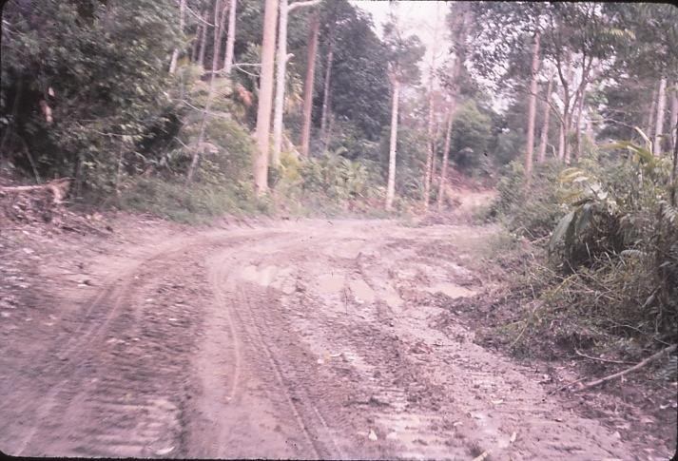  Jungle cleared for road | 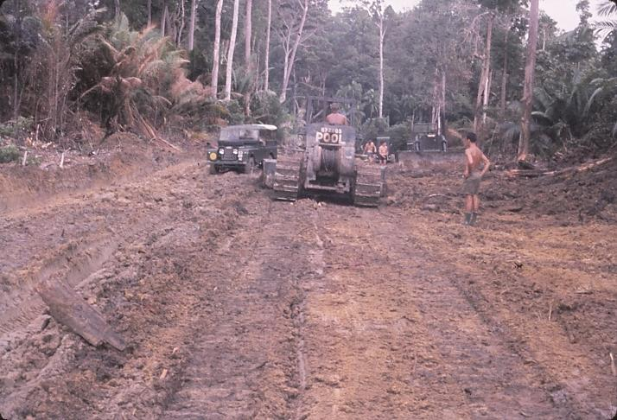  DZ bulldozer working on road base
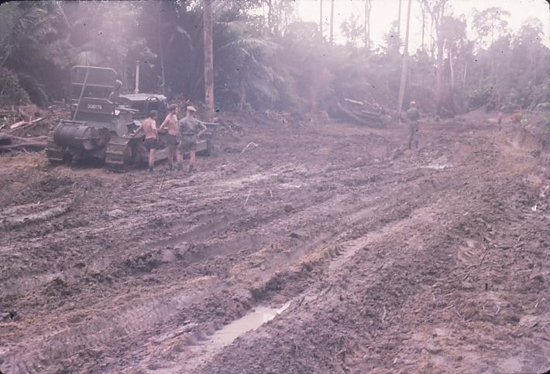  Widening the existing road track | 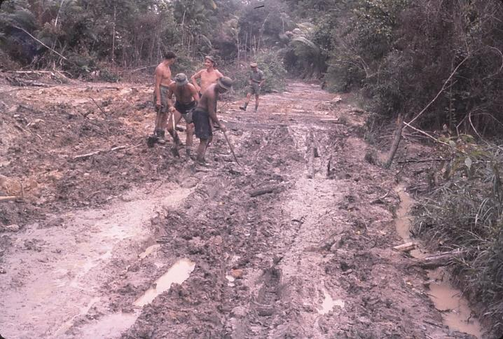  Placing corduroy^{(footnote 59)} over a boggy section

Jungle has to be cut from overhead. Filling can only be done when the ground is dry, which is not very often. Laterite is to be used as fill. Corduroy has been or is being laid in one really bad spot, and will be covered with laterite fill. Old Japanese corduroy is being unearthed by the plant.

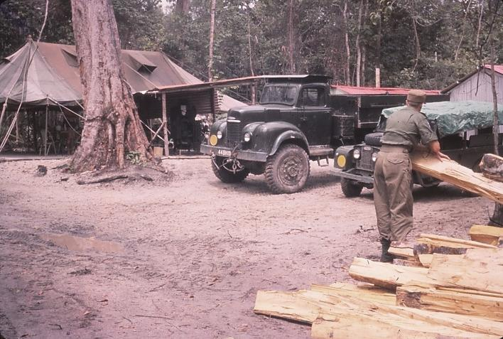  Rest camp construction depot | 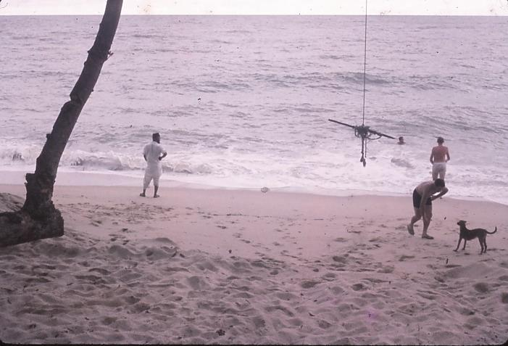  Rest camp beach

1415hrs saw us burling home, and it was a very interesting trip with a stop for coffee at a Chinese Restaurant in Trong. This coffee stuff I had experienced before, so I ordered a coke and enjoyed it while watching the others drink the thick, slopped in saucers, muddy coffee out of chipped cups. It tastes bitter and gritty. Ken and the driver left half of theirs. Then home to Butterworth.

Ken and I caught the ferry smartly, and buzzed into Penang and the Esplanade to see the Gurkha Band Parade. A drill squad put on a high precision display of first class brilliance. I have never seen the likes of it, with FNs and Kikri drill. Every man moved as one, even to nodding heads and bending at knees on the order “Inspect Kukris”.

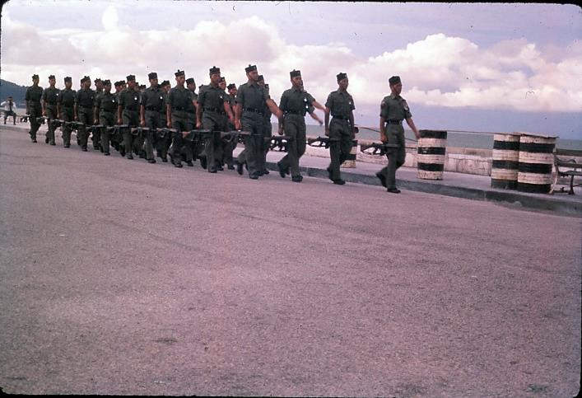  Gurkha drill squad | 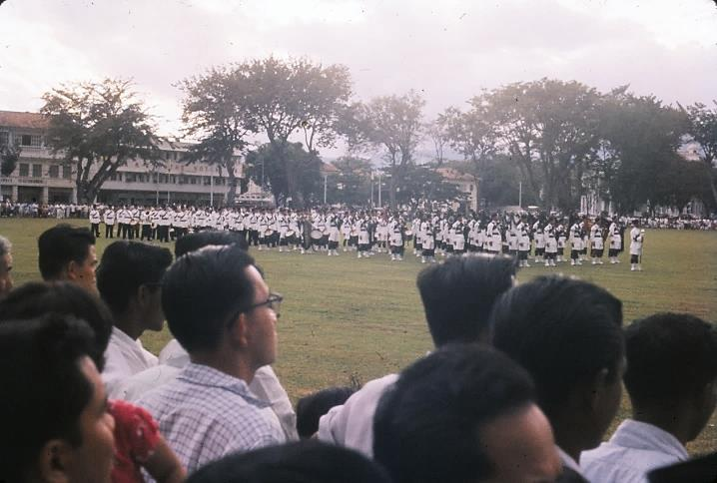  Gurkha Band Parade finale – combined Pipe and Brass Bands

Then the Brass Band preceded a marching and playing display by the Pipe Band, with a finale of both bands completely integrated line by line combining in music and step parading off the grounds. It was really a first rate performance.

DAY 74: Saturday 19 November
Ken had a yarn to the chaps last night, and they told him how one time after some of the boys came out off the Kedah Road job for a few days leave they went over to Penang and got a little rotten. On the way back on the ferry late that night they were causing quite a row on the passenger deck, and the Captain came down from the wheelhouse and told them to please refrain. So they grabbed the Captain and tied him up to one of the struts on the boat, and invaded the wheelhouse. They took over the steering, came across the harbour, beached the boat between the Terminal and the RE camp, then jumped off the boat and in the ensuing consternation betwixt crew and passengers made good their escape. The culprits were apparently never officially identified. How much truth is in the story I do not know. However, there it stands.

Demolition recce reports were completed to date and about 1100hrs we beetled into Penang deciding to shop. And we really went to town. After hiring a rental car we dined with me looking at slides over steak and eggs and a Penang Special (ice cream dessert). I then decided to purchase all my photographic gear. So, into the car and we called at Garrison NAAFI shop and bought gifts for home, then to the toy shop in Bishop Street and $22 on a model airplane. Next to Chulia Street and bought a movie viewer editor plus splicer and I said I would take the projector. We then rushed back to Mess for Ken to get tea. I changed and took the car back to Penang, collected the projector, and returned back to Mess for dinner. Phew! A rush today.

The car, a 1954 Consul two tone white and green, made an exhaust sound like a sports car and was very peppy for a Consul – quite a neat bus to buy. After dinner Ken and I buzzed up the road to have a look at the Opera, but it had gone.

DAY 75: Sunday 20 November
At 0950hrs we rushed to the ferry in the car, registering our cameras, and just making the 0910 ferry. It berthed at 0925 and we hot-tyred it through town, navigating furiously to reach St Andrews Presbyterian Church in Codrington at 0932hrs just as the first hymn was in progress. The church was a new building and very dignified, the structure a credit to the Church with an adjoining hall built with stone. Quite an outstanding building.

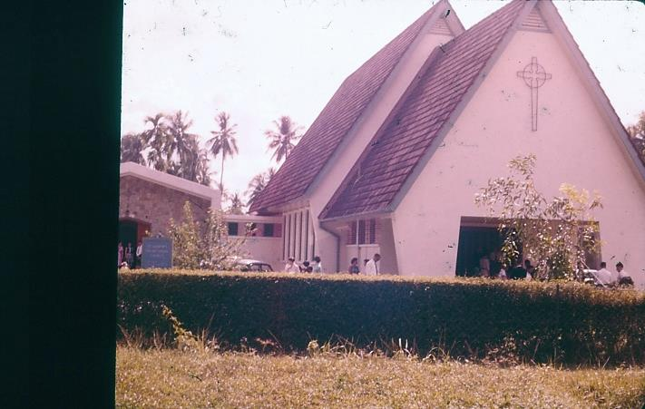  St Andrews Presbyterian Church, Penang | 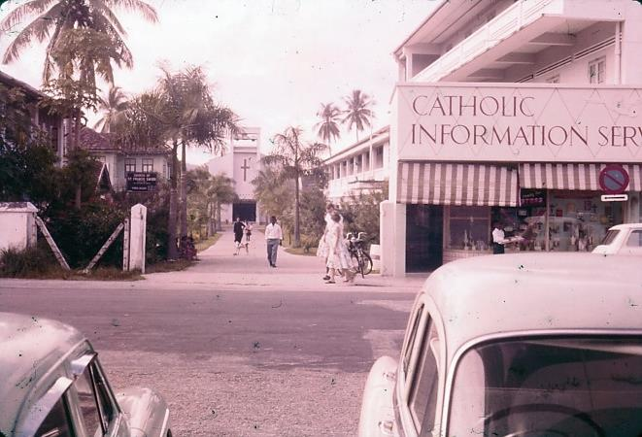  Penang Catholic Centre and Church

Rev McDonald the minister spoke on doubting Thomas, after hymns which stirred us to faith. He began by saying how easy it is for people to think they lower their principles by associating with those of lower standards, and of how people identify others by the company they keep. Christ was accused by the Pharisees for associating with publicans and sinners.

However, Christ understood these people and knew he could help them in their need, but the Pharisees did not realise their need. What sort of faith was it that really held on and then where is the place for doubt? Doubt is not disbelief. Thomas doubted but did not disbelieve. There is nothing wrong with doubting. A Bishop in Sydney, well known for his sermons, was once preaching on a certain subject and at the end he knew he had not “got his message across”. Afterward he said this was one subject on which he had never had a doubt.

Often people can know all the answers about their faith, but when really challenged they may collapse, because they have not passed trials of faith in overcoming their doubts. Thomas doubted – was he wrong? No. But where he perhaps was wrong was in taking off alone to keep his thoughts of the events to himself – thus he missed Christ’s return. We cannot survive as lone Christians. Thus faith is stronger for having doubted, and then investigated until the truth is reached. Those who think they know everything often fall because of confusion arising as they cannot distinguish doubt from disbelief. May we be stronger in faith through the resolving of our doubts. An excellent sermon, and made me feel good.

We took photos of the church afterwards – many of the congregation I had seen around town and at the Cold Storage Depot. Chauffer driven cars were waiting on members of the congregation and their children. There were a couple of Chinese families there I think. Obviously it was a very wealthy church. The area the church was in was full of fabulous mansions. Many new and of striking design and wealth, many older, but retaining a dignified luxury carried over from the colonial days. Huge grounds with gardens and driveways and the house set off the road in an 1 acre section.

Afterwards we took a look at the “Third Largest Reclining Buddha in the World”. We saw how well this massive concrete structure was finished. Saw the holes for ashes below (has only been about a year in the making).

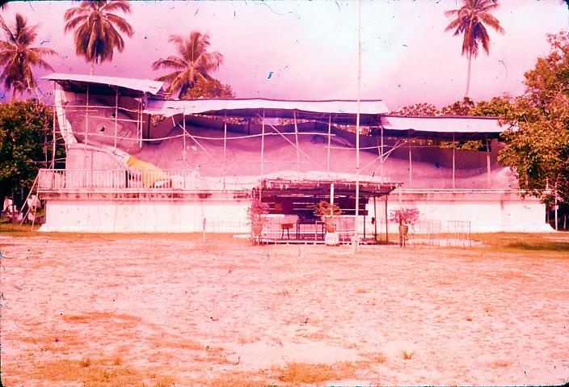  Third Largest Reclining Buddha in the World | 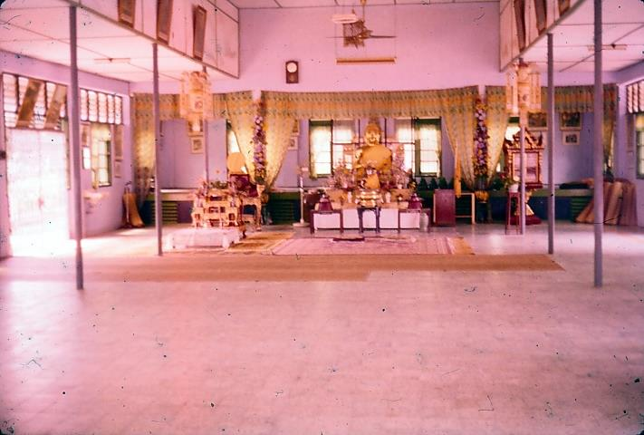  Meeting Hall at Reclining Buddha

Down past the Residency was the huge General Hospital and then Ayer Itam Road and well past the massage parlour we met a din of gongs and drums that heralded a Chinese funeral. It was a brilliant procession 200yds long, with women (old) in blue followed by six sedan chairs fashioned like tall wedding cakes with trimmings. Then the wooden coffin with a curved lid carried by stalwart guys and the hearse further back carrying wreaths. When they reached the Chang Sew Massage Parlour they began beating their drums with increasing tempo to a raucous crescendo which heralded a fast forward rush with the coffin apparently to ward off the evil spirits.

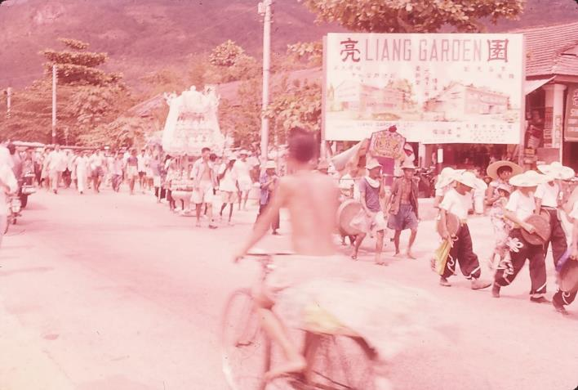  Chinese funeral procession | 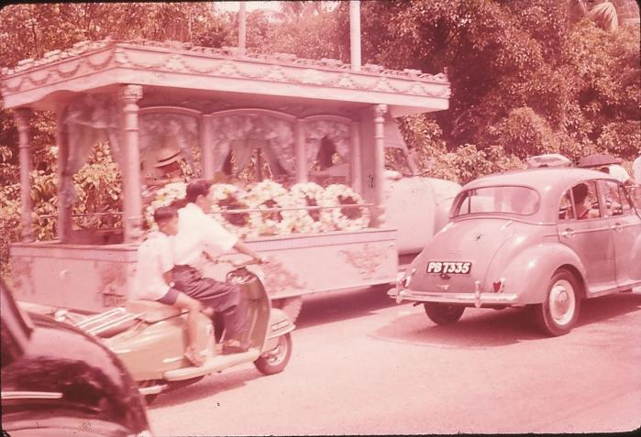  Funeral hearse and wreaths

Ken and I then went up on the Penang Hill railway just as cloud descended over the hill, and rain began to fall. Though dull, the view was very good, and the railway itself left quite an impression with me. Quite an engineering feat – masonry arches over the valleys and cuts through solid rock. Gradient was 1 in 1.93 and it rose about 2,000 feet in two sections, changing cars at the School Station.

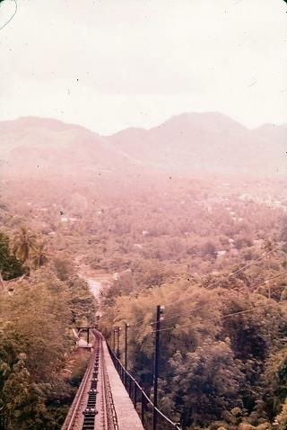  Penang Hill Inclined Railway | 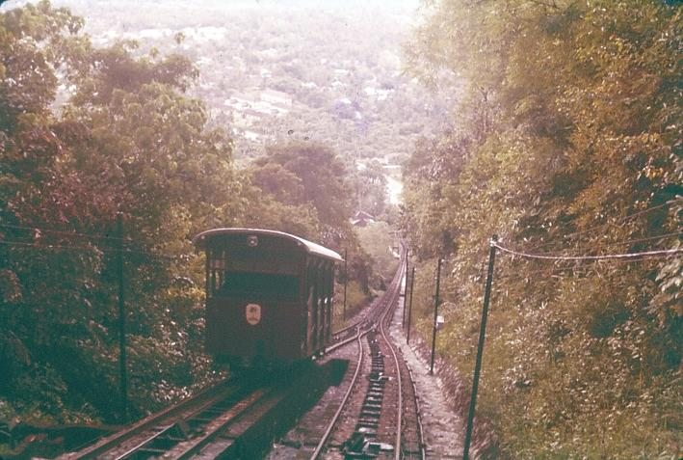  Passing loop on the Inclined Railway
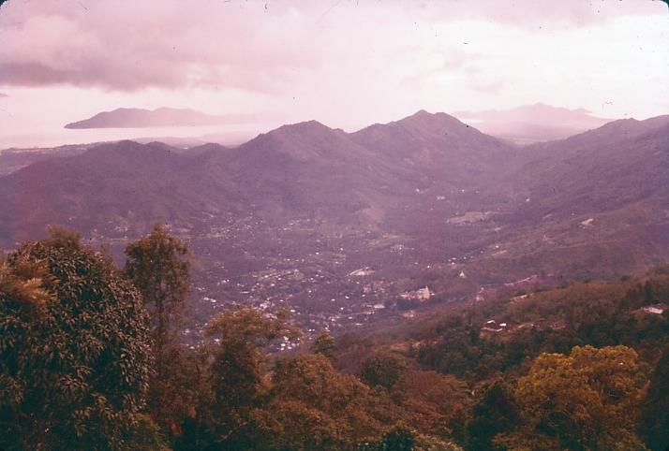  Ayer Itam Temple from the Railway Summit | 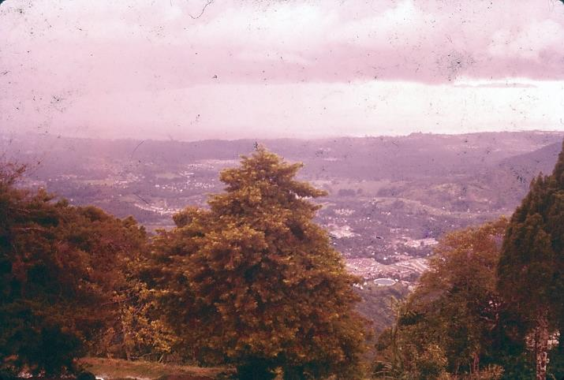  Georgetown and the Ayer Itam reservoir from the Summit

In our cabin were two English couples, both off a Swedish liner which had called at Penang for the day. The older gentleman asked if we were from Australia, and we got chatting. He was going to an Army job at Gillman Barracks, Singapore – a Senior Staff job. The other younger man and his wife, both very attractive people about 2 to 3 years older than me, were going to Works Services, Malacca. He was a quantity surveyor, and had become a civilian from the Army to remain in Works Services which is now being civilianised. They gave a lot of the army chaps – professional men – chances to keep their jobs in Works Services, and many took the opportunity and merely changed their uniforms for civvy clothes and carried on with the job. This has worked OK as it has done away with a lot of administration worries, and streamlined the system.

We reached the top of the Railway and ran to the Tea Kiosk in the rain. The English folk eventually arrived too, by which time we had consumed some coke and very nice Chinese cakes (the local baking here is really of a very high standard). The bakers’ artistry is very good and the dainties look most attractive. We saw the English young couple move out from the rowdy kiosk and its crowds and we went with them to stand under the eaves and chat. We found out they did not like the smell (the Malay taste) – they could not stand it. It was the cooking with garlic that I think was the trouble but Ken and I never noticed it. I guess we have got well used to it now.

Ken and I bumped into Brian and Trevor up for the weekend again, and we chatted with them and took photos, and then down in the rail car with me attempting a movie of a time compressed ride on the railway, which if it comes out OK should be quite amusing. Ken and I rushed off to the Ayer Itam Temple in a lightning visit to take photographs only. A quick long stride walk only – snap – snap – then whish, off to try and photo the Ayer Itam reservoir but road closed, so as rain set in we set off around the island.

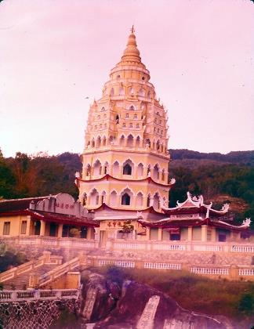  Ayer Itam Temple | 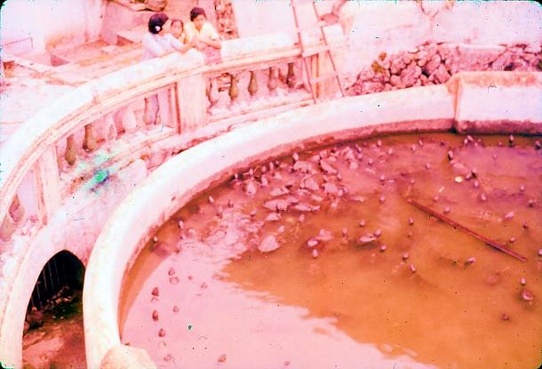  Ayer Itam Temple Turtle Pond

The coast road was delightful. It reminded me of Sunday afternoon drives around the Wellington bays. This was different and first class. New housing in strikingly modern Malayan architectural style was in abundance during the first five miles. At 9½ miles we called at the Lone Pine Hotel and bought some water colours of Malaya. These were very nice and very tempting and quite expensive ($15 each). Pressing on and at reasonable speed up winding road through rubber – the curving road provided most interesting driving.

We had to hurry with a stop for photos and then back to Georgetown at 50 mph. The island was similar to rest of the Federation, rubber, rice, coconut, but perhaps neater. Into Georgetown and handed the car back at 5pm, then the Cold Storage Depot, the Ferry and that trip over water that is even more interesting every time one crosses – Japanese, Russian, Norwegian, Swedish (and many other nationalities) ships plus old junks clutter the water night and day with lighters to and fro loading and unloading ships moored in the “Roads”.

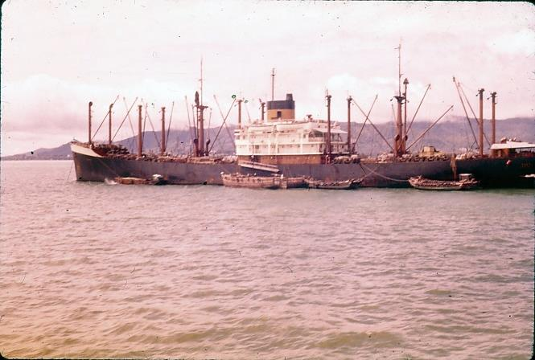 | 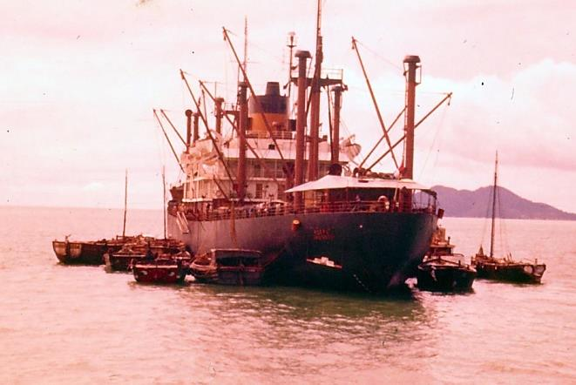
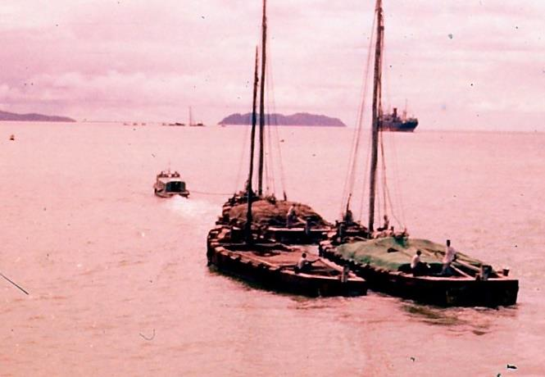  Lighters being towed to a ship moored in the Roads | 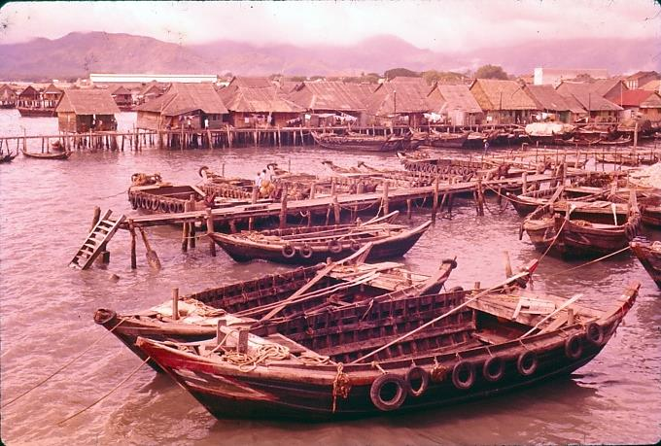  Lighters moored at foreshore
DAY 76: Monday 21 November
By 0915hrs a Land Rover was put in order after what appeared to be sabotage of the windscreen wiper, and off we went through to Kedah and masonry arch bridges both rail and road – then to Alor Star and bridge demolition inspection – a relic from the war plus a new bridge – then lunch at Jitra and a smooth trip back home, with snaps of wallowing water buffalo and roadside people on the way.

A quick trip into Penang by taxi, ferry and trishaw, and I tried on my suit and my shorts for fit. They were OK – very good in fact.

DAY 77: Tuesday 22 November
Today Ken celebrated his 28th Birthday. We spent it drawing diagrams and doing calculations on demolition recces with the cheering prospect of Thursday being the day on which we would get choppered into Grik.

After work I met Mr Phankuck and we went to Kingsley and Heather Calderbanks in Georgetown where we had an excellent meal with this jolly couple, an Aussie with an English wife with her accent still noticeable. Mr Phankuck and this couple were great company, full of fun, and we thoroughly enjoyed scrabble and a cosy chat till late. Mr Phancuck knows Chris Currie very well. Lester and I chatted again about all sorts of things. He noted that the Eurasians keep pretty much to themselves.

DAY 78: Wednesday 23 November
Today we very nearly completed the Demolition Recce Report. Only need to check mistakes and clean up gear and equipment.

Victors from the RAAF and white H bombers were screaming over and around us for some time today. What a noise they make.

A boil type thing that turned from a pimple to a tropical ulcer has developed on my left knee, and I have to wear a bandage now.

The chopper flight is on for Friday for one. Ken will miss out now, which is a dashed nuisance. I went to the island tonight and saw Mr Pallot the State Engineer PWD for Province Wellesley, or Penang as everyone seems to call it. He would be equivalent to our DCW at home, and very obligingly explained that if I wanted to see waterworks on the island the City Council administered the main ones.

Mr Pallot’s job was secure till 1965 when Malayanisation should be complete. Most engineers had been asked to stay till then, but many of course made arrangements to suit their family schooling. The waterworks section was concerned a lot with rural development, and supplying water to the towns and community areas. One thing I noticed about some of the areas we passed through were fire hydrants every so often, apparently way out in the country, but actually the roads are lined with houses all the way, hence the need for a water supply network. The fire brigades have apparently a fairly easy time in this country owing to the humid atmosphere.

DAY 79: Thursday 24 November
It was 1000hrs before I got back from seeing the MO at RAAF about my knee, and getting antibiotics prescribed for 4 days plus an OK for the chopper trip (if I did not do too much walking). Well I then realised it was my birthday, but it never sank in much. I handed the OC the report on the Bridge Recces, and he later gave me the info he wanted me to pass on to Ray Johnson at the engineer unit at Grik. The remainder of the day I just rested, with writing and reading to spend the time. Then a quiet evening after dinner reading a very good Readers Digest condensed book “The Searchers”.

DAY 80: Friday 25 November
Ken came with me to 110 Squadron as I checked if only one of us was able to get in to Grik via helicopter. Squadron Leader Simons greeted me from the pilots’ room and said “yes” only one, so Ken had to go back. A pleasant chat, and then we hopped into a Land Rover – two crews and two passengers, and headed for a pair of choppers. This was after having coffee and waiting for a weather clearance at Grik. Saw a Victor make tracks to take off directly in front of us. Then into the choppers we climbed. Passengers, crew members (helmets and all), survival kits, and of course pilots.

Start engine after cockpit check – spin blades; rev up to 280 RPM (blades or rotor speed) ease down and then boost again and lift slow, hover, then up rapidly and away rising toward the sun, sweeping up and over the paddy, with No. 2 chopper to left and above us like a watchful terrier to heel. This was exhilarating – boy did I wish I was a pilot.

Then 7, 8, 9 minutes pass – rapid conversation (throat microphones) between crew – a pointing at fuel pressure, and then a sudden right turn and we scooted back to Butterworth and landed. Well that was an enjoyable trip, nice and short. Trouble was the fuel pressure was around 40lb instead of being 27lb so no risks and back we went.

While crew paid a visit to the office, I talked to fitter on the chopper we transferred our gear to. He told me quite a few things in a most cooperative manner. He does quite a bit of flying when flight checks are made, as the pilots report on perhaps vibration etc. Adjustments are made to the planes on the blades. 1/1000th inch alteration with a special measuring instrument and tool will raise the blade when rotating ¼ of an inch. This is the minimum adjustment, and can be done quite accurately. Then each blade has to follow the same path, and a ¼ inch difference is the permissible error. Any greater and the adjustment has to be continued. The rotor tips are marked with red, blue and yellow chinagraph and spun against a canvas with sticking plaster backing and the marks observed.

Each blade is hand made in timber, the best the world can provide (hickory I think) and all three are made as a set – £6000 for the set – if one becomes damaged, the lot are renewed. Pre-flight and after-flight checks of the rotors for swelling, cracks and wear are made by the fitter and by the pilot. Another test is a spring balance test against the ascend-descend lever, a very important control.

If a chopper is doing 90mph into a 30mph wind, the tips of the blades may break the sound barrier which is not a good thing as they will break up. Cruising speed is generally 60mph (air speed). Gas usage is ½ gallon a minute, or 2 miles to the gallon. Tank holds 62 gallons.

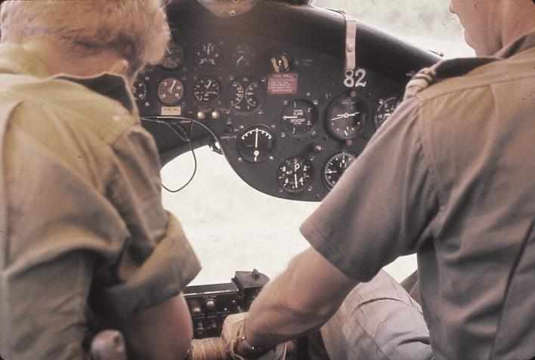  Pre take off check | 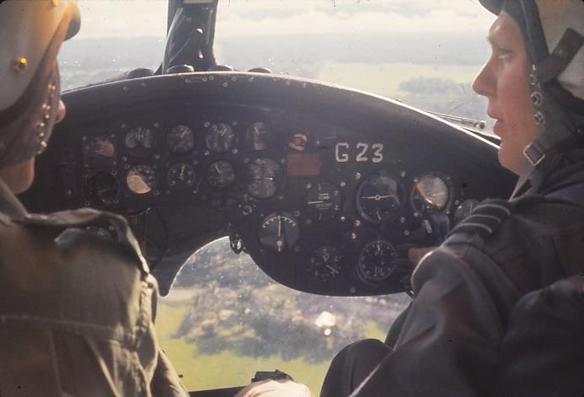  Under way at last

Crew arrives. All aboard and once more into the air. All OK this time. Across paddy and rubber crowning hillocks in ringlets or donuts in multiple shapes. Over the jungle – and a grim smile on my face as I saw massive tangles of bamboo, huge forest giants, light coloured trunks stretching far from the canopy to merge into foliage their own.

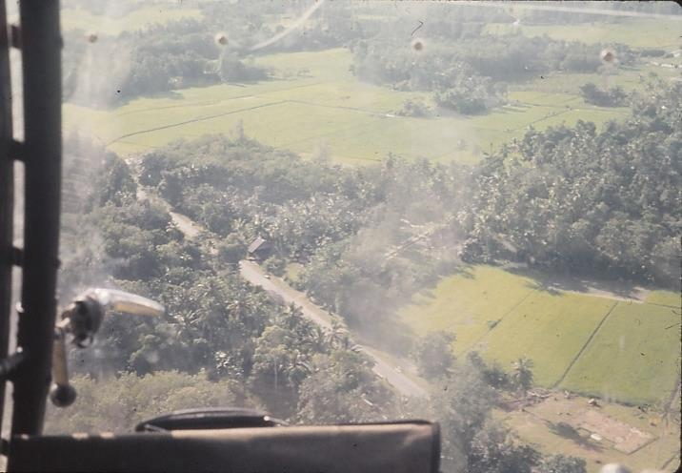  Rice paddy and coconut | 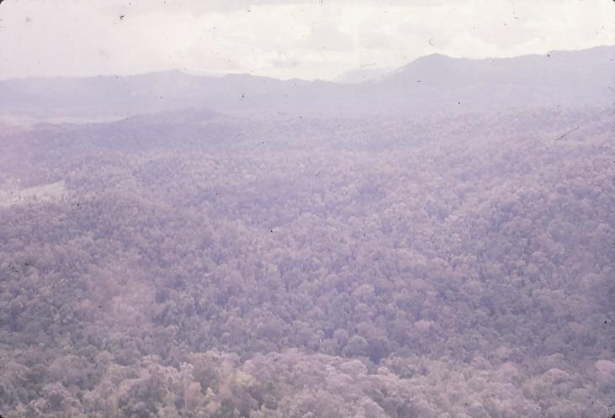  Above the jungle for a change

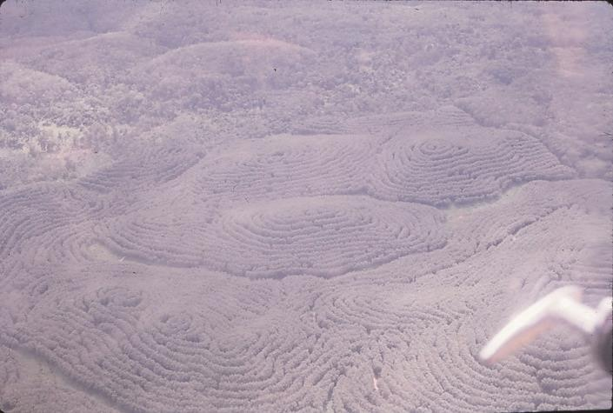  Contoured rubber plantings | 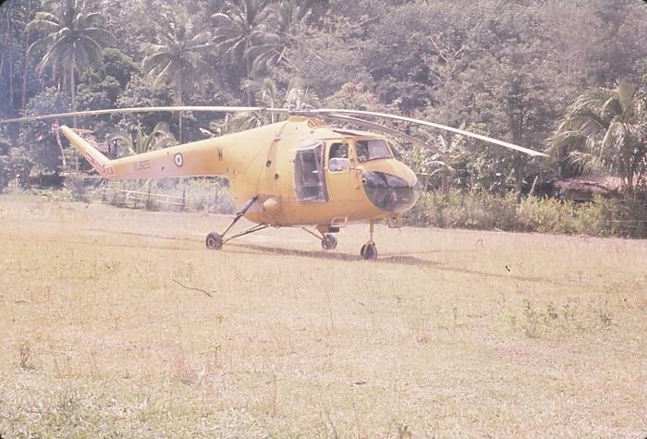  Landed at Krunei – “Hobart” base LZ

Then Krunei, or “Hobart” as the code name is. The choppers are to do a troop lift. Major Morrison of RAR lent me his Land Rover and I beetled into Rui and at the Kiwi camp was told the Aussie engineers were waiting at Grik. So then on into Grik and met Ray Johnson (1110hrs) and talked over the OC’s briefing points. Then at 1125hrs after a chat re past contact with Colonel Douglas and Merv Stewart from SME, I drove back to “Hobart” and filmed a few of the final troop lifts.

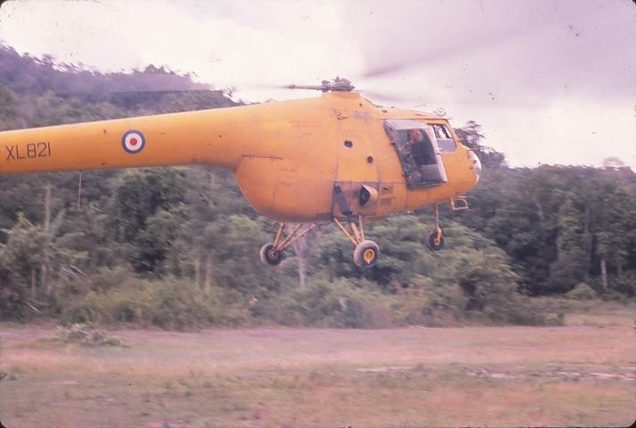  Incoming troop lift at “Hobart” | 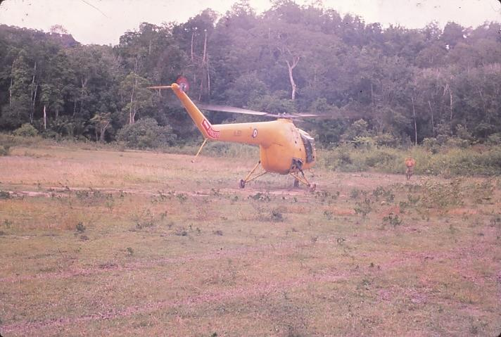  Touching down prior to disembarking troops

I saw the choppers land several times. Then lunch, and we saw clouds growing lower, and so off at the double, this time in No. 2 chopper. We edged alongside No.1 at 60 foot distance all the way to Butterworth on a most delightful journey through a little rain and beating cloud to the gap by about 5 to 10 minutes. This helicopter trip has been a highlight of this tour of duty – first rate – and I have been most fortunate to have experienced it.

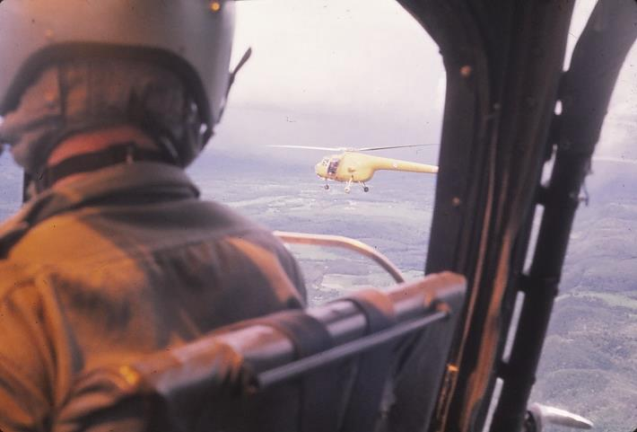  Returning from “Hobart” to Butterworth | 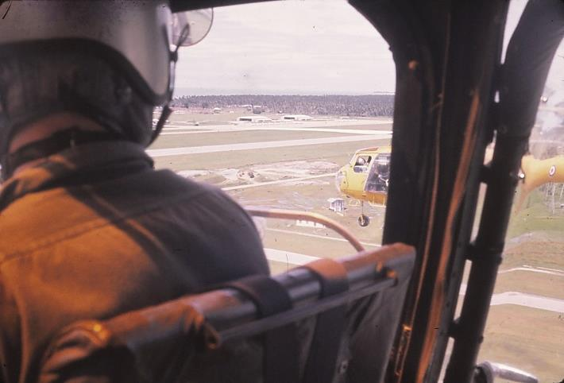  Coming in to land at Butterworth

DAY 81: Saturday 26 November
I had to collect my suit and also take some movie and still shots of the streets in Georgetown. This was speedily accomplished, with a final Penang Special at the Cold Storage Depot to speed me on my way by trishaw down past the Lila Store to a final ferry trip. On the way I passed the inevitable durian stall. Durian fruit has a most obnoxious smell on the outside, but the yellow pulp inside is apparently delicious – it was said to be like eating vanilla custard in a sewer. At the ferry terminal I caused the customs consternation by saying I had a suit (new), and they charged me 37 dollars duty on shorts and suit.

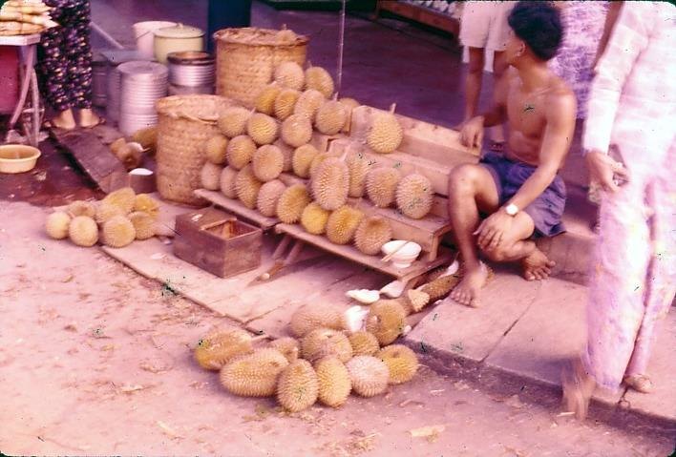  Durian seller off Penang Road | 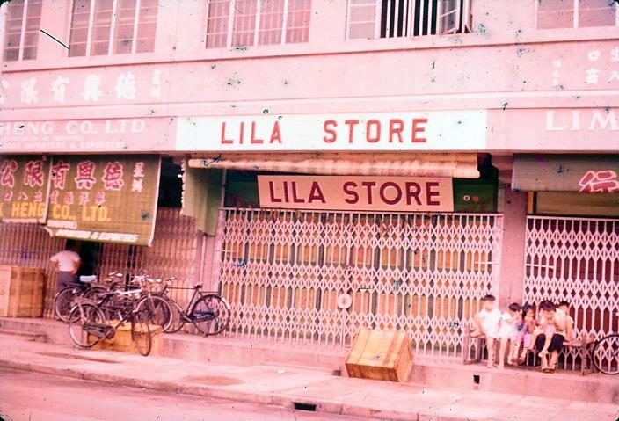  Lila Store as a reminder of home

The afternoon soon went as packing and sunbathing filled the time. After a final check with the MRS on my knee and collecting bandages etc I dressed and for ½ hour joined in with Gerrard and Laurie, Major O’Neill and David Cooper in Gerrard’s farewell party. He was to sail with Laurie to Hong Kong on the Nevasa. I met a few Gurkha officers and chatted about the Gurkha Sappers before moving off with Ken to the Prai Railway station by 3 tonner. As we travelled along the road the headlights picked up a naked man dressing at the side of the roadside canal. It appears the women and children wash during the day and the men at night.

After getting our luggage portered onto the train at 20 cents a bag we met with Chris Paske (one of the chopper pilots) in the dining car and talked about choppers, training of pilots and other aspects of flying.

PART 5: HOMEWARD BOUND via SINGAPORE
[DAYS 82 TO 85]

DAY 82: Sunday 27 November
At 0700hrs at Kuala Lumpur and we tucked into a $3 breakfast at the Station Hotel. A quick ½ hour taxi drive around KL showed us magnificent multi-storeyed business houses and banks set amidst the usual shops, though the city appeared to be zoned more effectively than others I had seen. Many of the houses belonging to diplomatic representatives were outwardly palatial and very tastefully set amidst gardens. Evidence of British influence was seen in several old English styles of buildings, in churches and administration buildings.

By train to Singapore showed the usual rubber plantations plus towns and rivers backed by jungle clad hills on which we saw, before Gemas, what looked like VHF relay stations on an upstanding ridge. After enquiring from the customs about return of duty we had paid on our purchases, Ken and I were taken by truck to Gillman Barracks and settled in for the evening.

The Engineer mess had a few more officers in it than last time I stayed, and all were very interested in my tour and the set-up of the TF back home. After dinner we tripped down town and ended up at the Lido theatre for the film “The Cossacks”. Who should be sitting in front of us at ½ time but Morris Kenny and Mel Jack. After the movie and in pouring rain they took us to Gillman Barracks in their rental car.

DAY 83: Monday 28 November
Force HQ Captain Colin Stanbridge was pleased to know our location as most of us had been lost at some stage of our attachments with all the chopping and changing around. After pay of $732 we buzzed down town and shopped cameras for Ken all morning. I also bought another camera – a Minolta.

When I met Rob Vickory (Royal Australian Engineers Lieutenant) after breakfast this morning he offered to arrange a trip around 10 Port Operating Squadron in the afternoon. After lunch with Rob and Ted Hunter, 10 Port’s Movement Officer (stores etc) we collected Ken and went down to 10 Port’s operating area. Here LCM, RSL and LCT craft were in use with an LCM Mark IV unloading their Squadron launch which could be used to ferry personnel. They used it to take us around Singapore Harbour, a magnificent site, the busiest port in the world, backed by a skyline of magnificent buildings, in many cases towering well into the sky.

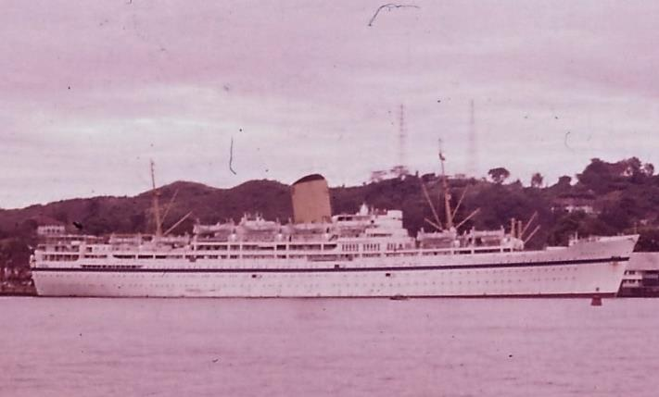  The Nevasa readying to sail to Hong Kong | 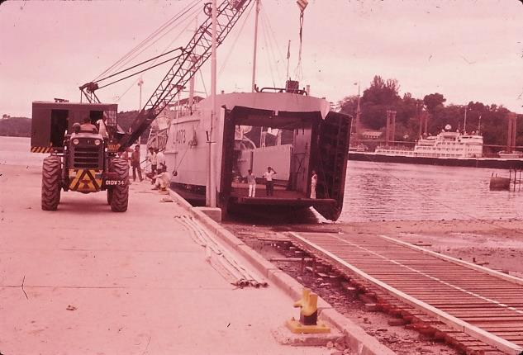  10 Port Operating – LCT Mark 8

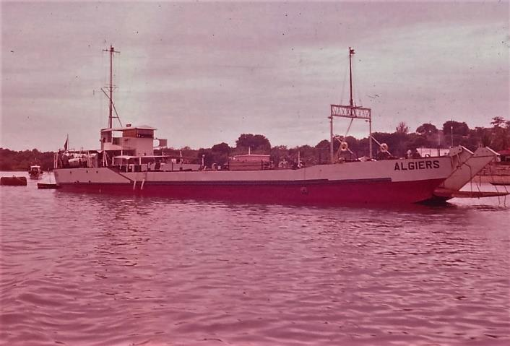  10 Port Operating – LCT Mark 4 | 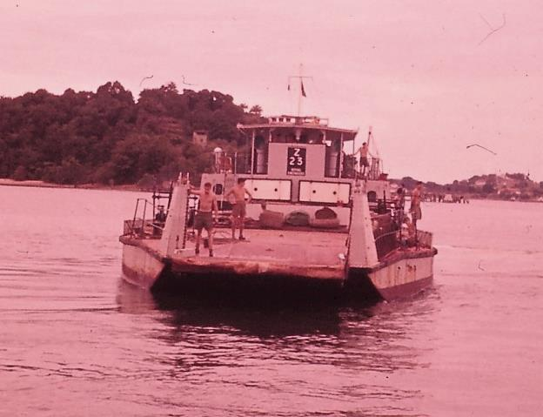  10 Port Operating – Z craft vehicle ferry

DAY 84: Tuesday 29 November
The Tiger Balm gardens we were not going to miss, but it was a pretty hectic 2 hours we spent when Allan McDonald ran us there in his Mini Minor hire car. We checked in with the MFO at Force HQ. At the Tiger Balm we took dozens of photographs of the hundred or so exhibits, and I wore out Ken and a Chinese guide who reeled off a great tale and made 8 dollars off us for showing us around.

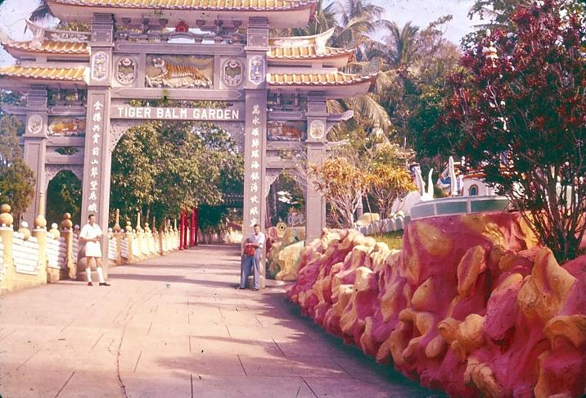  Tiger Balm Gardens – self on left with Ken on right | 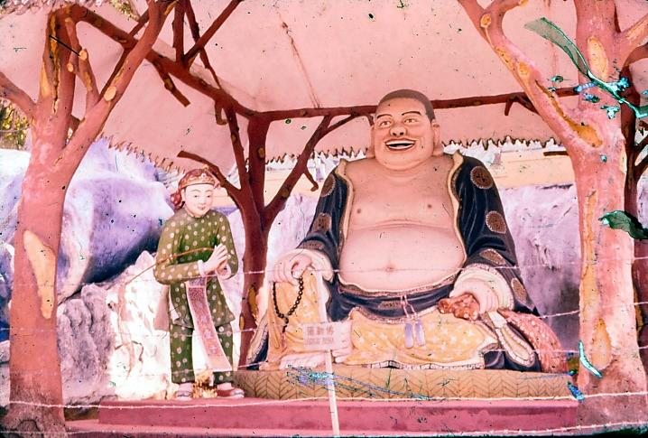  Laughing Buddha – the God Of Prosperity

Lunch at the Cold Storage Depot and while Ken went shopping I visited Mr Lye, Public Health Engineer, and spent the afternoon discussing with him Public Health Organisation. I met Mr Lau, Chief Sewerage Engineer under the Director Works, Ministry of Construction, and also the discussed the Public Health Inspector Training School attached to the University of Singapore. A report of my visit has been written for Mr Lough.

This evening we packed.

DAY 85: Wednesday 30 November
Reported to Force HQ and learned we were to be away to Changi at 1400hrs. So off we went and explored the Botanical Gardens, then taxied to Changi Alley and looked around. Ran across Corporal McDonald, the Aussie mess corporal from RE Butterworth.

And so, out to Changi, and the journey home began.

POSTSCRIPTS

- Travel Home
Our trip home was an uneventful journey via RNZAF Hastings to Darwin, Sydney and Auckland.

- Chin Peng – the last CT Leader
Our 25 day jungle patrol was part of a major exercise involving several units searching for Chin Peng (the long-time leader of the Malayan Communist Party and head of the Party’s guerrilla insurgency) and a small group of followers holed up on the Thailand/Malaya Border. Chin Peng was never found, was eventually pardoned by the Malaysian Government, and sought refuge in China in the 1980s. He subsequently lived in exile in southern Thailand, and died in Bangkok in September 2013 at the age of 88 years.

- The Sungai Ringat Jungle Patrol Area, 2015
In the 55 years since my experience with the TF All Arms Attachment on jungle patrol, travelling by boat up the Sungai Perak to Ali’s Ladang, and then patrolling in the Ringat Valley and surrounding tributary valleys, major changes have taken place in the landscape.

Two dams are now located in the valley of the S. Perak, one modest structure between Kuala Rui and Ali’s Ladang, and creating Bersia Lake. The other is the Temengor Dam, a major structure and reservoir upstream of the Ringat River junction.

Access roads to the two dam and reservoir projects lead in from Gerik (originally Grik) on the northern sides of the Sungai Perak. The jungle areas in which we patrolled to the south of Ali’s Ladang remain untouched by development.

UNIT ABBREVIATIONS: RNZE – Royal NZ Engineers; RNZAC – Royal NZ Armoured Corp; RNZ SIGS – Royal NZ Signals; RNZASC – Royal NZ Army Service Corp; RNZAMC – Royal NZ Army Medical Corp; RNZA – Royal NZ Artillery
ARMY RANKS WOII – Warrant Officer Second Class; CAPT – Captain; WOI Warrant Officer First Class; LT – Lieutenant; SGT – Sergeant; S/SGT – Staff Sergeant; CPL – Corporal; BDR - Bombardier
On our last day of training, Monday 5th September 1960, the 15 of us in the Attachment Unit were guided on a “jungle navigation exercise” by two Malaya experienced Regular Army soldiers into the bush of the Hunua Ranges. A straightforward 4 hour cross-country tramp got us floundering around thickly bushed steep ridges as darkness fell, and we spent the night on the side of a ridge during one of the most intense thunderstorms to hit Auckland in ages. We walked out the next day completely soaked with 24 hours to pack before leaving for the Whenuapai airfield for our flight to Australia.
Isobel Taylor with whom I boarded in Wellington while at Ministry of Works Head Office Design Office.
Lila Herron of the farm at Howe near Gore (my Aunt who brought me up from age 4)
SME – School of Military Engineering
ORs = Other Ranks
GHQ = General Headquarters
QM = Quartermaster
2IC = Second in Command
OC = Officer Commanding
CT refers to Communist Terrorists
JCLO refers to Junior Civil Liaison Officers
Very Rev Jack Somerville of St Andrews, The Terrace, Wellington.
The Bristol Sycamore was the first British manufactured commercial helicopter and was used extensively by the RAF during the Malaya Emergency for troop transport.
Recce is reconnaissance
IO is Intelligence Officer.
FARELF = Far East Land Force
The ASAL groups were established by the MNLA (Malayan National Liberation Army) which was the armed wing of the MCP (Malayan Communist Party).
There was a VD Status Board outside Camp HQ which showed the number of cases for each platoon of the Company units in the Battalion. We presumed it was a “shame board” but some saw it as a “score board”.
WO1 is Warrant Officer First Class
SLR is the Belgian self-loading rifle
Hand held short range automatic gun.
1 Malay Dollar was around two shillings and sixpence in 1960.
RF is Regular Force
The basha is an individual camp site and consists of a hammock under plastic shelter plus any “furniture” we make.
A vicious barbed vine.
FFI is physical fitness inspection.
NAAFI is Navy, Army, Air Force Institute
ASC – Army Service Corp
DZ – Drop Zone for parachuting in supplies.
Major Brian Poananga subsequently became Chief of General Staff in 1978 with the rank of Major General.
LZ – landing zone (for helicopters)
“Stand to” is the half hour at dusk to dark (and dawn to sunrise) when everyone is alert with loaded rifle, safety catch off, watching out beyond our perimeter for any potential surprise attack.
Gollok – a Malay machete
Book II of Journal commences from here. The cover is gone and outer pages are lined with mould from all the sweat absorbed during our travels.
Atap is a sort of ground rooted palm.
Nig and Des are the RF trackers assigned to our TF group.
This was another example of how tricky it is to accurately interpret a map in the jungle [or bush] – shades of our experience lost overnight in the Hunua Ranges a day before we left NZ for Australia at the commencement of this attachment.
HFID is Health Fitness Inspection Detail
By an interesting coincidence, I (as the only public health engineer in the group, this being unknown to the others) was assigned to carry the spade with my gear so as to be in charge of latrine digging. I became quite an expert at jungle latrine design with a sturdy bamboo seat supported by bamboo poles to assist those who preferred sitting rather than squatting.
Paludrine tablets were taken twice daily as an anti-malarial treatment.
RA - Royal Artillery
ASDC - Army Service Corp
SSM is Squadron Sergeant Major
TO is Transport Office
MRS is Medical Reception Station
CE is Chief Engineer
SWR is steel wire rope
LR is Land Rover
John is John Rhodes (my cable was re his invitation to be Best Man at his wedding to Pauline)
Lexie Yarrall, one of a number of Bible Class friends from Christchurch, was teaching in the Borders in Scotland. I subsequently visited her in Scotland in 1961 while a post-graduate student at Kings College (the University of Durham) Newcastle Upon Tyne, and we began courting. We married in New Zealand in 1963.
DS is Directing Staff
SU is Scripture Union
CMS is Church Missionary Society
D7 is a Caterpillar bulldozer
LCT is Landing Craft Tank
Corduroy is a log base laid across the road over swampy or boggy ground to support road base and surfacing material.
Kikri is the Gurkha bayonet/dagger.
RE is Royal Engineers
NAAFI is Navy Army Airforce Institute
These water colours of the planting and harvesting of rice have featured in all our homes since.
Chris was an engineering student contemporary at Canterbury College in Christchurch 1955 to 1957.
PWD is Public Works Department
Penang Island is labelled Ayer Itam on the Shell Map
DCW is District Commissioner of Works
MO is medical officer
25th Birthday
RAR is Royal Australian Regiment
SME is School of Military Engineering
Lila is the name of my Aunt on the farm at Howe, near Gore.
KL is Kuala Lumpur
VHF is Very High Frequency
TF is Territorial Force
LCM is Landing Craft Mechanised
RSL is squadron launch.
LCT is Landing Craft Tank
MFO is Movement Forwarding Office
Mr Roy Lough, Chief Public Health Engineer, Ministry of Works and Development Head Office in Wellington (and my boss).

