MINUTE

Minutes of the rnze charitable trust (RNZE CT) board meeting held at the 2 engineer regiment headquarters, linton camp

on THURSDAY 21 November 2019

Attendance
- Present:

Lt Col (Rtd) J.S. Hollander Trustee/Chair
Maj (Rtd) C.R. Parker Trustee
WO1 (Rtd) G. Findon Trustee/Treasurer
SGT R. Boyce Trustee/Assistant Treasurer (Incoming)
Lt Col I.J. Brandon Trustee
2LT F. Cotterill-Walker Secretary (Outgoing)
2LT M. Johnson Secretary (Incoming)
WO1 T. Kerekere Trustee/Deputy Chair (Incoming)

Apologies:

Lt Col P.M. Hayward Trustee (Outgoing)
WO1 B. McDonald Trustee (Outgoing)
WO1 (Rtd) H.E. Chamberlain Trustee and Deputy Chair (Latter Outgoing)
Moved: WO1 (Rtd) G. Findon Seconded: Lt Col I.J. Brandon Carried
Opening/Change of Trustee Appointments
- The Chair declared the meeting of the RNZE Charitable Trust Board open at 1400hrs and welcomed all members present.
- The Chair proposed the motion to formally retire Lt Col P.M. Hayward and WO1 B. McDonald as trustees. Sincere appreciation was noted for all the work that had been contributed and support by both pers during their tenure on the Trust Board.
Moved: Lt Col I.J. Brandon Seconded: Maj (Rtd) C.R. Parker Carried
- The Chair proposed the motion that WO1 T. Kerekere and SGT R. Boyce formally join the Trust Board as new trustees.
Moved: Maj (Rtd) C.R. Parker Seconded: Lt Col I.J. Brandon Carried
- A new Memorandum of Appointment of New Trustees was duly signed by the Chair and witnessed by the Secretary. Treasurer will make the necessary amendments and updates to the Charities Services records and website “dashboard summary”.
- The Chair proposed the motion to appoint WO1 T. Kerekere as the Deputy Chair of the Trust Board, vice WO1 (Rtd) H.E. Chamberlain. Once again, grateful thanks and sincere appreciation were bestowed upon WO1 (Rtd) H.E. Chamberlain, for all the hard work and dedication he has brought to the role as Deputy Chair, from inception of the Trust in 2011, to the present day.
Moved: Maj (Rtd) C.R. Parker Seconded: WO1 (Rtd) G. Findon Carried
- The Chair proposed to co-opt Lt Col P.M. Hayward onto the Trust Board. It was noted by Lt Col I.J. Brandon that Lt Col P.M. Hayward was deploying overseas in early 2020 for a period of approximately six to nine months and that this motion should be put upon his return to New Zealand later next year. This was agreed to.
- The Chair proposed the motion for the HOTO of Trust Board Secretary duties from 2LT F. Cotterill-Walker to 2LT M. Johnson. Thanks, were noted to 2LT F. Cotterill-Walker for his work and contribution throughout 2019.
Moved: Lt Col I.J. Brandon Seconded: WO1 (Rtd) G. Findon Carried
Approval of the Previous Minutes
- Trustees reviewed the minutes of the previous meeting held on 22 Aug 19 as circulated. These minutes were confirmed as a true and accurate record of that meeting.
Moved: Maj (Rtd) C.R. Parker Seconded: Lt Col I.J. Brandon Carried
Matters Arising from the Previous Minutes
- There were no matters arising from the previous minutes. All matters would be addressed throughout the conduct of the meeting.
Correspondence
- The Secretary noted that the majority of correspondence was email traffic. The only outgoing correspondence was as follows:
  - A formal written thank you for a charitable donation made by LCpl Jade Cummings, attached as Annex A.
Moved: WO1 T. Kerekere Seconded: Lt Col I.J. Brandon Carried

Finance
- Financial details and specifics for the RNZE CT were provided by the Treasurer, as circulated prior to the meeting. The financial report was tabled for the period 01 Aug – 31 Oct 19. Explanations were provided by the Treasurer to the satisfaction of the meeting. The period financial report is shown at Annex B to these minutes.
- The account balances as at 31 Oct 19 were:
  - 00 (RNZE CT Ops – Transaction) Account = $3,750.58
  - 02 (ECMC Reserve – 90 Day) Account = $6,185.73
  - 03 (ECMC Ops) Account = $19,836.18
  - 04 (RNZE CT Reserve) Account = $10,089.75
  - 18 Account (New investment) = $20,107.05
  - Total account balance = $59,772.49
- There were 14 accounts approved for payment, from the 00 and 03 accounts to a total of $24,643.88.
Moved: WO1 (Rtd) G. Findon Seconded: Maj (Rtd) C.R. Parker Carried
- The Chair noted that there was $317.60 in petty cash. The financial report was approved.
Moved: WO1 (Rtd) G. Findon Seconded: WO1 T. Kerekere Carried
Progress Report/General Business
- Bailey (Model) Bridging (BB) – awaiting task to be undertaken, before the end of 2019. It was noted by the Chair that the RAE Museum was willing to donate surplus parts if required by RNZE, free of charge. WO1 T. Kerekere noted that if possible, the committee should look to acquire a MGB model and parts. It was noted that investigations had been made by WO1 T. Kerekere and the initial cost to purchase this was approximately $200,000. Lt Col I.J. Brandon noted that the committee may be able to utilise their contacts IOT investigate further - WIP.
- Digitising, Scanning and Post-Processing of Books and Documents – in the ECMC library continues and is progressing. IRE Professional Papers from 1837 to 1904 have been completed, remaining to 1913 as a WIP. Other pre-Boer War publications have also been completed and uploaded. It is still the intention to apply for further funds of $4,000 to $5,000 from ECCT to continue with Stage Three later this year or early in 2020 - WIP.
- Corps History Project (CHP) – project completed. Of first print of 1,000 books, only 63 are left in stock at the ECMC, including presentation stocks.
- NZ Sapper’s Website – continuing to upload digitised archival material and other information onto the site. Some residual funding remains to continue to make incremental improvements. Site continues to be accessed and used for reference purposes, positive feedback coming in all the time. Awaiting material from 2 Engr Regt to establish a menu slot for them on the website and upload their latest material - WIP.
- ECMC Assistance tasks – has completed the duplicate cabinet to house the WW1 NZE Roll of Honour (RoH) in the Chapel, awaiting installation soon. The WW2 RoH cabinet used as a template will be returned to the Chapel shortly. Heritage Engineer equipment has yet to be mounted on or about the completed entrance structures and then final lighting installed and a mowing strip about the site. 25ESS has almost completed tasks including fixing display cabinet LED strip lighting contacts and repairing the US hand generator and handle. Also, the recreation of another display cabinet for the museum. It is hoped that all tasks can finally be completed before the end of this year. Monthly duty unit assistance is sporadic, requiring repeated reminders and requests to unit SSMs. It is hoped that this can be improved in the future – WIP.
  - ACTION: WO1 T. Kerekere to develop a duty roster of sub-units to support the ECMC in 2020 for promulgation to these units as soon as possible, prior to commencement of 2020.
- Medal Replicas – are continuing to be mounted and added to displays in the museum.
- Barcode/QR Code System – Discussions with Advantage Computers staff have temporarily stopped, to investigate barcode or QR code systems to use with the inventory of the “collection” as well as for the library and to explore the establishment of interactive electronic displays for and within the ECMC – low priority WIP.
- ECMC Collection – WEF 15 Aug 19, the updated ECMC “collection” inventory record is for 8,577 screens, with over 15,669 individual items (of an estimated 60,000 items, which includes over 4,900 pictures scanned (3,606 catalogued to date) and enhanced (out of the estimated collection of over 16,000 items), with an overall increased collection value of $449,270.
- Insurance – will be due in Apr 2020, as a reduced premium rate. We will need to reconsider the level/value of cover for the “RNZE Collection”.
- Visitor Statistics – as at 14 Nov 19 were 1,065 or a total of 7,870 since records commenced in mid-2013 (compared with totals of 1,202 at the same time last year, 1,267 for all of 2018, 1,178 in 2017, 1,008 in 2016, 968 in 2015, and 915 in 2014), showing an increasing trend year on year. We still need more visit group hosts, as if these are to continue to occur on a Thursday, then either the writer or Clas act as escort and tour guide, with a commentary (normally 90 mins) about the museum and Chapel. If Clas is unavailable or on a different day of the week, the writer normally provides this service. This will diminish in the future and replacements are required. These pers will need to be trained up to provide this service, if trustees want this activity to continue in the future. Visits remain a source of Trust revenue, as a “koha” of $5 per head is normally charged for group visits, as well as good publicity for the Corps and ECMC.
  - ACTION: Lt Col (Rtd) J.S. Hollander and WO1 (Rtd) H.E. Chamberlain to develop an aide memoire for each display, including talking points and notes to be completed by end of 2020.
  - ACTION: Whenever a tour is to be conducted from this point on, it is to be recorded and stored onto the computer for future reference.
- Donors - Our regular (serving and retired) donors have increased from 25 to 32 (comprising 18 x Offr, 13 x WO/SNCO and 1 x Civ), realising a monthly contribution of $556 (or $6,672 pa). We also received a one-off donation of $2,500 from a visiting RNZALR NCO, recently reported to trustees.
  - ACTION: An explanation of where these funds and donations go to is to be added to the NZ Sapper’s Website, with examples provided, such as the welfare and sporting (bursary) support provided throughout 2019.
- Monthly Midday Military History Presentation (MMMHP) – series is still proving popular and we have had some excellent presentations thus far. These activities continue to be a good source of publicity and revenue for the ECMC/RNZE CT, from the attendance. The programme for 2020 is now full, with a range of excellent speakers and topics for next year. Individuals are regularly volunteering, so we are now scheduling for 2021. We have started to record these sessions and have them uploaded onto our website for future access and reference. A programme for 2020 is attached as Annex C. A copy of the Draft PNCC Five-year Military Heritage/History Commemoration and Presentation Programme 2020-2025 is also attached as Annex D.
- RNZE CT Corps “Bursary Scheme” – We have approved three grants to date, totalling $1,750 to worthy causes (within the trial annual cap of $2,500). We are keen to consider more applications for this scheme. The trial ends on 31 Dec 19 and should be reviewed at the 20 Feb 20 trust board meeting to determine its success, continuance or otherwise.
- RNZE stained glass window – CO, 2ER was to get 3 Fd Sqn to check the RNZE stained glass window in St David’s Chapel in Burnham Camp to see if the lettering and graphics have finally been rectified/repaired. Previous CO, 2ER did this, but it appears that the repairs to lettering still has not been rectified.
  - NOTE: Capt Corlett (2IC, 3 Fd Sqn) is following up and has requested a quote for the work to be completed by the original service provider. Once received, Lt Col I.J. Brandon will initiate this with the use of Corps funds.
- ECMC Security Alarm and Detection System – Operating issues with the ECMC security alarm and detection system have been resolved with the installation of an updated system, including the main keypad, expansion unit and glass break detectors. DE&I provided the funding for this upgrade by Advanced Security (NZDF contractor). The upgraded system seems to be working well. We are awaiting a report back from NZ Police to see if we need to do anything else to comply with the new firearms legislation.
- RNZE Tukutuku Panel – now displayed in the Linton Camp Cultural Centre is being updated and will then become the source of a special RNZE logo that can be used on the new website, as well as presentation plaques in place of the RNZE hat-badge-based plaques. We need to secure suitable imagery and templates for this purpose.
- Weapons Register and Corps Silver Lists – are being further updated to ensure that detailed records (including photos and certificates of origin) are available for future reference and asset management. For the former and in relation to recent legislative changes, we have sought advice on our status and any other security requirements from our (outgoing) licenced armourer (WO2 Paul Cottington, RNZE) and the NZ Police Arms Officer in Palmerston North. NZ Police Arms Officer conducted an inspection of the ECMC on 5 Sep 2019 and we are waiting for some feedback. We have engaged SSGT Stephen Marshall, RNZALR of 2 Wksp Coy, 2CSSB, as our new replacement “armourer” for the ECMC, he has a Cat “P” licence endorsement. More to follow on the weapons holdings and security situation once all reports have been received.
- Grounds Maintenance – Kathy Bills has returned with advice on a plan for the maintenance of the trees and gardens within the ECMC area and scheduling this work for Spotless gardeners to complete over the coming seasons.
- Computer System – it has been noted at the last meeting that there was a bit of concern with the current computer system. This has since been updated by a contractor and system problems have been rectified, internet access has been upgraded and the backup system has been updated. This came to a cost of $1,205.
- Linton Country School – Several meetings were held with Linton Country School BOT members to work out relocating community WW1 and WW2 Roll of Honour Boards to the Chapel. However, as the Ministry of Education is now looking likely to reinstate their community hall where the boards are currently housed, there will not be a need to transfer them to the Chapel.
- 2019 RNZE Reunion – Chair attended the 2019 RNZE Reunion in Dunedin, 25-27 Oct 19. This event was well attended, supported and with an excellent programme of activities. The organising committee led by Terry Hokianga and comprising ex-members of 2 Tp (Dunedin), 3 Fd Sqn (Chris Aimers, Graham Jenkins, Don Bates, Paul Fricker, et al) did a superb job. Activities were centred on the Kensington Army Hall and adjacent Kensington (Tui) Pub, Dunedin Cenotaph and ToiTu Museum. OC and SSM, 3 Fd Sqn were present to represent the serving Sappers. An opportunity was taken to discuss a number of issues with the new President of the Sappers Association (John Fischer of Rangiora), regarding the future of the RNZE CT Trust Board objectives, structure, Deed, etc. The writer will provide a verbal report to the upcoming meeting and recommendations for a way forward.
- ECMC/RNZE CT Desk File and SOPs – Chair has compiled an “ECMC/RNZE CT desk file” covering all of the activities and important information concerning the ECMC, RNZE CT, various projects, infrastructure, points of contact, etc., and discussed these with 2LT F. Cotterill-Walker. There is an opportunity to convert these into SOPs for the ECMC and RNZE CT. This is for the potential of more involvement, over watch and support from SME (NZ) in the future, as currently Lt Col (Rtd) J.S. Hollander and WO1 (Rtd) H.E. Chamberlain reduce their hours involved with RNZE CT and ECMC management.
  - NOTE: It was noted by 2LT M. Johnson that his aim was to have this first draft of the SOPs completed within the first quarter of 2020. Once completed, this would be distributed to all trustees for consideration.
- Pers Update – Clas Chamberlain has been on “sick leave (knee replacement) from the ECMC since 03 Oct 19 and it is unlikely that he will return until 5 Dec 19. He requires a further operation in 2020 and will be away from the ECMC for another couple of months. In the meantime, and with the assistance of Noel Woodley and Mike Earley, we are continuing to operate the ECMC and have it open to the public most Thursdays. The ECMC was closed on Thu 31 Oct 19, while the Chair was in Australia.
- Biennial Meetings with Comd, 1 (NZ) Bde and RNZAF Base Ohakea – Wearing his PNDHAG Chair, PNAADOC Chair and PNRSA VP hats, the writer will hold biennial catch up meetings with Comd, 1 (NZ) Bde on 19 Nov 19 and Comd, RNZAF Base Ohakea on 03 Dec 19. Any ECMC/RNZE CT matters arising will be fed back to the Trust Board in due course. The Chair noted that the Comd, 1 (NZ) Bde and Comd SM are to visit the ECMC on 04 Dec 19.
- RNZE CT Chair and CO, 2ER - meetings are now held on a monthly basis IOT cover all aspects of ECMC and RNZE CT matters.
- St David’s (Sappers 1929) Church – in Khyber Pass Road, Auckland has been confirmed as a Category A heritage historic place by the Auckland Council and is now protected from enforced demolition due to its severe earthquake prone condition. RNZE CT made submissions and the Chair presented in person to the formal Hearings held in Auckland during early 2019.
- ECMC Keys – Two new keys have been cut for the ECMC. These have been issued to the SSM SME (NZ) and RSM 2nd Engr Regt. Access codes to the building will follow in due course.
- ECMC Closure – the ECMC will close for the year on Thu 12 Dec 19 and re-open on Thu 16 Jan 20.
- RNZE CT Meeting Schedule – A similar schedule for 2020 will follow on 20 Feb, 21 May 20 Aug and 19 Nov 20. Chair will be overseas from 14 Feb to 04 Mar 20 and therefore unavailable for the 20 Feb 20 meeting – this could be held earlier or later in Mar 20.
- External Funding Applications/Resolutions – There has been no action during this quarter. A further review will be made at the next Trust Board meeting on 20 Feb 20. Chair and SGT R. Boyce have met to discuss future fundraising requirements and the preparation of funding applications and accompanying business cases and supporting documentation. It is intended that Rachel will take over this function in the future and also assist Treasurer Greg Findon with Trust financial management and reporting
- Expenditure/Funding Priority – No changes are proposed to the priorities adjusted and set at the last Trust Board meeting held on 22 Aug 19. The following priority order and action is still recommended and was subsequently approved:
  - Scanning and documentation digitisation – continuation of Stage Two funding. Explore further supplementation (possibly from ECCT) for an additional $5,000 later in 2019, or early 2020, for Stage Three. It was resolved to apply to ECCT for these funds.
Moved: WO1 G. Findon Seconded: Lt Col I.J. Brandon Carried
  - RNZE CT/ECMC Website – Ongoing development and population of the RNZE CT/ECMC website as a stand-alone entity has almost been completed. Sufficient funds remain for ongoing site maintenance.
  - ECMC Printers – It has been identified that the current printing and scanning equipment is no longer fit for purpose. Once the remaining ink cartridges have been used the replacement of this equipment will be investigated. This is to include the potential to hire equipment from the current NZDF provider (Fuji Xerox – POC is Troy Holmes).
  - Bar Code (or QR code) Printer, Reader System – ICR&T Stage 3 remainder comprising bar code (or QR code) printer, reader and system (>$4,000) for the ECMC library and “collection” inventory (Mainland Foundation), once details have been provided by Advantage Computers Ltd.
  - Interactive Electronic Display Equipment and Systems – Investigate opportunities for the ECMC museum displays, using Advantage Computers and UCOL for advice (possibly Mainland Foundation to fund). This could include support for items under para 24. above, to assist with visitors to the ECMC and accompanying commentary.
  - Remaining Signage – including internal signage for display cabinets (>$2,000), once refreshment/refurbishment and exterior painting of cabinets has been completed.
  - Staffing Assistance – explore for ECMC (>$10,000) later.
Moved: WO1 (Rtd) G. Findon Seconded: WO1 T. Kerekere Carried
Other Business
- WO1 T. Kerekere discussed the brass plates on the pews within the RNZE Chapel and who this is managed by. A recent survey undertaken by Capt G. Hucker, RNZE established that there are currently six missing plaques. Lt Col I.J. Brandon noted that the Corps fund will pay for this cost. The Corps History book “Won By The Spade” has the most accurate record of these details to late 2018. The memorials listing on the NZ Sappers website will also require correction and updating in due course.
Moved: WO1 T. Kerekere Seconded: Maj (Rtd) C.R. Parker Carried
Closure
- The Chair commended all incoming and outgoing trustees and thanked them for their contribution and support for 2019. Also, to those trustees remaining on the Trust Board for the future. He also gave his best wishes to all for the coming festive season and it was noted that significant progress had been achieved throughout 2019.
- The Chair thanked all those present for their attendance and contribution to the meeting. There being no further business, the meeting was declared closed at 1527hrs.

F. cotterill-walker j.s. hollander

2lt LTCOL (Rtd)

secretary CHAIR

Annexes:
- Outgoing Correspondence dated 8 Nov 19
- Period Financial Report, 1 Aug to 31 Oct 19
C. 2020 Monthly Midday Military History Presentation (EPLP/MMMHP) Programme D. Draft PNCC Five-year Military Heritage/History Commemoration and Presentation Programme 2020-2025

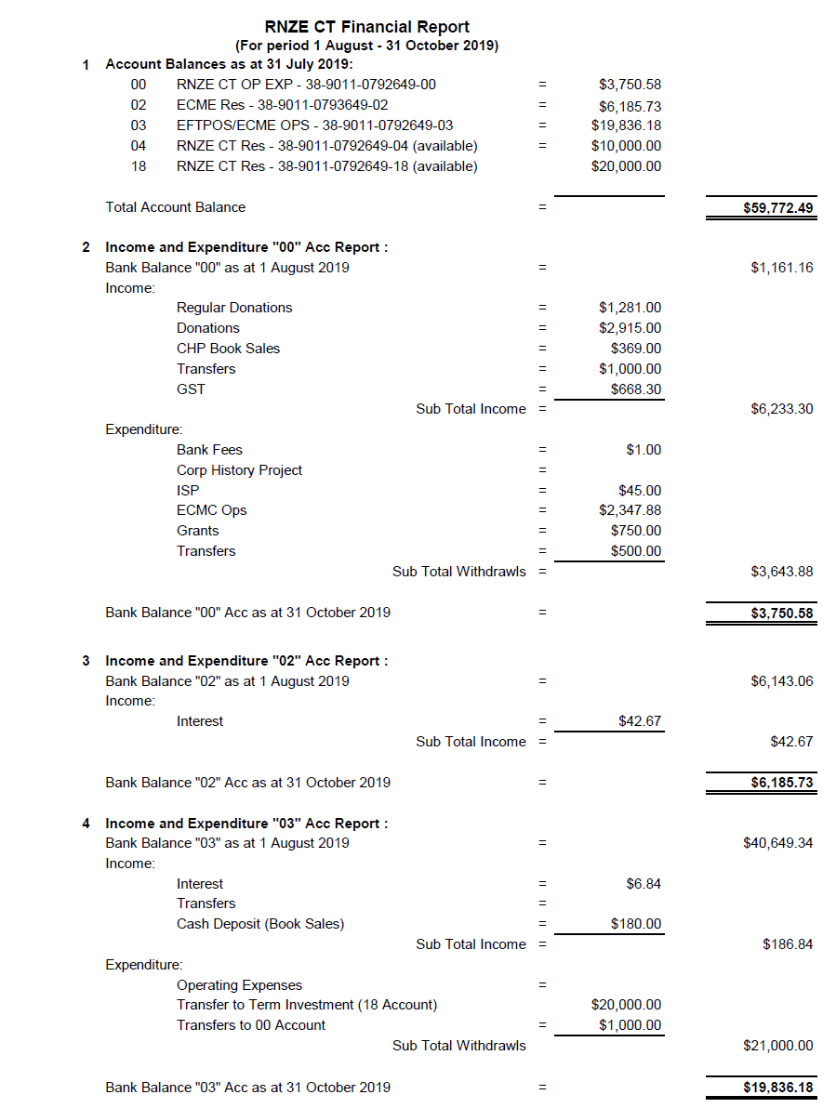

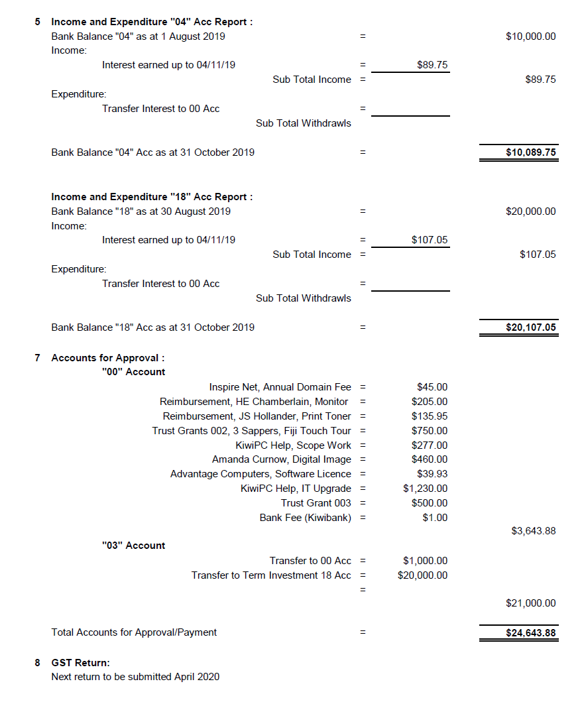

DRAFT
PNCC MILITARY HERITAGE/HISTORY COMMEMORATION PROGRAMME 2020-2025
This draft programme follows on from the approved and successful 2019 activity listing. 2020 activities are now mostly confirmed and an outline for 2021 and similar format/schedule for years 2022 to 2025, is provided. This includes the military history presentations known as the “Evening Public Lecture Presentations” (EPLP in Event Central (or as otherwise noted) and the “Monthly Midday Military History Presentations” (MMMHP, also in Event Central). This programme has been based around discussions with the PNCC Mayor, Chair of the Arts, Culture and Heritage Committee, PNCC Events (Marcomms) team and PNDHAG.
2020:

13-15 Feb – Military History Conference - “Heavy and Continuous Sacrifice – New Zealand, Its Allies and The Second World War” conference at Massey University in Wellington
20 Feb (MMMHP) – “NZ’s Involvement in the Boer War” (120th anniversary), by LTCOL (Rtd) Bryan Wells (note on third Thursday of Feb 20, to avoid clash with preceding conference)
12 Mar (MMMHP) – “175th Anniversary of the NZ Army”, by HQ 1 (NZ) Bde, Linton Camp
31 Mar – “Battle of the Bridges” (PN Secondary Schools) competition in The Square
4 Apr – “Sounds and Salutes” event in The Square, (1000-1400) to precede the NZ Mil Tattoo
4 Apr – NZ Military Tattoo at CET Arena (PM)
5 Apr – Heritage Presentation at PNCL, Event Central (Military Uniforms, by Barry O’Sullivan)
8 Apr (MMMHP) – “NZ Airmen in the WW2 Battle for France, 1939-40”, by Dr John Moremon
17 Apr – Poppy (Friday) Day
25 Apr – ANZAC Day Dawn and Civic Parades and Services in The Square and elsewhere in Ashhurst, Bunnythorpe, Linton Camp and Maori Battalion Hall
14 May (MMMHP) – “Fleet Air Arm in the Pacific during WW2”, by Denis O’Rourke
11 Jun (MMMHP) – “NZ Staff College at Massey University and Caccia Birch”, by Dr John Moremon
23 Jun (EPLP) – 75th Anniversary of WW2 VE Day – “Unpublished Photos of WW2”, by Prof Glyn Harper
9 Jul (MMMHP) – “The Merchant Navy in WW2”, by RADM (Rtd) David Ledson
13 Aug – “Nga Toa Trust” and Military Veteran Oral History Interview Programme – “Soldiers Stories”, by Patrick Bronte
25 Aug (EPLP) – 75th Anniversary of WW2 VJ Day – Presentation on Hiroshima and Nagasaki, involving the PN Japanese Community
10 Sep (MMMHP) – “Singapore Strategy 1920-1942”, by CDR (Rtd) Richard Jackson
8 Oct (MMMHP) – NZ Wars Month – “Battle of Ruapekapeka”, by Dr Chris Pugsley
11 Nov – Armistice Day Parade and Service in The Square and NZPPT (Linton Camp) launch of more streets of significance, following the service
11 Nov (EPLP) – “70th Anniversary of the Korean War” presentation, by Dr Ian McGibbon
12 Nov (MMMHP) – PNCC 150th Anniversary – presentation on PN’s military history and heritage, as part of the Sesquicentennial commemoration/celebration programme
2021:

MMMHP Programme for monthly midday presentations Feb thru Nov 2021, as per normal
(Emerging list comprising presentations by Dr Chris Pugsley (“NZ’ers in WW1 through Artists Eyes” and Roy Sefton (“Mururoa Nuclear Testing”) already established). Also the potential for more books launches from the remaining WW1 Centennial History Project.
Mar – PNCC 150th Anniversary Commemoration - Potential for a combined Charter Parade, and Beating of the Retreat ceremony, involving Charter Partners Linton Camp and RNZAF Base Ohakea
25 Apr – ANZAC Day Parades and Services in The Square and elsewhere in Ashhurst, Bunnythorpe, Linton Camp and the Maori Battalion Hall
Jun (EPLP) – “75th Anniversary of the Formation of the UN” presentation
Aug (EPLP) – TBA
11 Nov – Armistice Day Parade and Service in The Square and NZPPT (Linton Camp) launch of streets of significance following the service
11 Nov (EPLP) – TBA

2022 to 2025:

Similar format/pattern as in previous years for both EPLP and MMMHP programmes, two major commemorative events (ANZAC Day and Armistice Day), plus an annual NZDF activity/event, provided by Linton Camp (1 (NZ) Bde) and RNZAF Base Ohakea

