The Engineer Corps Memorial Centre with Palmerston North Public Library
ECMC
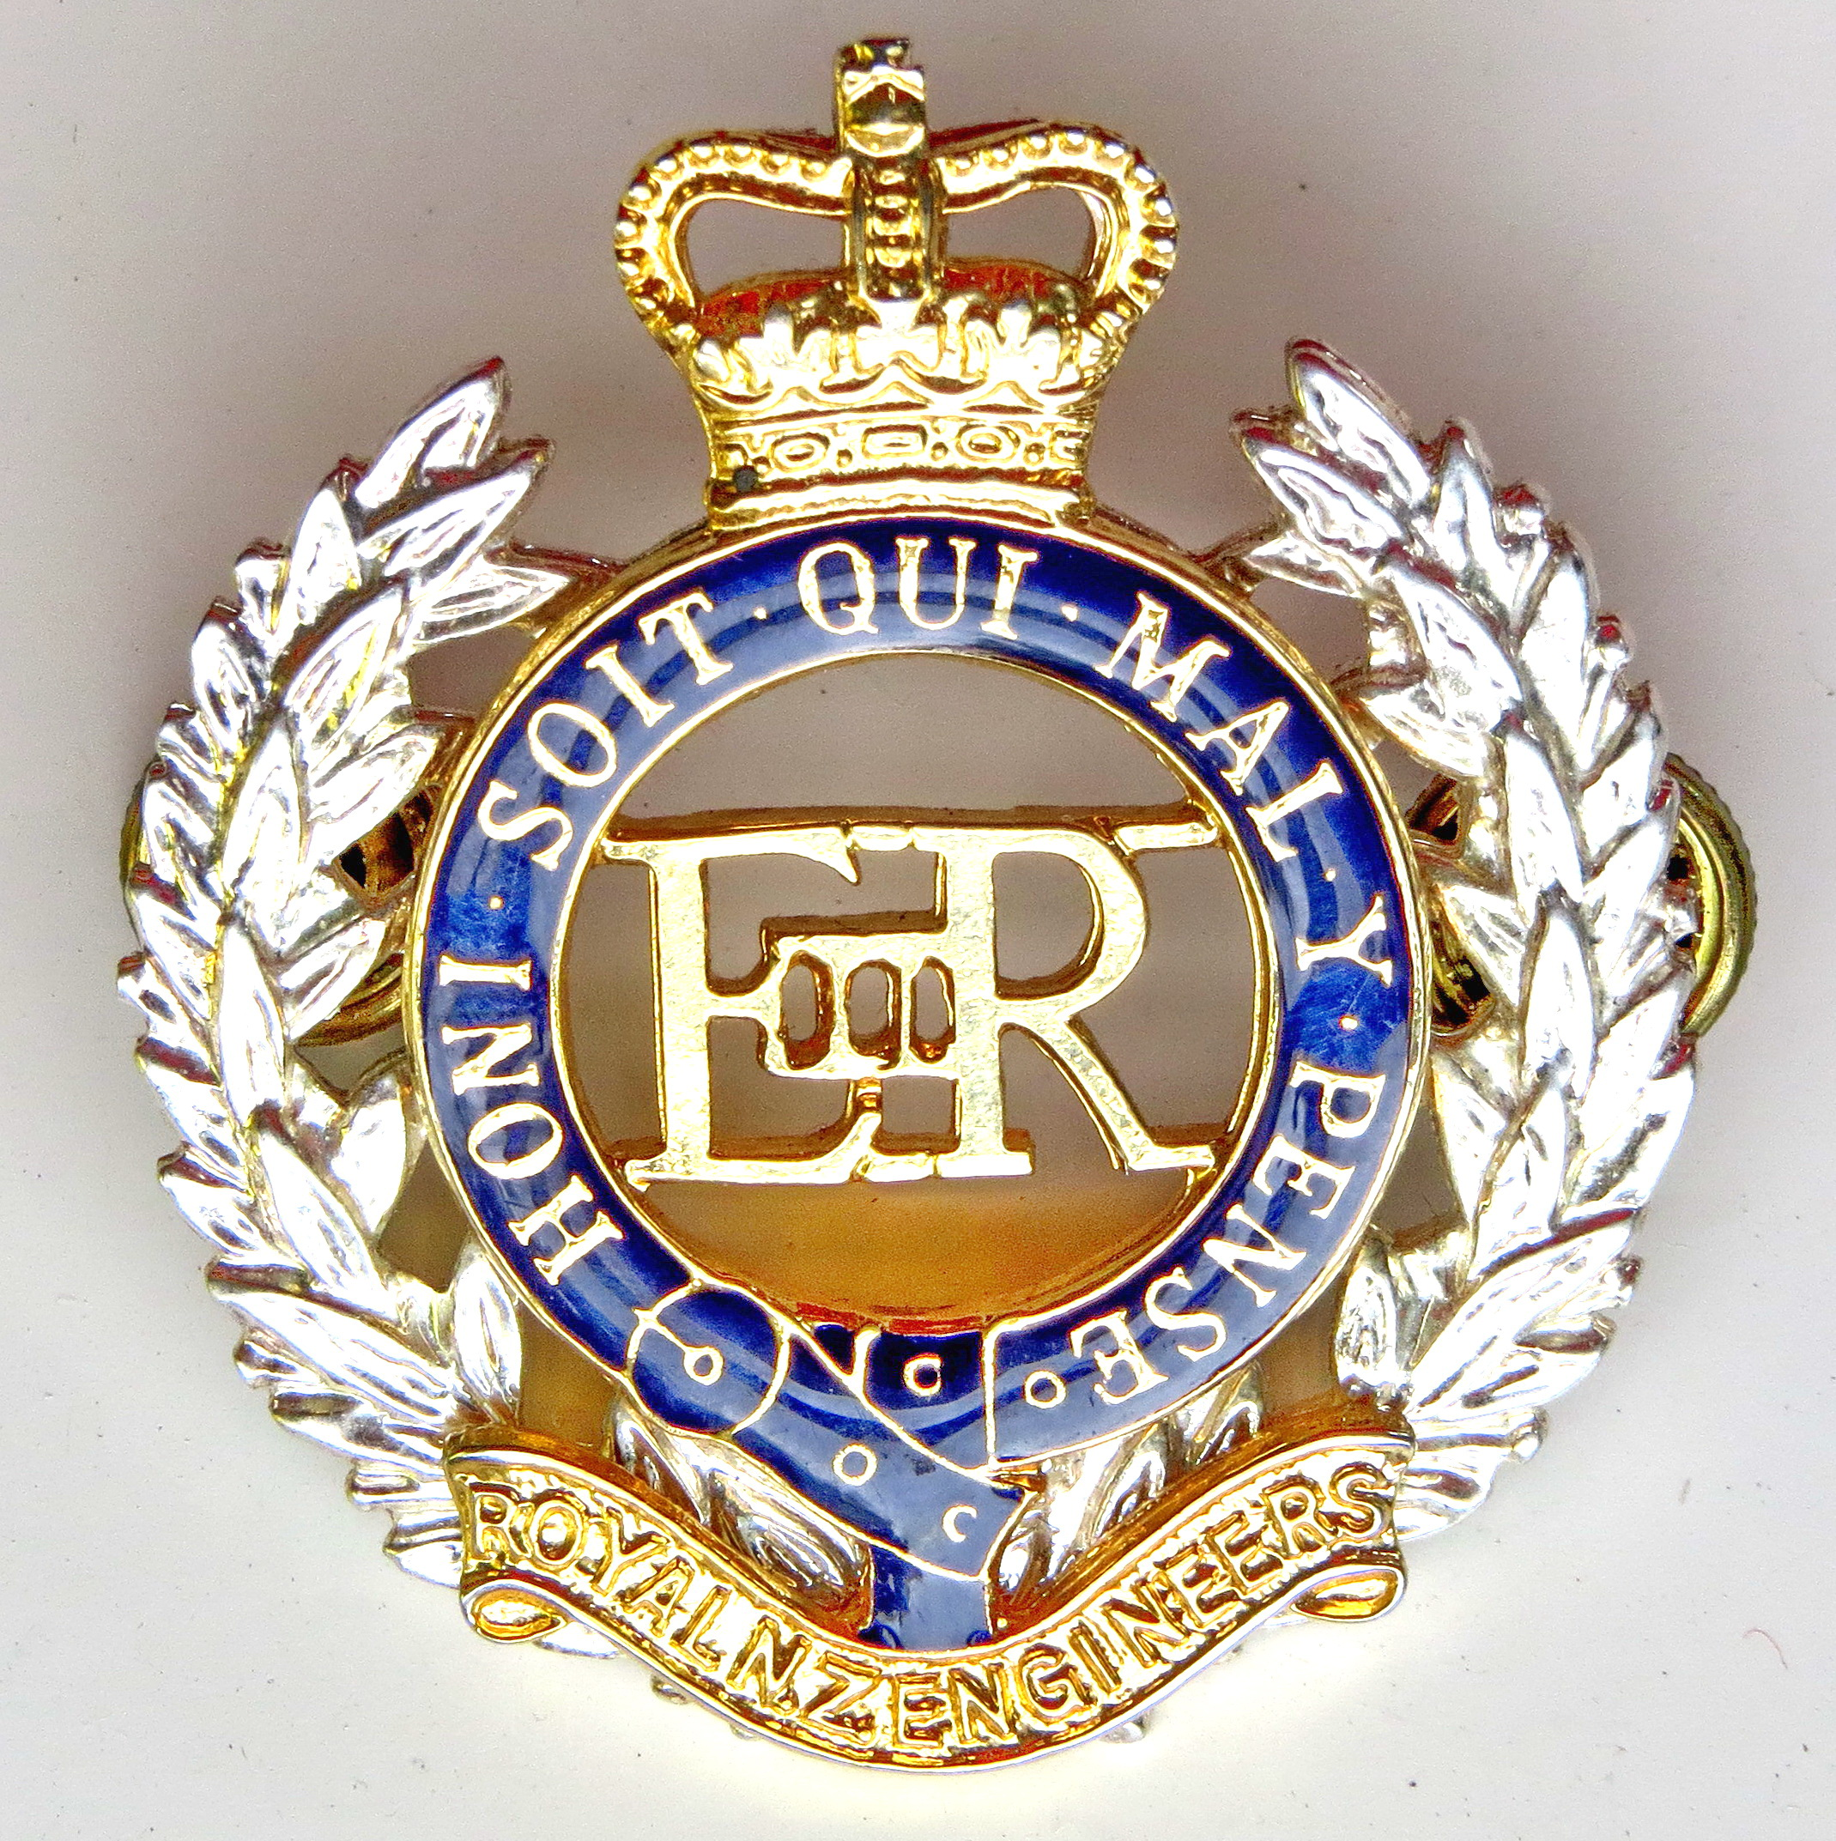Engineer Corps Memorial Centre

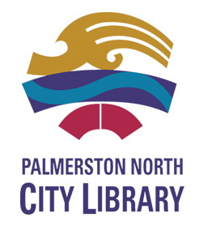

RNZAF Deployments
in the Pacific during WW2
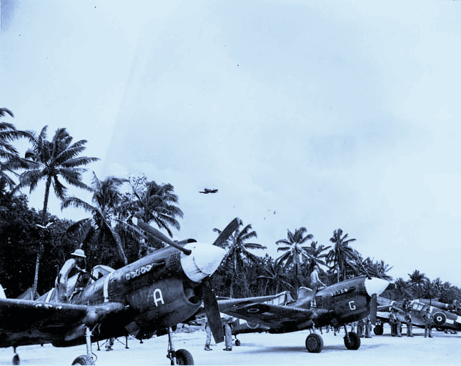

Presented by Brian Oliver,
Air Power Development Center, RNZAF.
Upstairs, Level Two Heritage Section
Public Library, Palmerston North
Thursday 13 June 2019 at 12.00 pm
$3.00 entry proceeds to RNZE Museum

