The Engineer Corps Memorial Centre with Palmerston North Public Library
ECMC
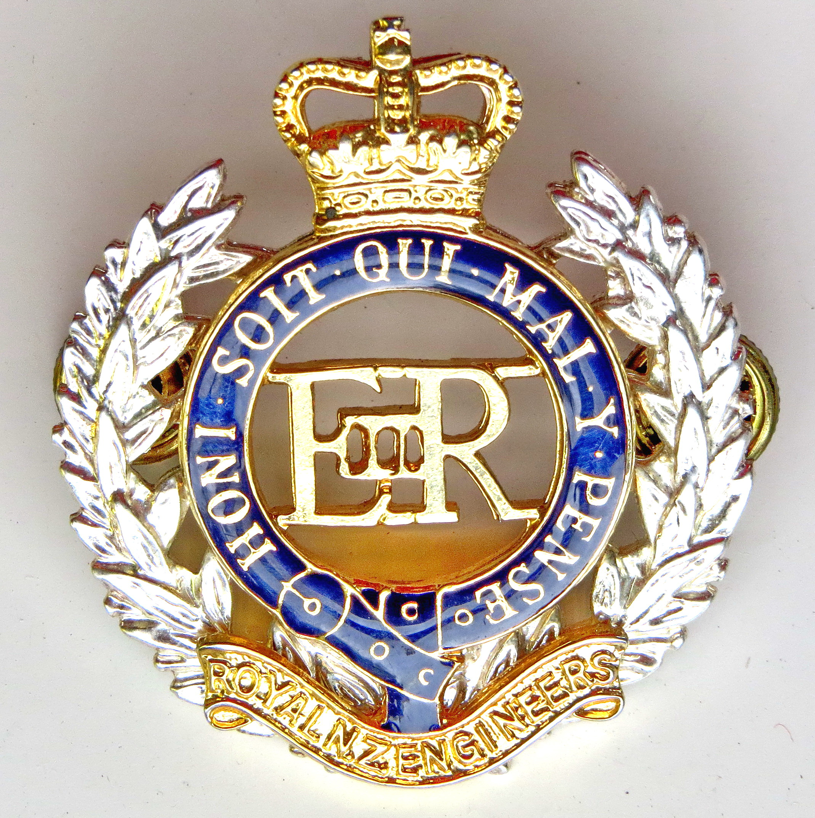Engineer Corps Memorial Centre

War in a Small Boat
– the story of Lieutenant Commander James Macdonald DSO, DSC and Two bars, MID (2) RNZNVR
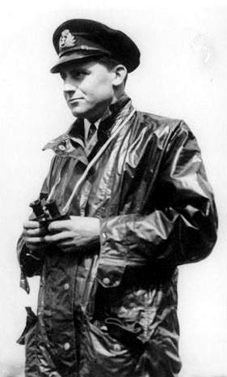
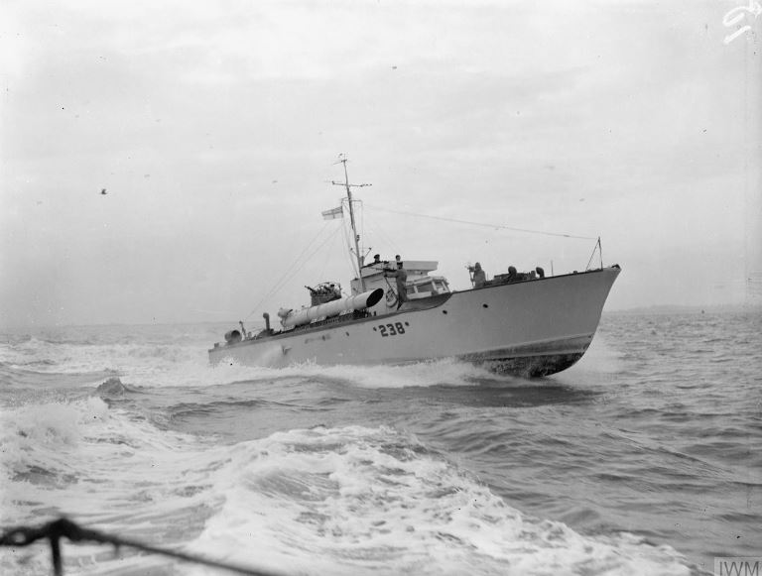

Presented by RAdm David Ledson, ONZM
Former Chief of the RNZN (2004-2009)
Event Central, Ground Floor,
Public Library, Palmerston North
Thursday 14 June 2019 at 12.00 pm
$3.00 entry proceeds to RNZE Museum

