The Engineer Corps Memorial Centre with Palmerston North Public Library

ECMC
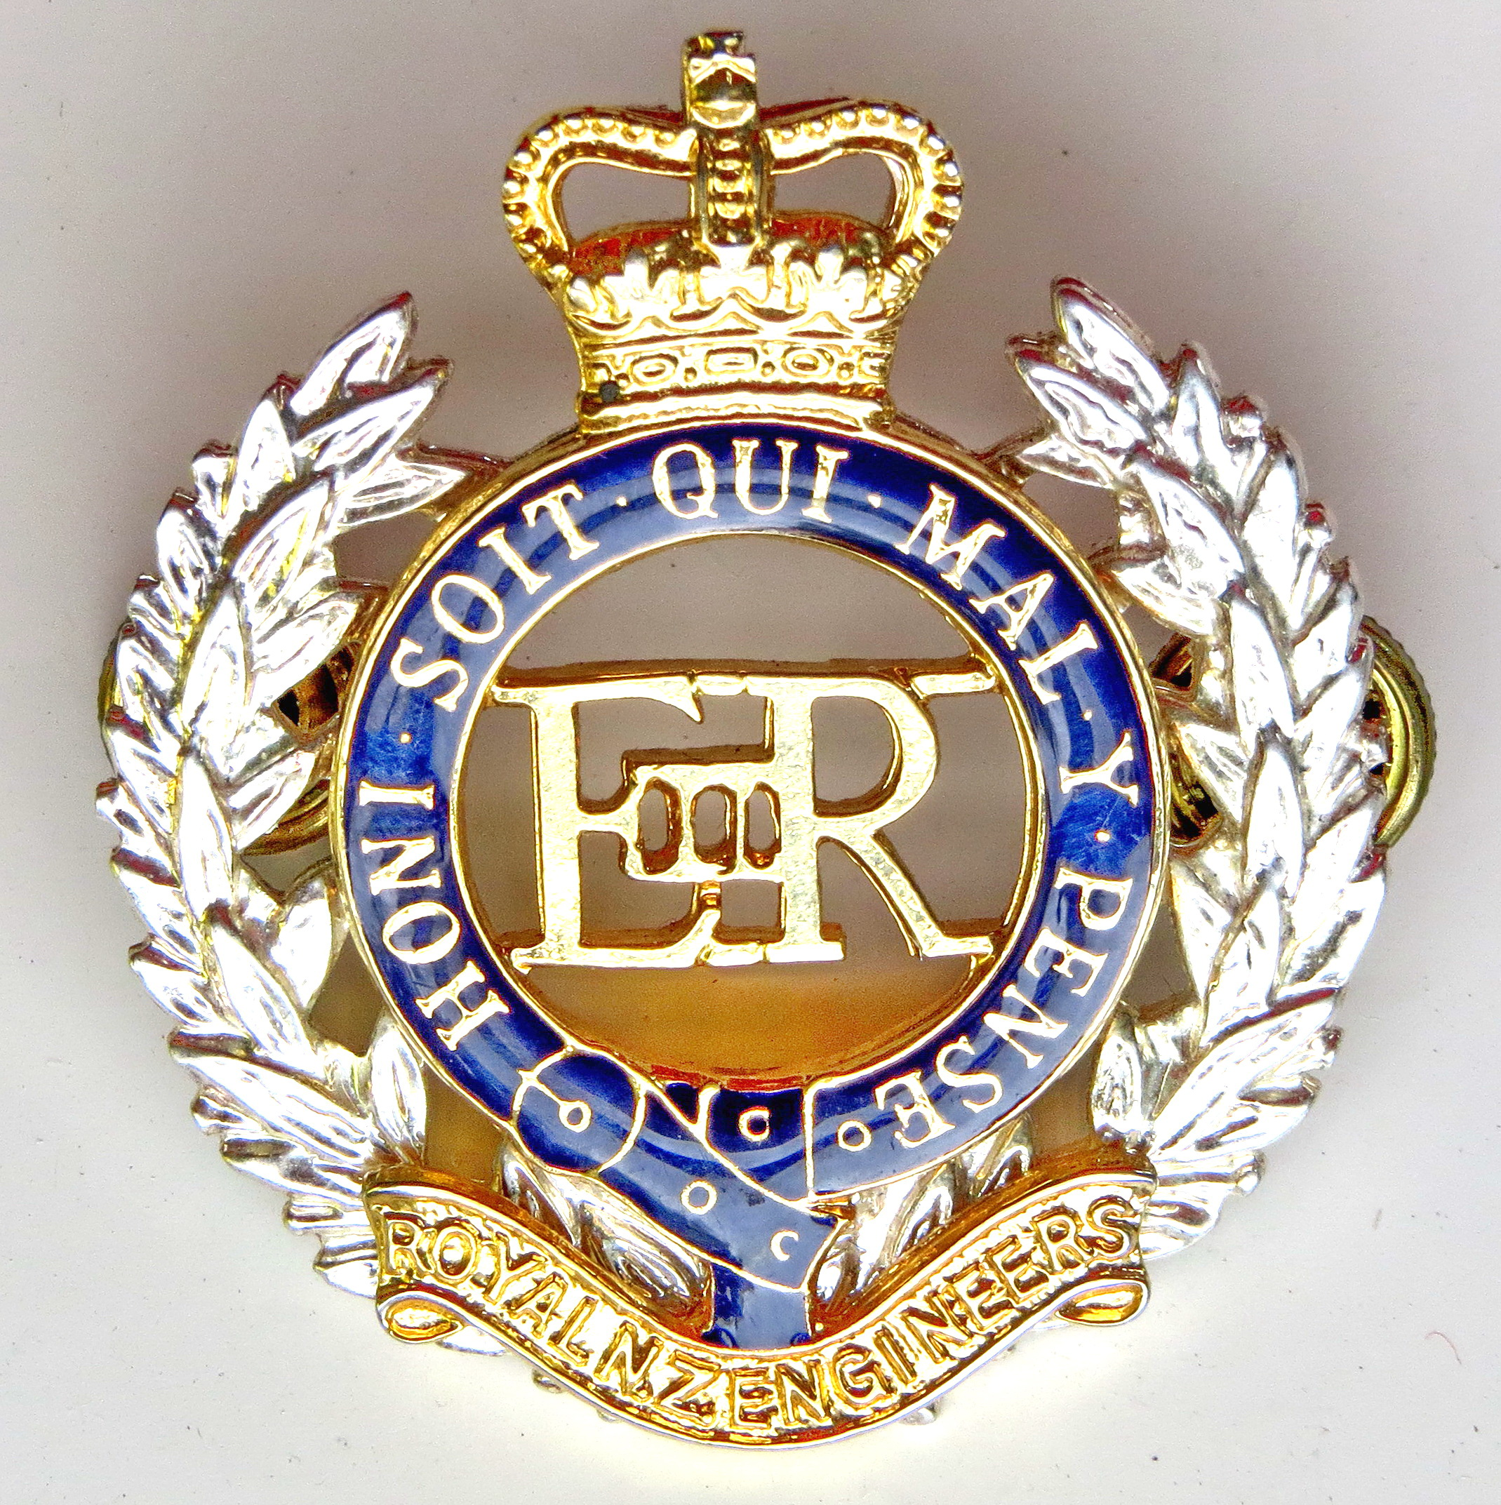Engineer Corps Memorial Centre

The Strategy Of War:
The Development of British and Maori Strategy in the New Zealand Wars
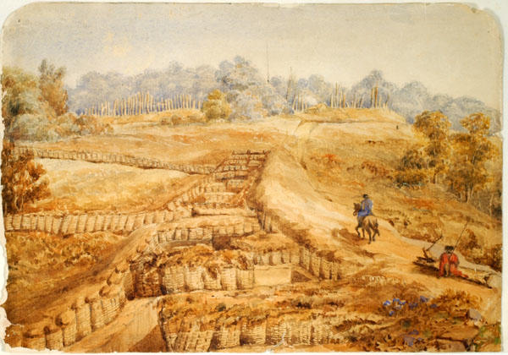
Particularly during the Hutt, Whanganui and Taranaki Wars
Presented by Lt Col Richard Taylor
In the Wilkins Theaterette, Upstairs,
Te Manawa Main Building, Palmerston North
Thursday 11 October 2018 at 12.00 pm
$3.00 entry proceeds to RNZE Museum

