New Zealand Division and
The Spring Offensive 1918

Covering the battles of manoeuvre that blunted the German attacks during the Great War, Doctrines and Organisations
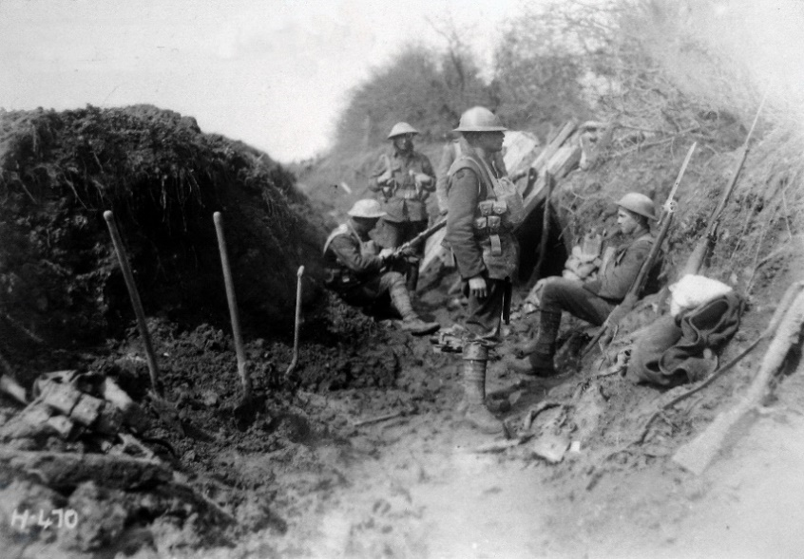

Presented by:
Lt Gen Rhys Jones, CNZM
Formerly Chief of the New Zealand
Defence Force
At The Wilkins Theaterette, Te Manawa (Upstairs
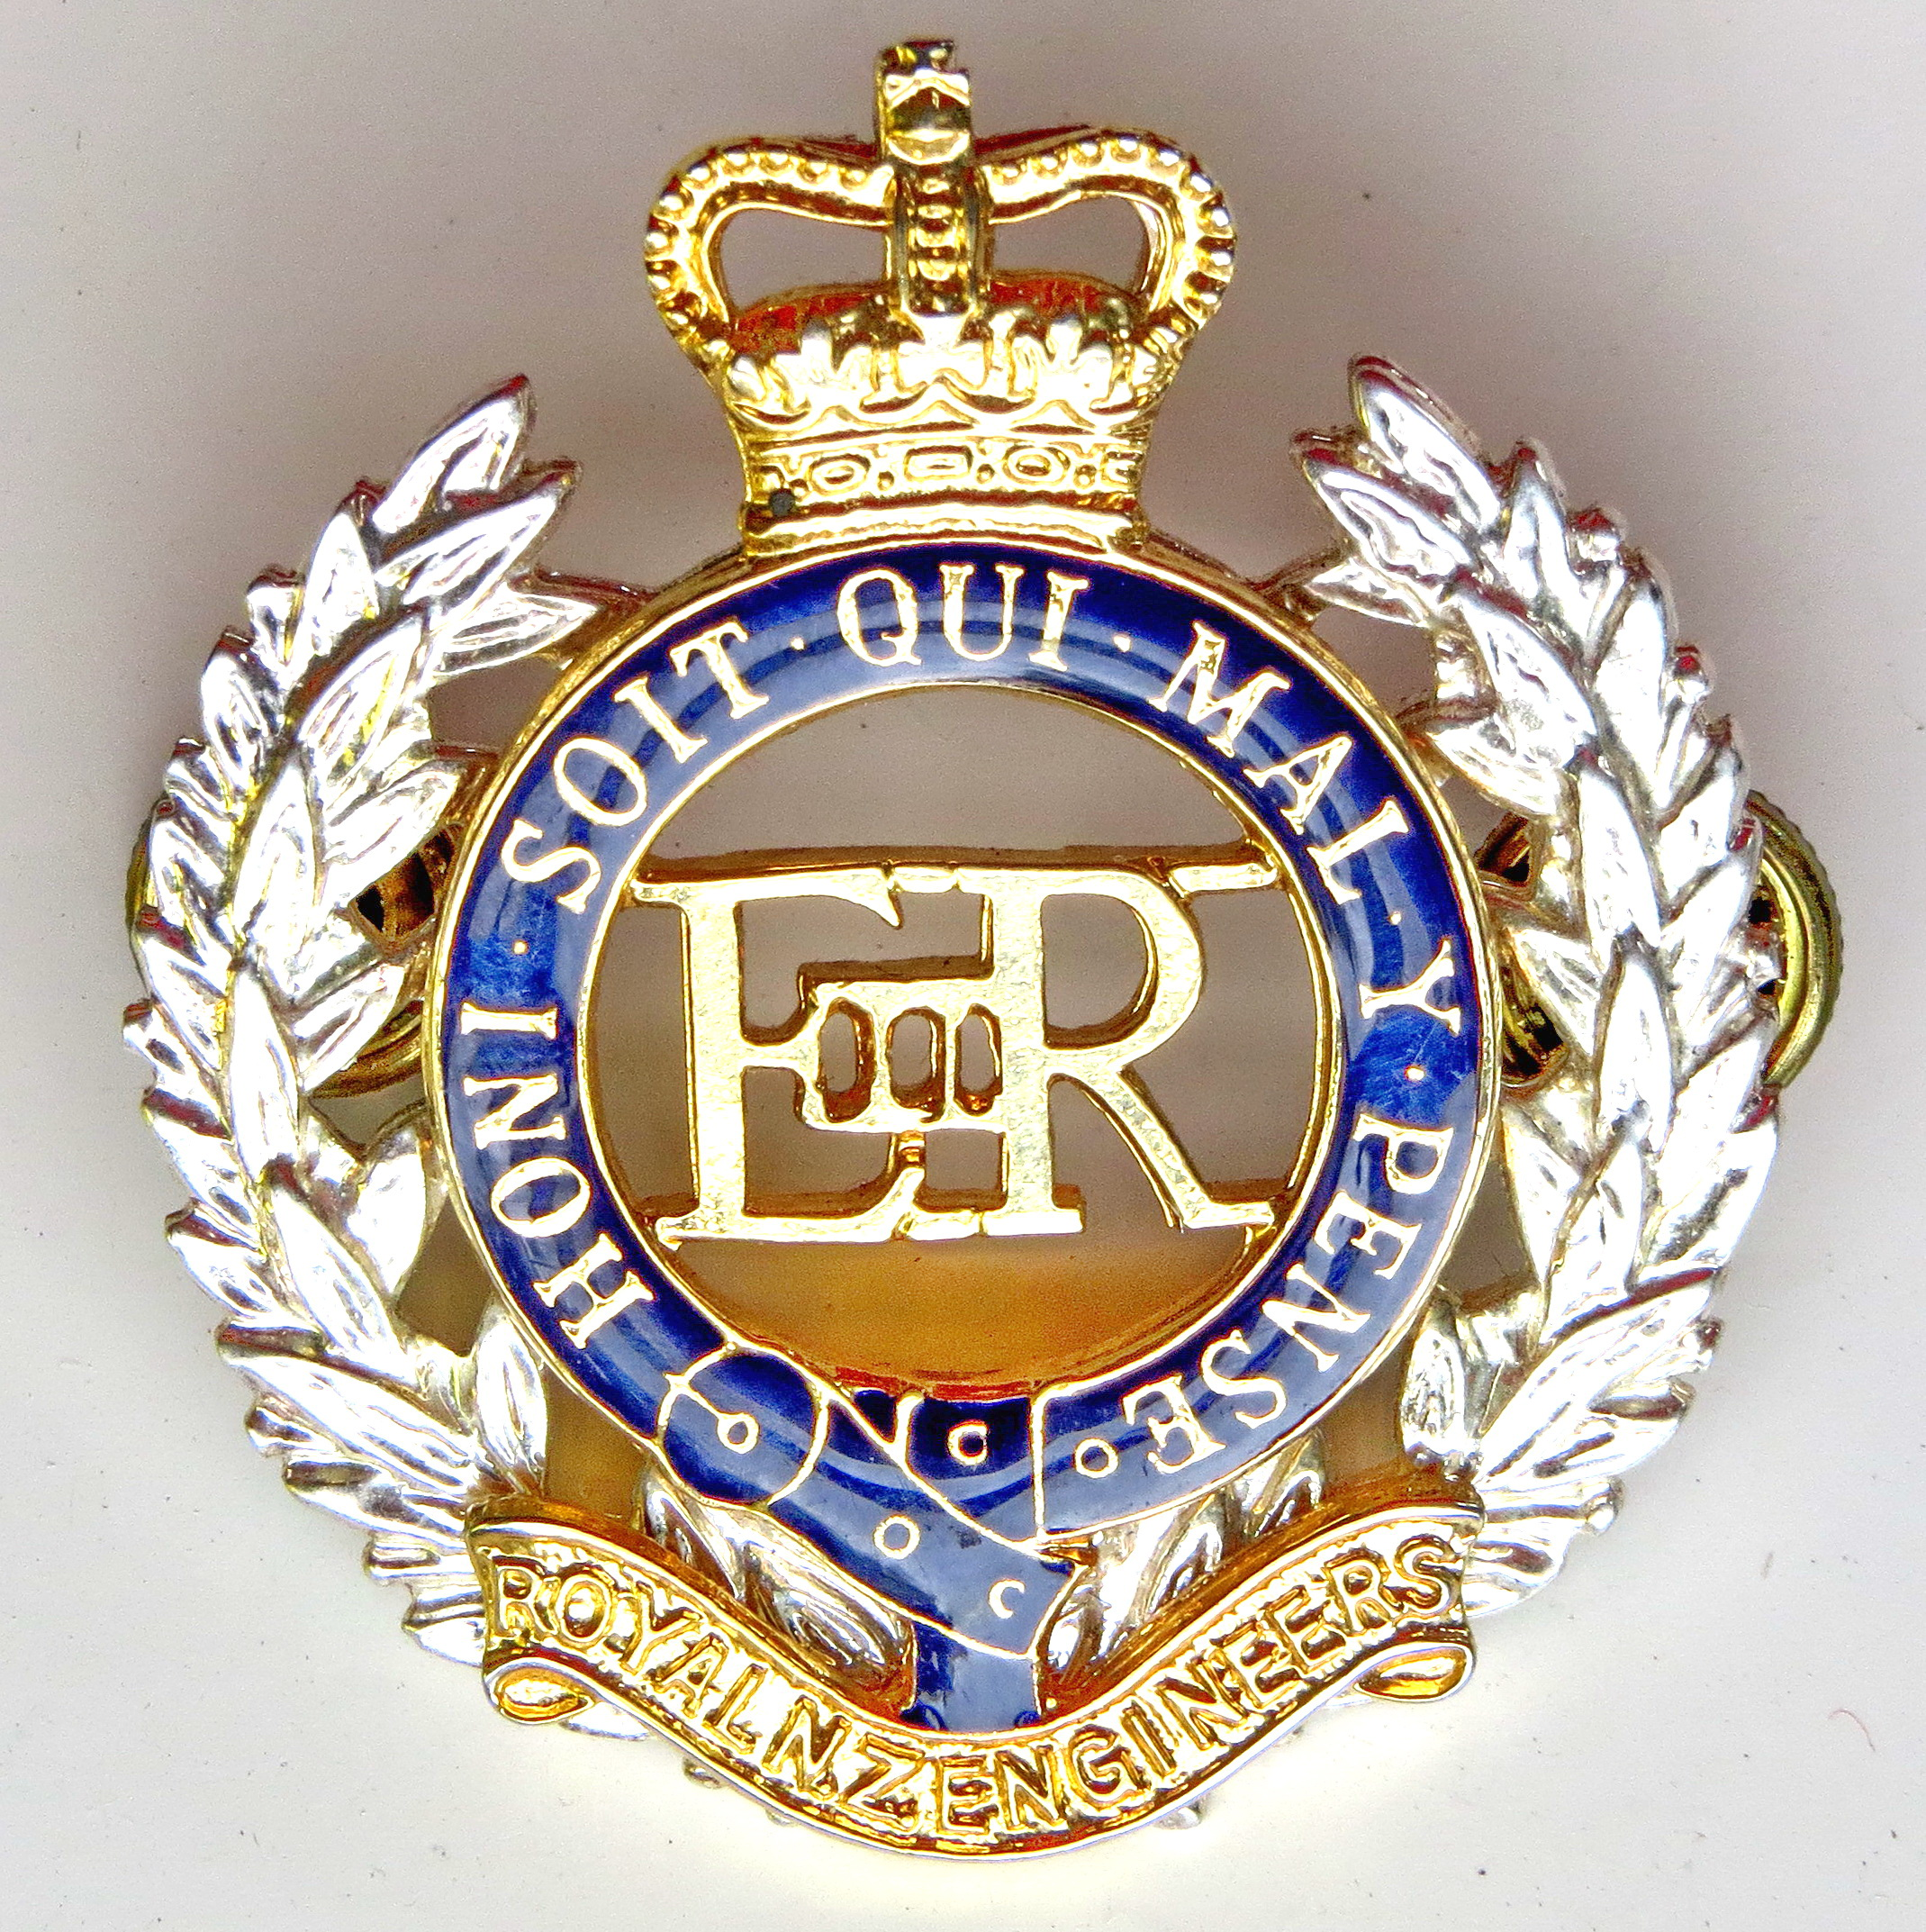ECMC
Engineer Corps Memorial Centre

in the Main Building), Palmerston North
Thursday 10 May 2018 at 12.05
All Welcome $3.00 entry

