The Engineer Corps Memorial Centre with Palmerston North Public Library
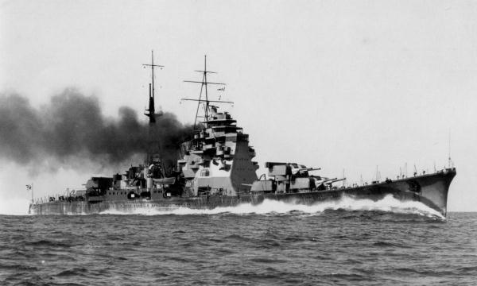
New Zealanders and Midget Submarines in Asia during WW2

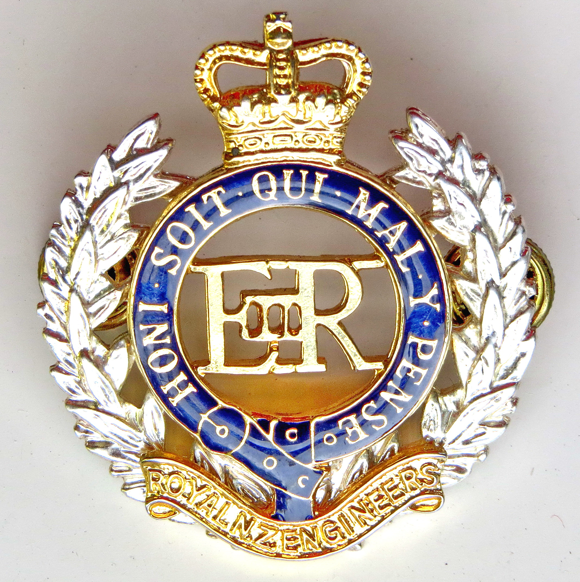ECMC
Engineer Corps Memorial Centre

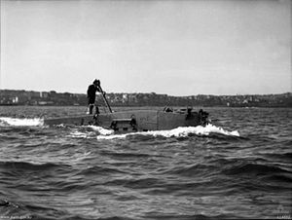
Presented by RADM (Retd) David LEDSON,
In the Wilkins Theaterette, Upstairs,
Te Manawa Main Building, Palmerston North
Thursday 12 July 2018 at 12.00 pm
$3.00 entry proceeds to RNZE Museum

