The Engineer Corps Memorial Centre with Palmerston North Public Library
ECMC
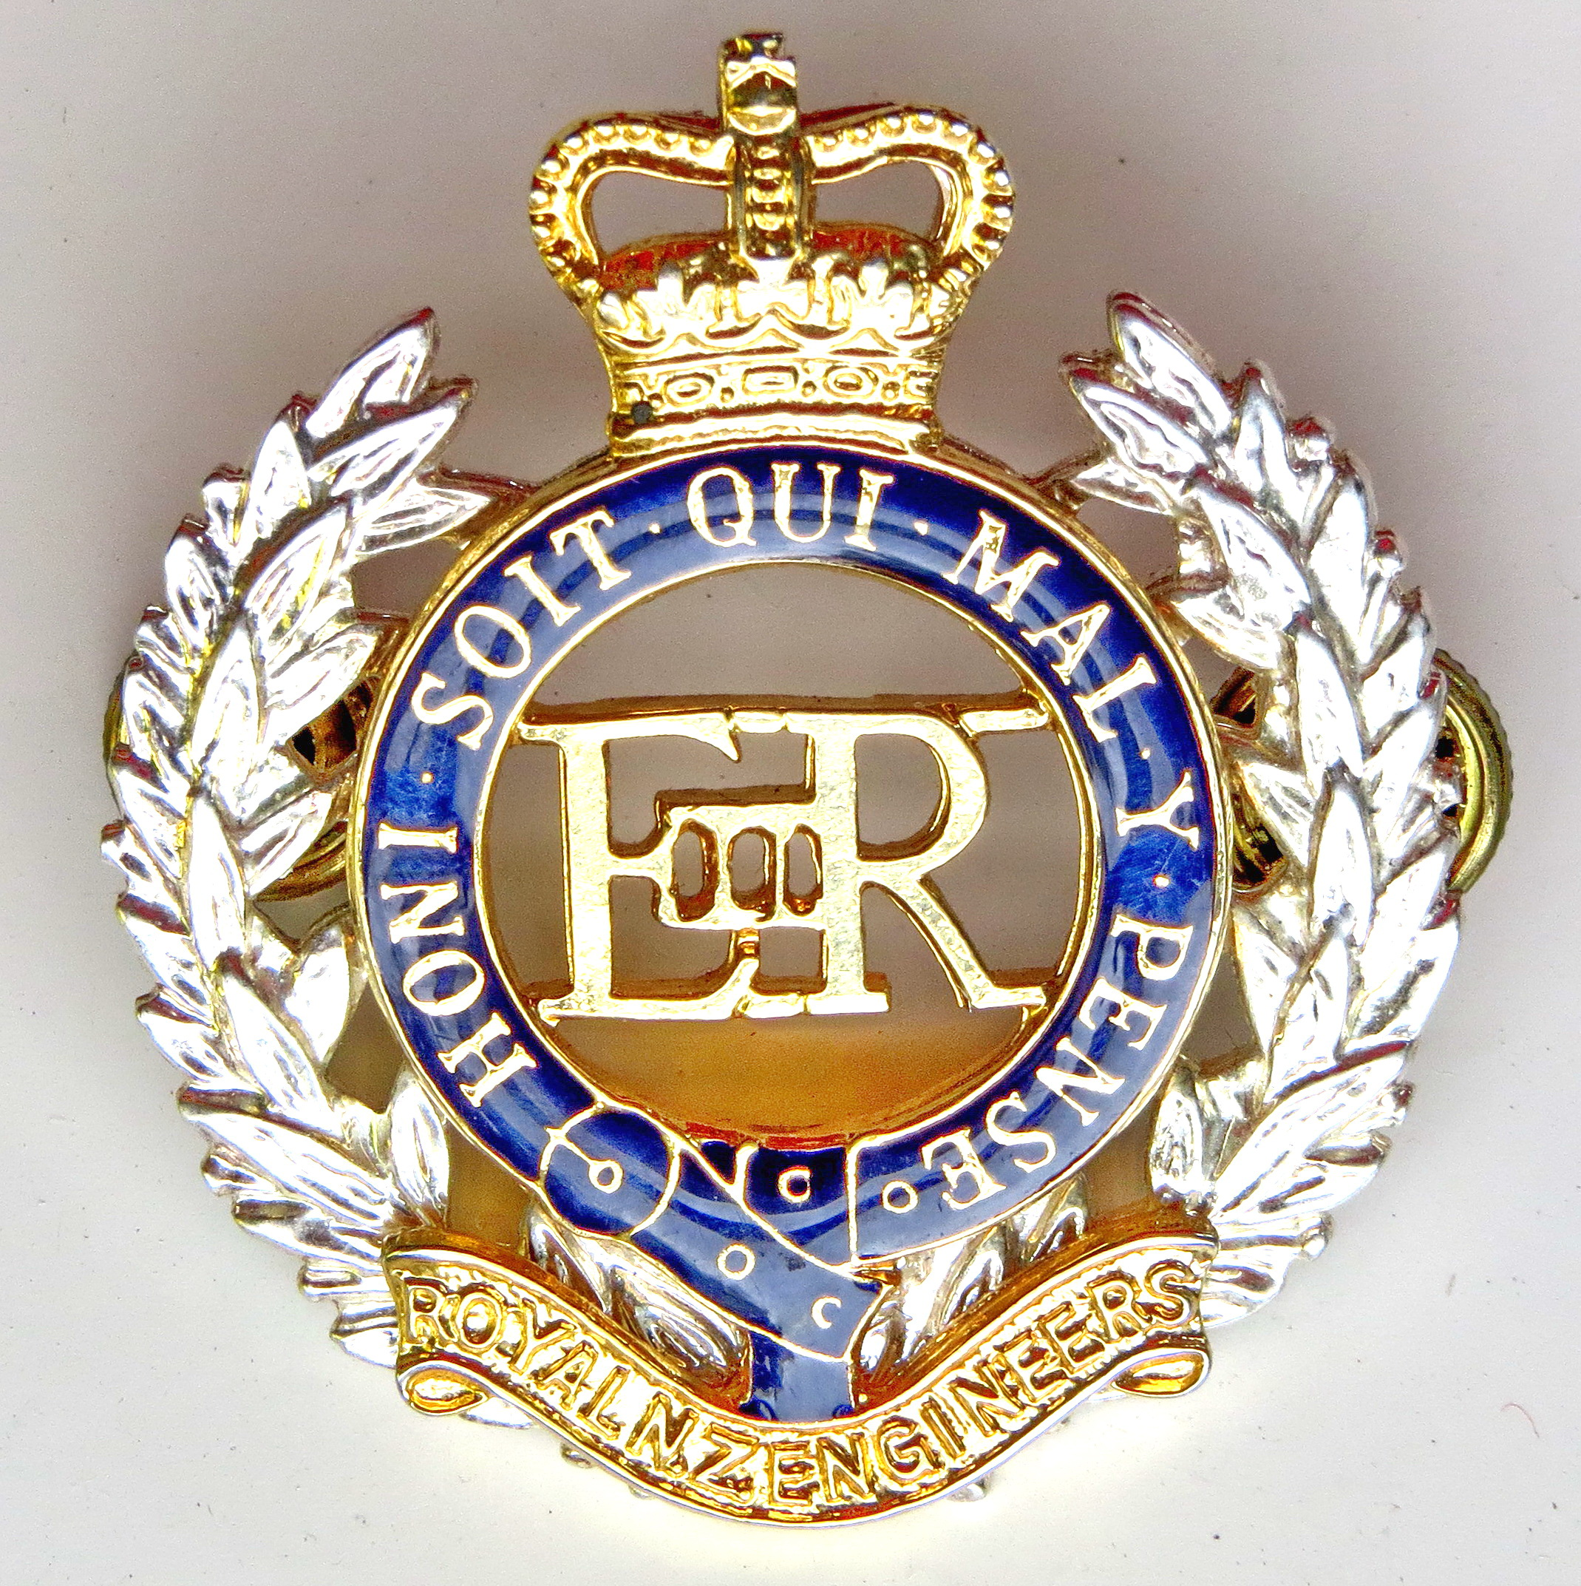Engineer Corps Memorial Centre

The development of Maori
Defence Systems 1860 to 1864

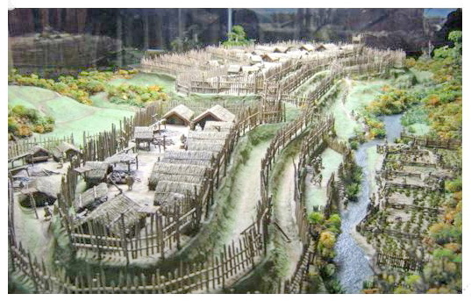

- Presented by Lt Col (Retd) Bryan Wells
- Former Lecturer at NZ Defence College

- Upstairs, Level Two
  - Public Library, Palmerston North
- Thursday 14 March 2019 at 12.00 pm
- $3.00 entry proceeds to RNZE Museum

