The Engineer Corps Memorial Centre with Palmerston North Public Library
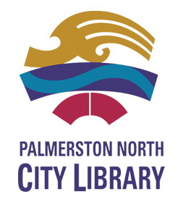
ECMC
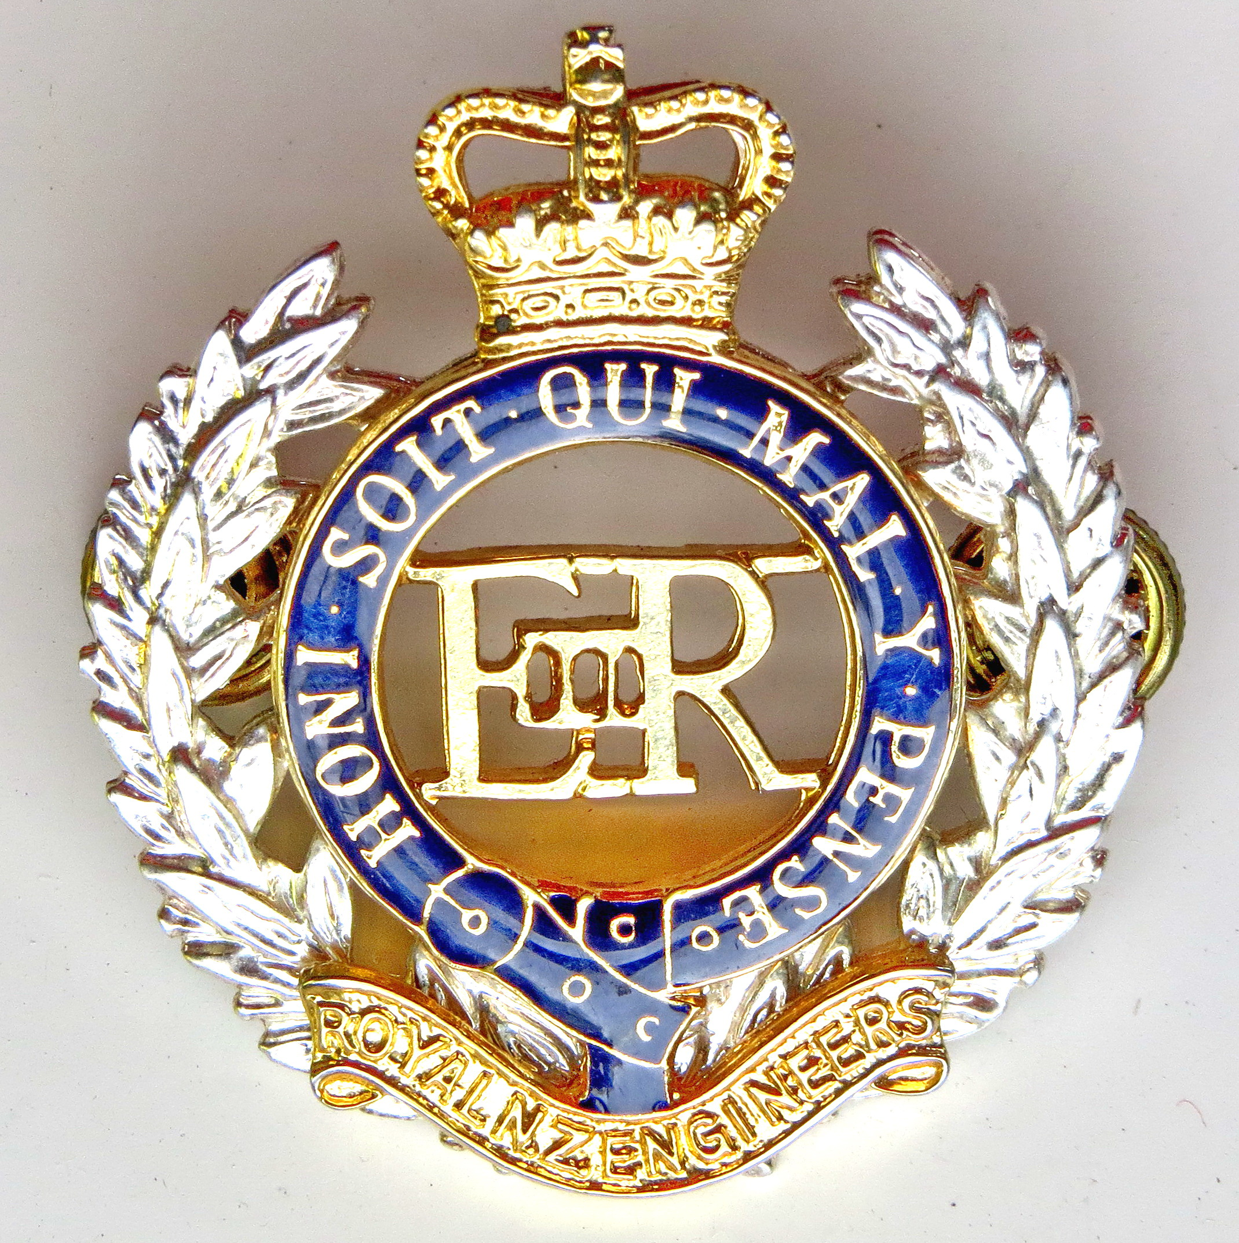Engineer Corps Memorial Centre

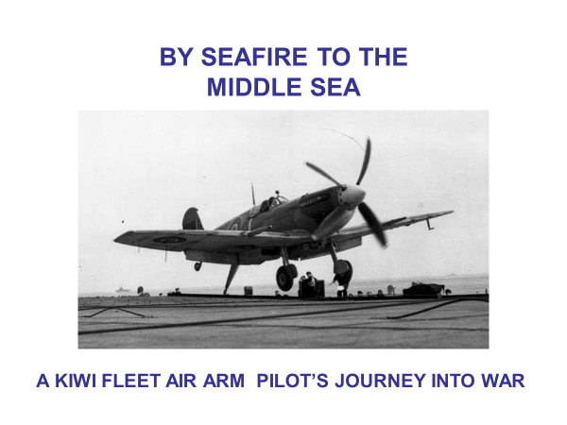

Presented by Dennis O’Rourke, MNZM
Chairman of Palmerston North Branch of Royal Aeronautical Society
Upstairs, Level Two
Public Library, Palmerston North
Thursday 14 February 2019 at 12.00 pm
$3.00 entry proceeds to RNZE Museum

