

*Arras Tunnels*

*France 1916 - 1918*

Digital survey and search of the tunnels and caves where New Zealand Engineers served during the Great War

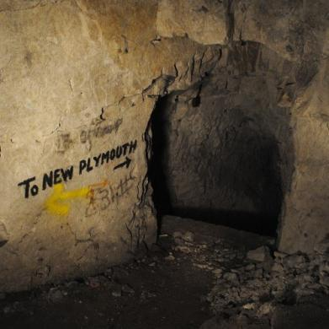Presented by

Mr Richard Hemi

Professional Practice Fellow at the

National School of Surveying

University of Otago

Level Two Palmerston North Public Library



Thursday 12 April 2018 at 12.05

All Welcome $3.00 entry