The Engineer Corps Memorial Centre with Palmerston North City Library
ECMC
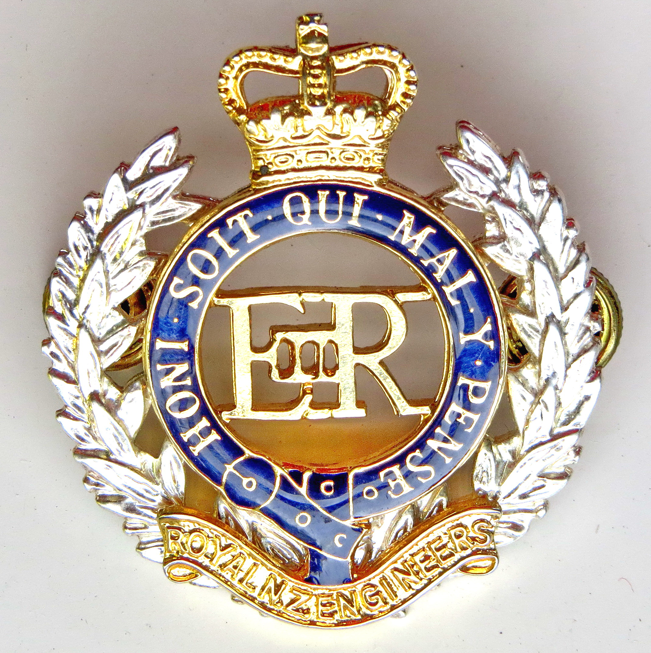Engineer Corps Memorial Centre

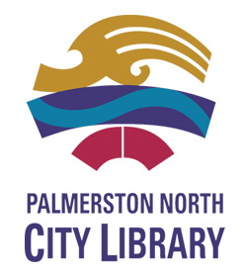

Invite you to a presentation on:

“A Mighty Coalition?
- The Allies and the
Battles of Monte Cassino”

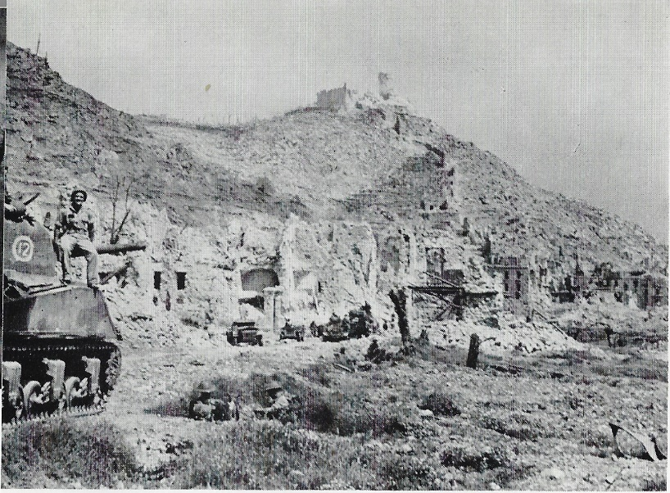

- Presented by Prof Glyn Harper, QSM
- Upstairs, Level Two (Heritage Section), City Library, Palmerston North
- Thursday, 9 May 2019 at 12.00 midday
- $3.00 entry proceeds to the RNZE Museum

