The Engineer Corps Memorial Centre with Palmerston North Public Library
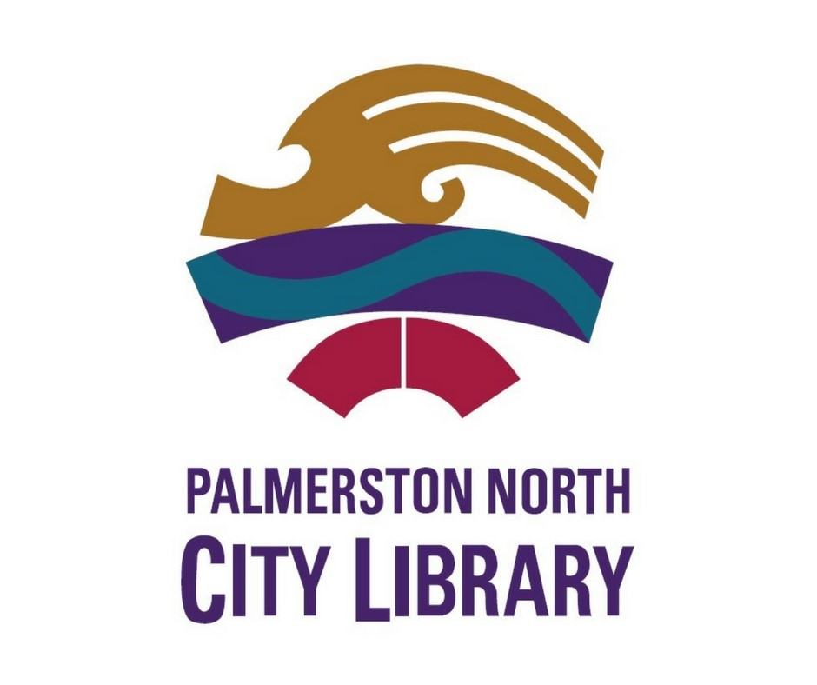

ECMC
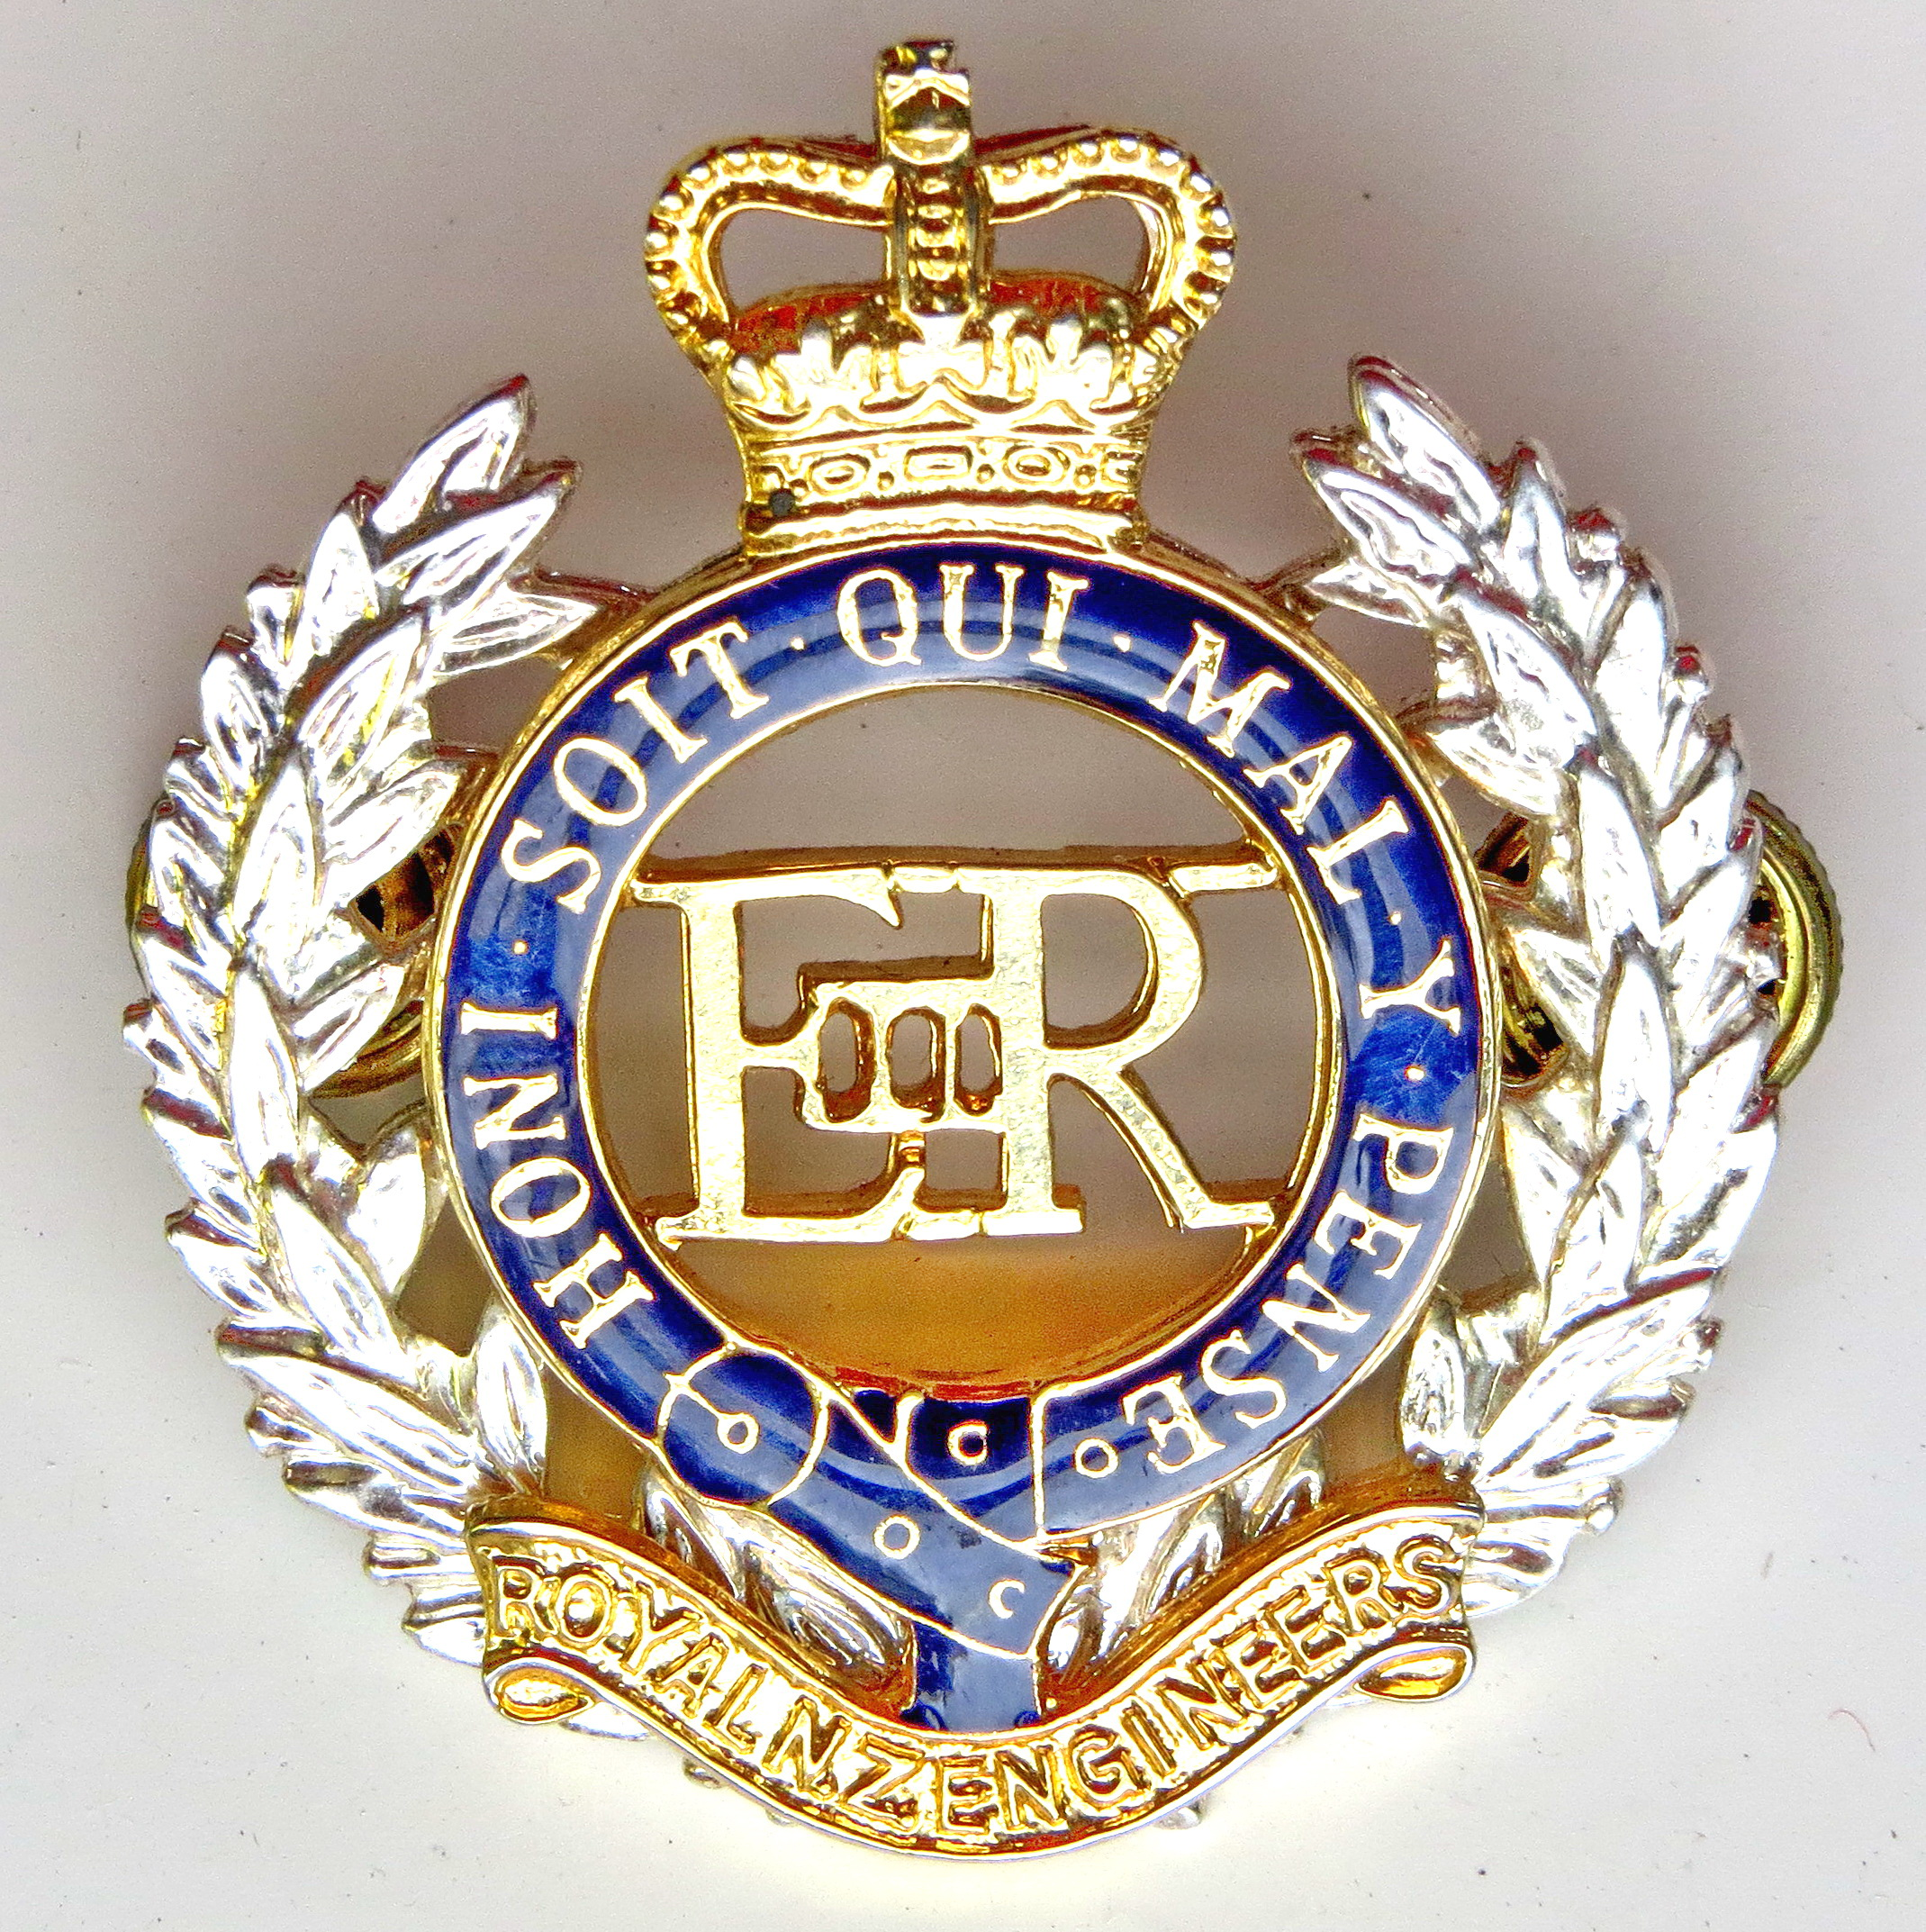Engineer Corps Memorial Centre

A topsy – turvey old world:
from fighting to dancing with the enemy
The New Zealand Division’s War-
November 1918 – March 1919
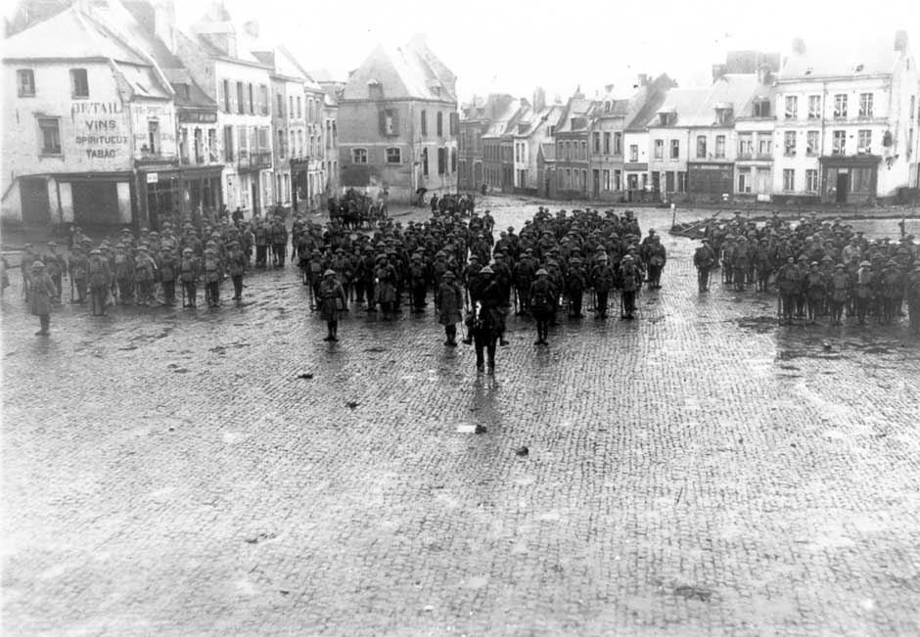
New Zealand troops in Le Quesnoy’s main square November 1918
Presented by Prof Glyn Harper, QSM
In the Wilkins Theaterette, Upstairs,
Te Manawa Main Building, Palmerston North
Thursday 8 November 2018 at 12.00 pm
$3.00 entry proceeds to RNZE Museum

